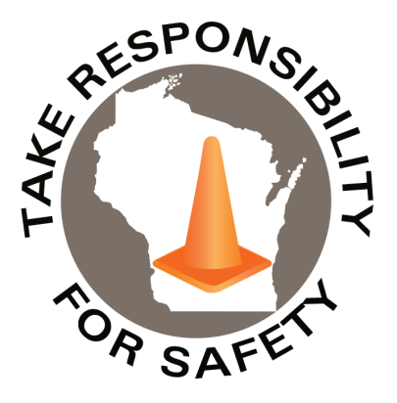

May 2021

Volume 8, Number 5

In This Issue:

**Riskiest Driving Trends**

**Rules of the Road Reminders**

|  |
| --- |
| Safety Net(work)  Produced by Department of Administration Bureau of State Risk Management  Produced by Department of Administration Bureau of State Risk Management |

Safety Spotlight:

[National Electrical Safety Month](http://www.esfi.org/program/national-electrical-safety-month-314)

Riskiest Driving Trends

A leading provider of machine vision and artificial intelligence-based video telematics, analytics, productivity and safety solutions for commercial, public sector and service fleets in the U.K. recently revealed the top fleet risk driving trends. The providers database contains more than 120 billion miles of driving data from more than one million commercial drivers worldwide, capturing over 64 million risky driving events globally each year!

**According to data for the UK, the top five observed riskiest behaviors for fleet:**

1. Improper following distance
2. Late response
3. Mobile phone use
4. Driving without a seatbelt
5. Failure to keep an out (maintaining proper space around the vehicle for escape route should the unexpected occur)

The data showed a significant percentage of fleet drivers and passengers not wearing their seatbelts, despite organizational policy. Late response results from the driver not paying attention to what is happening down the road, waiting to slam on the brakes around two seconds before impact. Which is not early enough to avoid a collision. This happens frequently around traffic signals. Additionally, short following distance occurs from drivers following too closely as to not let other cars merge in front of them. This creates a high chance for a collision. In reality letting someone merge only adds two minutes to the commute.

More data shows that collisions are occurring at or below five miles an hour. This typically occurs in parking lots. According to the National Safety Council, 5,000 collisions in parking lots occur annually, resulting in 500+ fatalities and over 6,000 injuries. Most of these could be avoided by moving the seats and mirrors in addition to not relying too heavily on backing cameras.

<https://www.safetynational.com/conferencechronicles/top-collision-causes-in-municipal-fleets/>

“More than 90% of car crashes involve human error.”

-National Safety Council Injury Facts

1,594

Claims

FY21 YTD

[National Physical Fitness & Sports Month](https://www.hhs.gov/fitness/index.html)

Workers Comp

Quote of the Month:

Five Minutes for Safety:

460

388

Claims

FY20 YTD YTD

Lost Time

FY21 YTD

Lost Time

FY20 YTD

2,085

Rules of the Road Reminders

Every year, more than four million people seek medical attention due to a motor vehicle crash, and 35,000 die in crashes on U.S. roads. **The direct cost of these crashes** – including wage and productivity losses, medical expenses, administration expenses, motor vehicle property damage, third party liability, and employer costs – **exceeds $385 billion every year** (National Safety Council Injury Facts, 2017 Edition).

It is estimated that half of those killed in motor vehicle crashes would be alive today, if they had been wearing seat belts.

* All drivers and all passengers must wear safety belts while operating or riding in a motor vehicle. Wisconsin Statute Section [347.48](https://docs.legis.wisconsin.gov/statutes/statutes/347/III/48)
* Additionally, the [Wisconsin Department of Administration Fleet Driver and Management Policy](https://doa.wi.gov/DFTS/Fleet%20Driver%20and%20Management%20Policies%20and%20Procedures%20Manual.pdf) requires compliance with this law.”

**Texting while driving is against the law in Wisconsin** and it’s a primary enforcement law, which means law enforcement officers may stop motorists suspected of this offense alone. Violators will receive a ticket of $187.90 and four points added to their license. Avoid the risk and stay safe:

* Turn off phone or switch to silent mode every time you get behind the wheel.
* Record voice mail message to tell callers status of driving.
* Pull over and stop in a safe area if cell phone must be used.
* Ask a passenger to assist with any calls or texts on behalf.

Sharing the road with others is very important; the more distance kept between everyone, the more reaction time to be had. More space equals the safer it will be:

* A minimum following distance of four seconds is recommended under ideal driving conditions. There are many situations though where more distance between vehicles is needed to be safe.

**Driving Resources for state employees**

As a state employee, some key examples to access of additional online resources about state-wide policies, procedures, regulations, and information:

[Fleet Driver and Management Policies and Procedures](https://doa.wi.gov/DFTS/Fleet%20Driver%20and%20Management%20Policies%20and%20Procedures%20Manual.pdf)

[Motorists Handbook Wisconsin Department of Transportation](https://wisconsindot.gov/Documents/dmv/shared/bds126-motorists-handbook.pdf)

Consumer Safety

[United States Consumer Product Safety Commission](http://www.cpsc.gov/)

Contact Us

<https://doa.wi.gov>

E-Mail

[Jake.Lowell@Wisconsin.gov](mailto:jake.lowell@wisconsin.gov)

[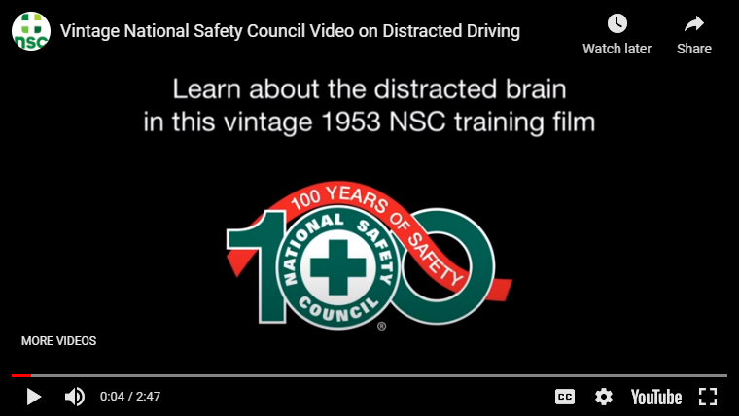](https://youtu.be/D-qiQh4mrHA)[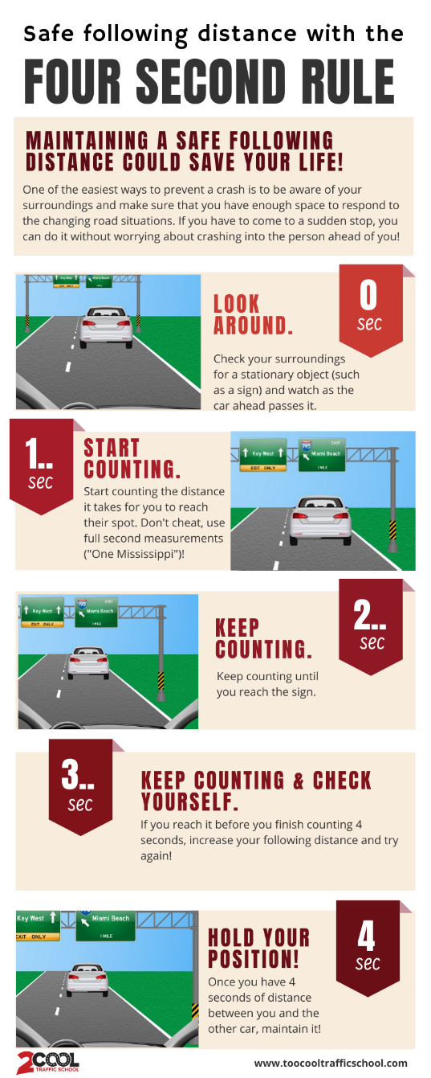](https://toocooltrafficschool.com/how-to-use-the-four-second-rule-infographic/)