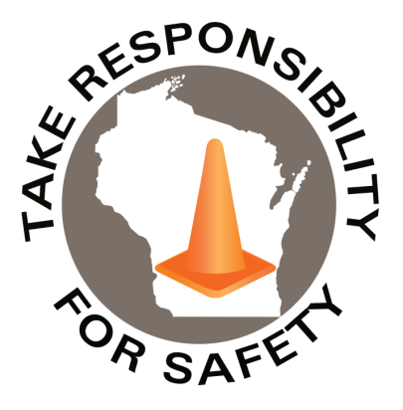

**Free** for state, municipal, public school and tribal government employees

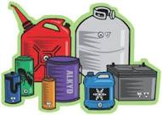

In This Issue:

**Hazardous Materials Awareness**

**& Waste Disposal Training**

**Proactive Fall Prevention**

Volume 8, Number 3

March 2021

|  |
| --- |
| Safety Net(work)  Produced by Department of Administration Bureau of State Risk Management  Produced by Department of Administration Bureau of State Risk Management |

Safety Spotlight:

[National Ladder Safety Month](https://www.laddersafetymonth.com/About/National-Ladder-Safety-Month)

Physical Properties, Hazards, Compatibility of Chemicals

Tuesday April 6 9 a.m. – 11 a.m. Series Part 1 of 4

Hazardous Waste & Spill Awareness

Thursday April 8 9 a.m. – 11 a.m. Series Part 2 of 4

Solid & Universal Waste

Tuesday April 13 9 a.m. – 11 a.m. Series Part 3 or 4

Regulatory Update, Top Violations

Thursday April 15 9 a.m. – 11 a.m. Series Part 4 of 4

**REGISTER online at** [**seminars.veoliaes.com/seminars**](http://seminars.veoliaes.com/seminars)

**2021 Wisconsin Hazardous Materials Awareness**

**& Waste Disposal Training**

Employees working at state-owned or operated facilities or employees of municipalities, tribal governments, public K-12 schools, technical colleges and universities, need to be thoroughly familiar with proper waste handling and emergency procedures relevant to their facilities operations.

The Bureau of State Risk Management sponsors this **free** training to familiarize, refresh and engage the audience with photos, videos and activities to explain requirements and best management practices for waste handling, storage, disposal and recycling. Some example products include: fluorescent lamps, batteries, laboratory chemicals, oils, antifreeze, paints, thinners, cleaners, corrosives & poisons.

Due to the ongoing COVID-19 pandemic, all 2021 training will be provided remotely through Microsoft Teams (no in-person options). Microsoft Teams meeting invites with instructions will be sent to all registered email addresses in advance of the sessions. A phone call in option will be made available for those without computer access. For any potential scheduling conflicts or technical difficulty, recordings of the sessions will be available to review in the original Microsoft Teams calendar invites.

# Who should attend?

* Employees who work with hazardous chemicals
* Facility operations, maintenance, buildings and grounds management
* Employees involved with vehicle and equipment maintenance
* Employees who manage waste storage areas
* Laboratory workers who generate waste solvents or other chemical waste
* Stock/supply-area workers who order, receive or store chemical products
* **Supervisors who oversee personnel with the duties listed above**

**Online training dates and times:**

“My job is to give my team a chance to win.”

-Nolan Ryan

1,258

Claims

FY21 YTD

[Basic Ladder Safety](https://www.americanladderinstitute.org/page/BasicLadderSafety)

Workers Comp

Quote of the Month:

Five Minutes for Safety:

388

316

Claims

FY20 YTD YTD

Lost Time

FY21 YTD

Lost Time

FY20 YTD

1,810

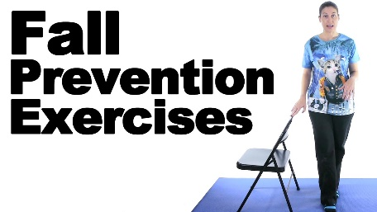[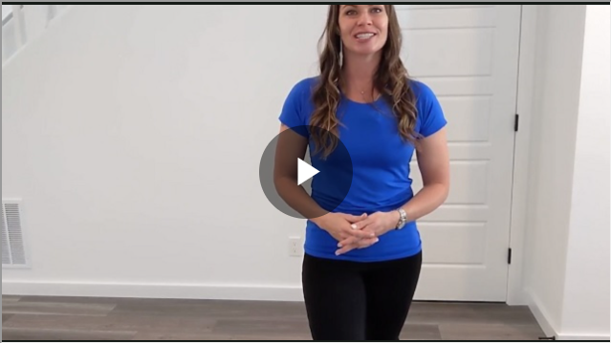](https://www.youtube.com/watch?v=UoczONH9rJE)

**Proactive Fall Prevention – In Just Two Minutes**

Industrial Safety & Hygiene News (ISHN) reports the second leading cause of preventable workplace injuries are falls. According to U.S. Bureau of Labor Statistics, in 2018 falls to the same level resulted in 147,390 incidents causing 10 median days away from work per incident. One of the top attributing factors in falls to the same level is balance. The National Safety Council articulates this causation as “the motion of the person generated by gravity following the individual’s loss of equilibrium.” Lifelong health enthusiast, Chelsea Kidd, reviews the key components (eyes = vision, inner ears = vestibular and musculoskeletal system) that make up our equilibrium of balance and provided a two-minute fall prevention drill.

* This exercise should be attempted by individuals who do not have known health risks that increase susceptibility to fall, injury or illness. The drill is intended to be completed in a safe location where the individual can easily brace themselves on a nearby stationary object if needed. The drill should be stopped at any time in the case that the individual performing the drill or a supervisor feels these movements are placing the individual at risk of injury or illness.

***Ctrl Right Click to Play***

**2-minute fall prevention drill \***

1. Begin standing upright with weight evenly distributed to both feet. Shift weight to the right foot as much as possible. Left foot can maintain a point of contact with the ground or hover over the ground.
2. Balancing on the right foot, close the eyes removing visual input. Feel the effect that removing visual input has on stability and balance. Aim to keep the eyes closed for 20 seconds.
3. With eyes still closed, still balancing on the right foot, slowly turn the head side to side then up and down. Repeat this movement in varied sequences for 20 seconds, causing a disturbance to the vestibular fluid of the inner ear.
4. Eyes remain closed, continue to balance on one foot. Hinge at the hip with back flat to lean slightly forward as if picking up an object from a low platform. Moving safely, vary the direction of your reach from side to side and overhead for 20 seconds.
5. Open eyes, both feet return to the ground, recover. Repeat this process on the left leg.

Expand daily warm-ups with this drill or introduce it in your next safety meeting. The step-by-step removal of key equilibrium components will help demonstrate the importance and sensitivity of these systems to employees. The practice of maintaining balance when tested will translate to improved physiological outcomes that reduce the risk of falls within the workforce.

<https://www.ishn.com/articles/112823-proactive-fall-prevention-in-just-2-minutes?oly_enc_id=4569J0142745I7Y>

Consumer Safety

[United States Consumer Product Safety Commission](http://www.cpsc.gov/)

Contact Us

<https://doa.wi.gov>

E-Mail

[Jake.Lowell@Wisconsin.gov](mailto:jake.lowell@wisconsin.gov)