**

Volume 8, Number 7

July 2021

In This Issue:

**Drive Safe Wisconsin – Now Live!**

**Keep Workers Safe in the Heat**

|  |
| --- |
| Safety Net(work)  Produced by Department of Administration Bureau of State Risk Management  Produced by Department of Administration Bureau of State Risk Management |

Safety Spotlight:

[Fireworks Safety](http://www.cpsc.gov/en/Safety-Education/Safety-Education-Centers/Fireworks/)

Workers Comp

1,968

Claims

FY21 YTD

[Child Safety - Heatstroke Prevention](https://www.trafficsafetymarketing.gov/get-materials/child-safety/heatstroke-prevention)

“The best fights are the ones we avoid.”

-Jackie Chan

Quote of the Month:

Five Minutes for Safety:

543

490

Claims

FY20 YTD YTD

Now live! The Bureau of State Risk Management partnered with the Department of Transportation in creating a “Drive Safe Wisconsin” training course to help mitigate injuries and loses involving motor-vehicles.  The course provides information about driving risks and best practices to help reduce the chances of motor vehicle collision, injury, and loss by improving knowledge and behavior while on the road.  The training series is focused on four important driver safety topics that are common contributing areas of risk & loss for the State of Wisconsin.  The topics included share valuable information that can dramatically lower the risk of injury when behind the wheel:

* Using Safety Belts
* Seeing Well
* Avoiding Dangerous Driving Behaviors
* Adjusting to Road Conditions

The “Drive Safe Wisconsin” training course is available through [Employee Self Service](https://ess.wi.gov/psp/ess/EXTERNAL/HRMS/?cmd=login&languageCd=ENG&) (ESS) via the “My Learning” icon for agencies and via [UW System OSH Training](https://www.wisconsin.edu/ehs/training2/) web page for campuses. Keyword search “Drive Safe” in Leader (Cornerstone).  The course is broken in four sessions, topically as outlined above, and total run time of entire program is approximately 40 minutes.  It’s designed either to be taken in a single sitting or by topic to accommodate any time constraints.  This training is beneficial for both personal and work-related operation of vehicles and encourage anyone operating a vehicle to complete this training.

Drive safe Wisconsin!

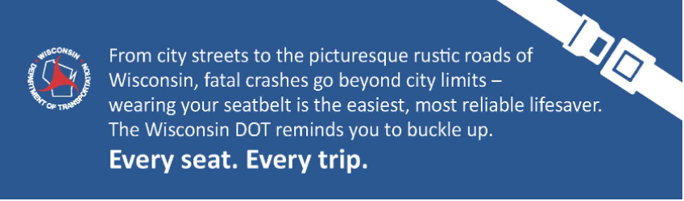

Lost Time

FY21 YTD

Lost Time

FY20 YTD

2,380

[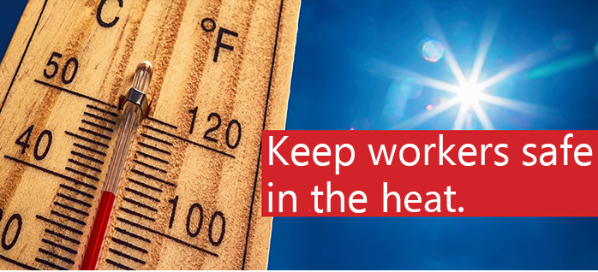](https://www.osha.gov/heat)[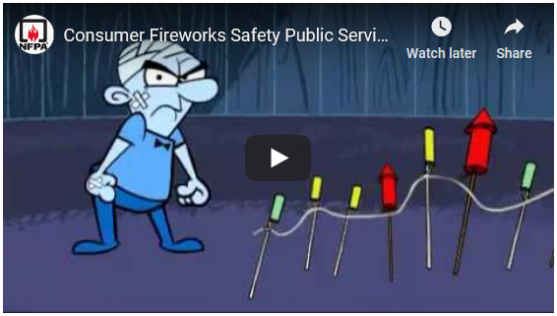](https://youtu.be/PcFuIEwbITA)

[](https://www.cpsc.gov/s3fs-public/ConsumerProductInjuriesCOVID19pandemic.pdf?StV8YoN146UhwbIv6rclS53mTYuH1b21)

Consumer Safety

[United States Consumer Product Safety Commission](http://www.cpsc.gov/)

Contact Us

<https://doa.wi.gov>

E-Mail

[Jake.Lowell@Wisconsin.gov](mailto:jake.lowell@wisconsin.gov)

|  |
| --- |
|  |

According to the Occupational Safety & Health Administration (OSHA), every year, dozens of workers die and thousands more become ill while working in extreme heat or humid conditions. Beginning in 2011, OSHA launched a [Heat Illness Prevention Campaign](https://www.osha.gov/heat) educating employers and workers on the dangers of working in the heat. Additionally, the Heat Illness Prevention Campaign just released a brand-new resource pamphlet ([English](https://www.osha.gov/sites/default/files/publications/OSHA4135.pdf) or [Spanish](https://www.osha.gov/sites/default/files/publications/OSHA4135SP.pdf)) explaining what employers can do to keep workers safe and what workers need to know to protect themselves in hot and humid conditions. The overall message comes down to three key words: **Water. Rest. Shade.**

The Centers for Disease Control and Prevention (CDC) has a free heat safety tool smartphone application available for download. Some valuable features the tool includes are:

* A visual indicator of the current heat index and associated risk levels specific to current geographical location
* Precautionary recommendations specific to heat index-associated risks levels
* An interactive, hourly forecast of heat index values, risk level, and recommendations for planning outdoor work activities in advance
* Editable location, temperature, and humidity controls for calculation of variable conditions
* Signs and symptoms of heat-related illnesses including: heat stroke, heat exhaustion, rhabdomyolysis, heat cramps, and heat rash
* First aid information for heat-related illnesses

Take steps to work safely in the heat and download this valuable tool today!