[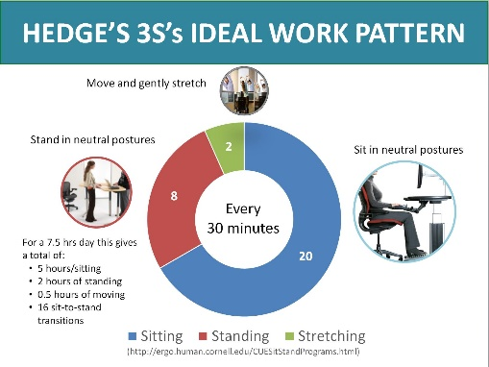](http://ergo.human.cornell.edu/hedges3Ss.JPG)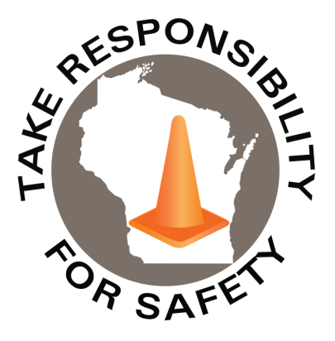

January 2021

Volume 8, Number 1

In This Issue:

**Safety Tips for Office Workers**

**“R-U-A” Defensive Winter Walker?**

|  |
| --- |
| Safety Net(work)  Produced by Department of Administration Bureau of State Risk Management  Produced by Department of Administration Bureau of State Risk Management |

Safety Spotlight:

[National Radon Action Month](https://www.epa.gov/radon/national-radon-action-month-event-planning-kit)

Safety Tips for Office Workers

Happy 2021! It’s true, office workers are at a lower risk for workplace injuries than most, but it is still important to review simple office safety tips. Below are some reminders for office employees to prevent workplace injuries, let’s make 2021 be a safe one!:

* **Make sure the desk setup is ergonomic**

To maintain a neutral posture, the head should be centered over the neck and shoulders, wrists flat and elbows resting comfortably at the side. For more information check out our [Ergonomic Resources](https://doa.wi.gov/Pages/AboutDOA/DEO_Safety-and-Loss-Control.aspx).

* **Follow Hedge’s 3S’s Ideal Work Pattern**

A best practice to organize the day of sit-stand-stretch work pattern. It means that in every 30-minute cycle, a worker is allowed 20 minutes sitting, followed by 8 minutes standing, and finally 2 minutes standing and moving. For a total 7.5 hour workday (lunch excluded), this means that workers would have a total of 5 hours of sitting, 16 sit-to-stand changes, 2 hours of standing, and 0.5 hours of moving.

* **When it’s slippery due to ice and snow, walk like a penguin when entering and leaving the office**

Winter slips and falls are extremely common. To avoid them, walk like a penguin by walking flat footed taking short, slow steps. It’s also very important to wear proper footwear, with good traction, and limit carrying items. For more information check out our [Slip, Trip & Fall Prevention Manual](https://doa.wi.gov/DEO/Slip%2c%20Trip%20and%20Fall%20Prevention%20Manual.pdf) and [Winter Slip & Fall Prevention Poster](https://doa.wi.gov/DEO/WalkLikeAPenguinPoster.pdf).

* **Practice safe lifting techniques**

Simple best practices like warm up stretching, proper body mechanics, and aids used for lifting can help prevent lifting injuries. For more information check out our [Safe Lifting Injury Prevention Manual](https://doa.wi.gov/DEO/Safe_Lifting_Injury_Prevention_Manual.pdf).

* **Keep your workplace tidy**

Clean up spills immediately, keep floor free of clutter, and tie up or secure cords so they don’t pose trip hazards.

* **Know the office emergency procedures**

Review procedures for what to do in the event of a fire, severe weather, violent intruder, medical problem or other emergency.

**“You are never too old to set another goal or to dream a new dream.”**

**-C.S. Lewis**

905

Claims

FY21 YTD

[Hazardous Chemicals in the Workplace?](https://dsps.wi.gov/Documents/Programs/PublicSafety/SBD6894.pdf)

Workers Comp

Quote of the Month:

Five Minutes for Safety:

297

228

Claims

FY20 YTD YTD

Lost Time

FY21 YTD

Lost Time

FY20 YTD

1,367

“R-U-A” DEFENSIVE WINTER WALKER?

The National Safety Council reports that the most dangerous part of the day is when we are on the road. Nevertheless, severe injuries can also happen in parking lots as we exit vehicles and walk into the workplace during the winter season. We cannot avoid winter conditions entirely, but the National Safety Council provides ways all of us can act defensively this winter season to minimize risk and avoid injuries:

**Recognize and identify winter hazards**

* Recognize icy roads, distracted or careless drivers, construction zones
* Spot icy parking areas BEFORE exiting the vehicle
* Look out for untreated outdoor walking surfaces BEFORE walking on them
* Spot and avoid uneven walking surfaces

**Understand your defense: plan for winter hazards**

* Proper clothing and shoe selection (Supervisors: monitor and coach employees to help make safer winter footwear selections)
* Proper vehicle maintenance and emergency planning
* Monitor local weather to stay informed
* Allow enough time for traveling

**Act in time to avoid injuries**

* Apply defensive driving techniques to arrive to the destination safely
* Driving and walking too fast for conditions are leading causes of incidents: avoid both
* Choose a different parking space if detecting ice before exiting the vehicle
* Use the three point of contact rule while exiting the vehicle: always maintaining three of four limbs in contact with the vehicle or the floor at all times, while exiting a vehicle
* Walk slowly keeping hands free for balance
* Stay on treated sidewalks as much as possible
* Walk very slowly and use extreme caution while walking on untreated sidewalks
* Avoid distracted walking
* Decide to stay home if local weather and road conditions seem extreme

**Report hazards to warn others and keep each other safe this season**

* Hazardous parking lot conditions
* Water on hard floors, entrances and restrooms
* Rugs and mats not taped down

**REMEMBER:** When it comes to winter conditions, **Recognizing** the hazard, **Understanding** our defense and **Acting** in time can be the difference between a severe injury, a near miss, or just a hazard report.

<https://www.safetyandhealthmagazine.com/ext/resources/files/news/winter-defensive-walker.pdf?utm_source=sfmc&utm_medium=email&utm_campaign=mbrnewsalertdec18&utm_content=>

Consumer Safety

[United States Consumer Product Safety Commission](http://www.cpsc.gov/)

Contact Us

<https://doa.wi.gov>

E-Mail

[Jake.Lowell@Wisconsin.gov](mailto:jake.lowell@wisconsin.gov)

