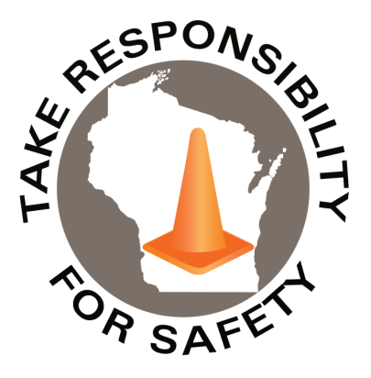

February 2021

Volume 8, Number 2

In This Issue:

**Seven Common Accident Causes**

**Personal Safety Responsibility**

|  |
| --- |
| Safety Net(work)  Produced by Department of Administration Bureau of State Risk Management  Produced by Department of Administration Bureau of State Risk Management |

Safety Spotlight:

[American Heart Month](https://www.cdc.gov/heartdisease/american_heart_month.htm)



Seven Common Accident Causes

According to Gallagher Bassett Risk Control, 80 out of every 100 accidents are the fault of the person involved in the incident. Unsafe acts cause four times as many accidents and injuries as unsafe conditions.

Accidents can happen for many reasons. In general, people tend look for “things” to blame when an accident happens because it’s easier than looking for “root causes.” Below are seven common behavioral causes to consider, when trying to identify root causes of unsafe act accidents:

* **Taking Shortcuts**
* **Being Over – Confident**
* **Starting a Task with Incomplete Instructions**
* **Poor Housekeeping**
* **Ignoring Safety Precautions**
* **Mental Distractions from Work**
* **Failure to Pre-Plan the Work**

Has anyone been guilty of any of these attitudes or behaviors? If so, maybe it did not result in injury the first time, but next time it might not be so fortunate. As Mark Twain once said, “It is better to be careful 100 times than to get killed once.”

**“It is better to be careful 100 times than to get killed once.”**

**-Mark Twain**

1,077

Claims

FY21 YTD

[Household Hazardous Waste](https://dnr.wi.gov/topic/waste/householdhw.html)

Workers Comp

Quote of the Month:

Five Minutes for Safety:

351

269

Claims

FY20 YTD YTD

Lost Time

FY21 YTD

Lost Time

FY20 YTD

1,604

Personal Safety Responsibility

Establishing and maintaining a safe work environment requires a team effort, which includes everyone doing their part to ensure the safety of themselves and their coworkers. To promote a safe work environment for everyone, it is important for each employee to be responsible for actions taken in the workplace and adhere to the following best practices shared by Gallagher Bassett Risk Control:

**Preventing Incidents**

* Always follow all company safety rules, policies and procedures.
* Attend all safety training sessions offered by your employer.  Taking short-cuts is not an excuse.  Take initiative and learn how to safely perform your job duties.
* Familiarize yourself with all OSHA safety requirements pertaining to the place you work.
* Read and understand all applicable Safety Data Sheets (SDS) to familiarize yourself with hazards associated with the substances or materials you work with.
* Get to know the emergency and evacuation procedures for your workplace.
* Know the location of all emergency stops for the equipment you work around.
* Never operate equipment that you have not been properly trained on.
* *Ask questions!*  If you are unsure of or need clarification on a process or procedure, it is important to ask a question before an incident occurs.

**Maintain a Safe Work Environment**

* Keep your work area clean and organized.  Dirty or cluttered work areas are potential slip, trip and fall injuries waiting to happen.
* Always wear the appropriate personal protective equipment (PPE).  These items are meant to protect you.
* Maintain your PPE to ensure proper protection.  If you notice that your PPE is worn or malfunctioning, notify your supervisor.
* Stay focused on the task at hand.  Distractions can lead to injuries to both you and your co-workers.

**Reacting to Unsafe Conditions**

* If you notice an unsafe or hazardous condition, notify your supervisor immediately.  Do not wait for an incident to occur before reporting it.
* Report any accidents or near-misses to your supervisor.  Bringing these incidents to your supervisor’s attention allows the problem to be investigated which will help prevent any further injuries.
* Place a sign or other barrier around an unsafe condition until it can be fixed.
* If you recognize a way to make the workplace safer, suggest these improvements to your supervisor.

Consumer Safety

[United States Consumer Product Safety Commission](http://www.cpsc.gov/)

Contact Us

<https://doa.wi.gov>

E-Mail

[Jake.Lowell@Wisconsin.gov](mailto:jake.lowell@wisconsin.gov)

