[](https://txdrivingconcern.org/)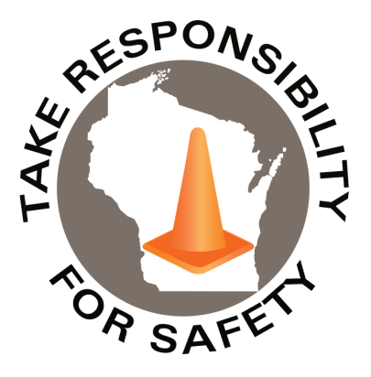

December 2021

Volume 8, Number 12

In This Issue:

**Our Driving Concern**

**Preventing Back Over Injuries**

|  |
| --- |
| Safety Net(work)  Produced by Department of Administration Bureau of State Risk Management  Produced by Department of Administration Bureau of State Risk Management |

Safety Spotlight:

[National Handwashing Awareness Week](http://www.henrythehand.com/news-events/national-handwashing-awareness-week/)

Our Driving Concern

According to the National Safety Council, injuries resulting from roadway incidents involving motorized land vehicles are the leading cause of work-related deaths and the ninth leading cause of non-fatal injury involving days away from work. Additionally, the average workplace motor vehicle crash costs an employer more than $24,000 and if the employee is injured, the average cost increases to more than $125,000 (the cost of a life is priceless).

[Our Driving Concern](https://txdrivingconcern.org/) is a program of the National Safety Council in cooperation with the Texas Department of Transportation. [Our Driving Concern](https://txdrivingconcern.org/) provides free training, education and resources on distracted driving, aggressive driving/speeding, passenger restraint, impaired driving and other transportation and driver safety topics.

Backing Safety was one recent topic Our Driving Concern recently sponsored. One interesting statistic provided was that the backing activity occupies less than one percent of a driver’s time behind the wheel, but regularly produces 25% of the collisions (backing collisions cause 500 deaths and 15,000 injuries per year). Some tips offered to help drivers [back up safely](https://txdrivingconcern.org/wp-content/uploads/2021/01/safety_huddle_backing_up.pdf):

* Choose easy-exit parking spaces that don’t crowd neighboring vehicles and park the vehicle in the center of the parking space. Park away from entrances, exits and other cars whenever possible.
* Pull through or back in on arrival when parking in a parking lot or parking in an alley that doesn’t permit driving through all the way.
* Do a walk-around. Walking around a vehicle gives a driver firsthand view of the backing area and any limitations. Check for children, soft or muddy areas, potholes, tire hazards, and other dangers. Begin backing directly after walk-around.
* Back up slowly and continually check the rear and sides.
* Get to know vehicle’s blind spots. In a medium sized truck, blind spots can extend up to 16 feet in front and 160 feet behind the vehicle.
* Drivers need to remember that mirrors can never give the whole picture while backing.
* Get navigational help from a person outside the vehicle, if possible. Ensure the guide/spotter is reliable, trained and a plan is established on how to use hand signals.
* Remember G.O.A.L., which stands for Get Out, And Look. Don’t assume what is around the vehicle.

Be sure to check out Drive Safe Wisconsin in corresponding agency/campus learning management systems for additional driver safety training resources.

**“When you talk, you are only repeating what you already know. But if you listen, you may learn something new.”**

**-Dalai Lama**

943

Claims

FY22 YTD

[Safe Toys & Gifts Month](https://preventblindness.org/safe-toy-checklist/)

Workers Comp

Quote of the Month:

Five Minutes for Safety:

222

224

Claims

FY21 YTD YTD

Lost Time

FY22 YTD

Lost Time

FY21 YTD

833

Preventing Back Over Injuries

The National Highway Transportation Safety Administration reports about 210 fatalities occur every year when a vehicle backs over a person. [Our Driving Concern](https://txdrivingconcern.org/) shared through a combination of safe backing tips, as well as technology and effective use of spotters, can help prevent crashes while on the job. Additionally, OSHA developed [construction hazard prevention videos](https://www.osha.gov/vtools/construction) including [vehicle back over struck by](https://www.osha.gov/vtools/construction/struck-by-backover-fnl-eng-web). Some suggested effective ways a process incorporated with technology is helping drivers [avoid the dangers of backing over](https://txdrivingconcern.org/wp-content/uploads/2021/01/safety_huddle_backing_over.pdf):

* Cameras: OSHA states that most vehicles can accommodate a camera to provide drivers with a view of the rear and other blind spots. When equipping vehicles with cameras, it is important to consider the worksite environment. Some construction sites may require more rugged cameras, and vehicles such as dump trucks may need two or more cameras to monitor blind spots.
* Primary detection systems: These systems use radar and ultrasonic technology to bounce a signal off an object. The system then alerts the vehicle operator with a visual or audio warning that an object is in its way.
  + However, these systems are only useful when they can be heard and when used with an Internal Traffic Plan.
  + Create a plan to coordinate the flow of moving equipment, workers, and vehicles to help minimize the number of times workers and vehicles cross paths. According to OSHA, these plans can significantly reduce and even eliminate the need for vehicles to back up on a job site.
* Spotters also play a key role in ensuring safe communications on a worksite.
  + A spotter is another person who can help a driver with backing.
  + The driver and the spotter should use hand signals instead of verbal ones and ensure they understand each other’s signals.
  + Ensure spotters always have visual contact with the driver when a vehicle is in motion. If the driver losses sight of the spotter, they must stop moving the vehicle immediately.
  + A spotter should never be walking backwards while giving instructions.
  + A spotter should not be given additional duties while spotting.
  + A spotter should not be using a mobile device or headphones while spotting.
  + Spotters should be provided high-visibility clothing.

Additional reading on preventing back overs:

<https://www.osha.gov/preventing-backovers>

*OSHA Suggested Spotting Signals*

Consumer Safety

[United States Consumer Product Safety Commission](http://www.cpsc.gov/)

Contact Us

<https://doa.wi.gov>

E-Mail

[Jake.Lowell@Wisconsin.gov](mailto:jake.lowell@wisconsin.gov)

](https://www.osha.gov/preventing-backovers/solutions)

[**Our Driving Concern Resource Summary Guide**](https://txdrivingconcern.org/)

[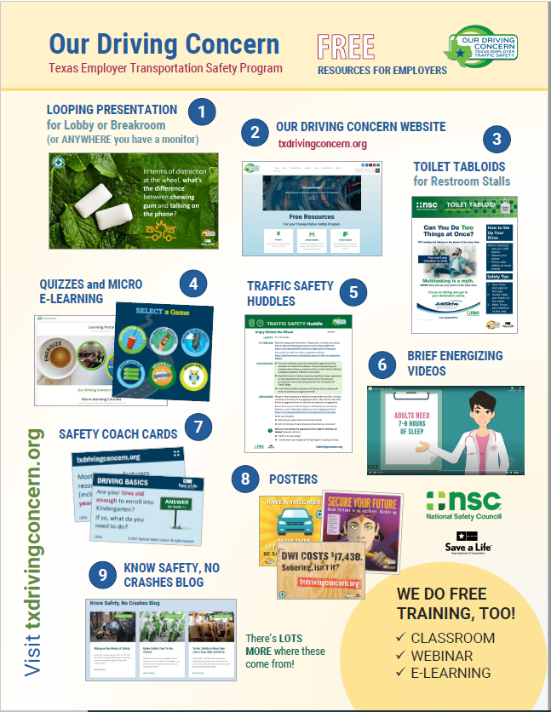](https://txdrivingconcern.org/)