*[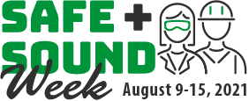](https://www.osha.gov/safeandsoundweek)*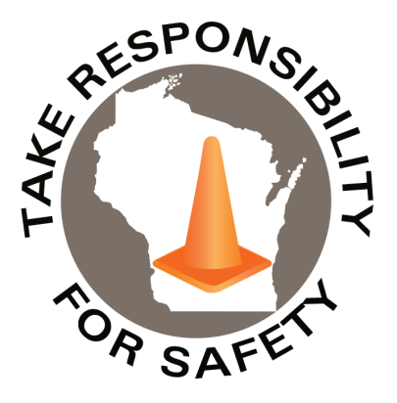

Volume 8, Number 8

August 2021

In This Issue:

**Recognize Your Safety Successes!**

**Plan Your Safe + Sound Events**

|  |
| --- |
| Safety Net(work)  Produced by Department of Administration Bureau of State Risk Management  Produced by Department of Administration Bureau of State Risk Management |

Safety Spotlight:

[Drive Sober or Get Pulled Over](http://www.trafficsafetymarketing.gov/LaborDayWeekend)

Workers Comp

169

Claims

FY22 YTD

[National Stop on Red Week](http://ncsrsafety.org/stop-on-red/)

“Never underestimate the power of dreams and the influence of the human spirit. We are all the same in this notion: the potential for greatness lives within each of us.”

-Wilma Rudolph

Quote of the Month:

Five Minutes for Safety:

39

44

Claims

FY21 YTD YTD

Recognize Your Safety Successes!

OSHA encourages America’s workplaces to commit to workplace safety and health by participating in Safe + Sound week. The nationwide event recognizes the successes of workplace safety and health programs and offers information and ideas on how to keep America’s workers safe. The year-round campaign also encourages every workplace to have a safety and health program that includes management leadership, worker participation, and a systematic approach to finding and fixing hazards.

Wherever you are, take a step in the right direction!

Participate in Safe + Sound Week August 9 – 15, 2021!:

<https://www.osha.gov/safeandsoundweek>

[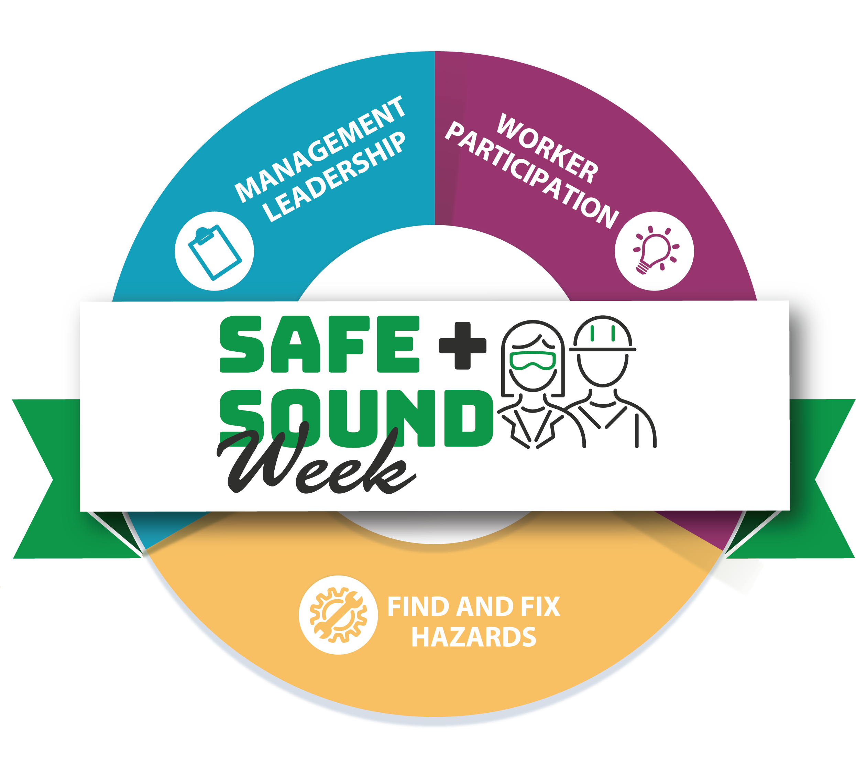](https://www.osha.gov/safeandsoundweek)

Lost Time

FY22 YTD

Lost Time

FY21 YTD

157

[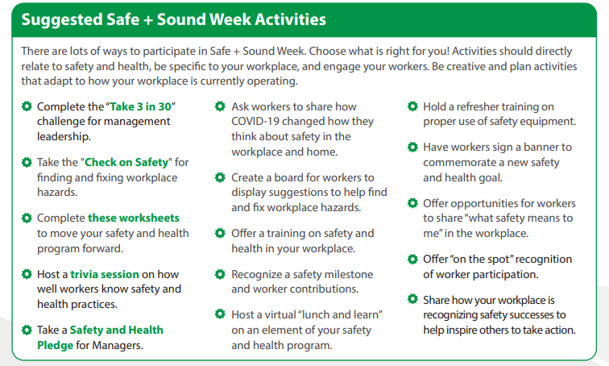](https://www.osha.gov/sites/default/files/Graphics_How_To_Participate.pdf)[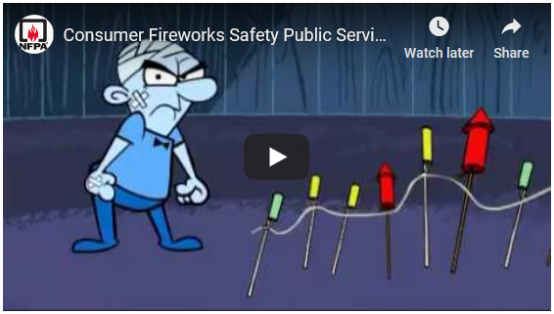](https://youtu.be/PcFuIEwbITA)





Consumer Safety

[United States Consumer Product Safety Commission](http://www.cpsc.gov/)

Contact Us

<https://doa.wi.gov>

E-Mail

[Jake.Lowell@Wisconsin.gov](mailto:jake.lowell@wisconsin.gov)

|  |
| --- |
|  |

There are many ways to [participate](https://www.osha.gov/sites/default/files/Graphics_How_To_Participate.pdf) in Safe + Sound Week; so OSHA recommends picking what works best for each individual location! Some highlighted example activities are provided below. [This page](https://www.osha.gov/safeandsoundweek/plan-and-promote#plan) provides additional examples and materials to help promote activities in the workplace and online.

Plan Your Safe + Sound Events