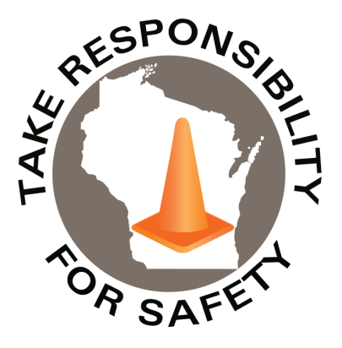

**[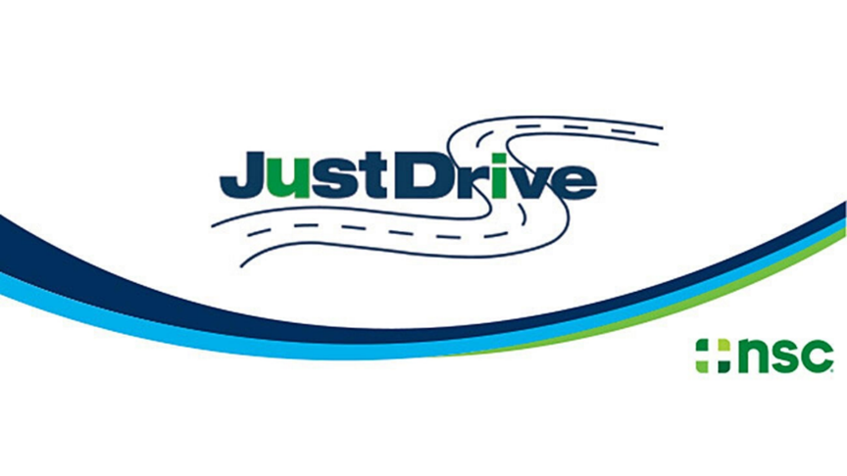](https://www.nsc.org/pages/ddam/ddam-materials)**

In This Issue:

**Distracted Driving Awareness Month**

**Most Important Things Healthy People Do**

Volume 8, Number 4

April 2021

|  |
| --- |
| Safety Net(work)  Produced by Department of Administration Bureau of State Risk Management  Produced by Department of Administration Bureau of State Risk Management |

Safety Spotlight:

[Distracted Driving Awareness Month](https://www.nsc.org/pages/ddam/ddam-materials)

“The foundation of success in life is good health: that is the substratum fortune; it is also the basis of happiness. A person cannot accumulate a fortune very well when he/she is sick.”

-P.T. Barnum

**Distracted Driving Awareness Month**

According to the National Safety Council (NSC), more than 2,800 people in the U.S. died in distraction related crashes in 2018 alone – that is **at least seven people every day**. In the same year, 276,000 people were injured in distraction-related crashes.

“For your life, your passengers, or for those around you on the road, put your phone down.” Distracted driving took her only child. A mother’s message: A bad decision can cost you your life:

[](https://www.youtube.com/watch?v=WRfMBEMmtrQ)

<https://www.youtube.com/watch?v=WRfMBEMmtrQ>

The NSC annually produces resources to help create or enhance a distracted driving program to engage the workforce, share safe driving messages, and help keep the roadways and people safer.

<https://www.nsc.org/pages/ddam/ddam-materials>

434

1,438

Claims

FY21 YTD

[Violence in the Workplace – Warning Signs](https://www.ccohs.ca/oshanswers/psychosocial/violence_warning_signs.html)

Workers Comp

Quote of the Month:

Five Minutes for Safety:

355

Claims

FY20 YTD YTD

Lost Time

FY21 YTD

Lost Time

FY20 YTD

1,972

**Most Important Things Healthy People Do**

According to Jasprit Takher, MD, associate program director of internal medicine at MountainView Hospital in Las Vegas, Nevada, “There are three key things that healthy people do every day: exercise, maintain a nutritious diet and get a good night’s sleep. However, it’s not a one-size-fits-all equation.” Dr. Takher shares in more detail small changes that can help improve optimal health:

**Sleep**

* Getting enough sleep every night can improve immune function, memory, cognition and mood.
* Ages 16-60 should aim for 7-9 hours of sleep nightly. Ages 65 and over should aim for 7-8 hours.
* To optimize sleep, commit to a regular sleep schedule; always wake up and go to bed at the same time every day (even on weekends), avoid naps and don’t hit the snooze button.

**Eat Healthfully**

* A balanced diet is extremely important; it keeps one healthy now and is an investment for future health, too.
* The ideal balance of dietary nutrients: 40-60% carbohydrates, 10-30% protein, 10-30% fat.
  + Sources of these nutrients are not created equally, as there are both good and bad carbs, proteins and fats.
  + Good carbs tend to be high in fiber and have a low glycemic index. Choose whole grains, fruits and vegetables, and avoid refined carbs and added sugar.
  + Good proteins often come from lean meats and legumes, and only rarely should come from red meat.
  + Good fats are monounsaturated and polyunsaturated fats, like those that come from salmon, nuts and avocados. Avoid trans fats and saturated fats.
* Drinking enough water is integral to good health; it helps to flush out toxins, carries nutrients and aids in cell renewal. Most men over the age of 19 should get at least 11-12 8-ounce glasses of water daily and women should aim for 8-9 glasses.

**Exercise**

* Regular exercise can help prevent disease as well as contribute to emotional wellness because of the feel-good chemicals released during and after physical activity.
* First, find an exercise that is truly enjoyed when doing.
* The recommended amount of weekly exercise is 150 minutes of moderate-intensity aerobic activity, or 75 minutes of high-intensity aerobic activity. 150 minutes a week can equal approximately 20 minutes a day, 35-50 minutes every other day, or 1-1.5 hours twice a week.

**Ctrl + Click the hyperlink to read further:** [The-Most-Important-Things-Healthy-People-Do-Every-Day-and-Tips-for-Leading-a-Balanced-Lifestyle](https://mountainview-hospital.com/about/newsroom/the-most-important-things-healthy-people-do-every-day-and-tips-for-leading-a-balanced-lifestyle-in-the#:~:text=%E2%80%9CThere%20are%20three%20key%20things,get%20a%20good%20night's%20sleep).

[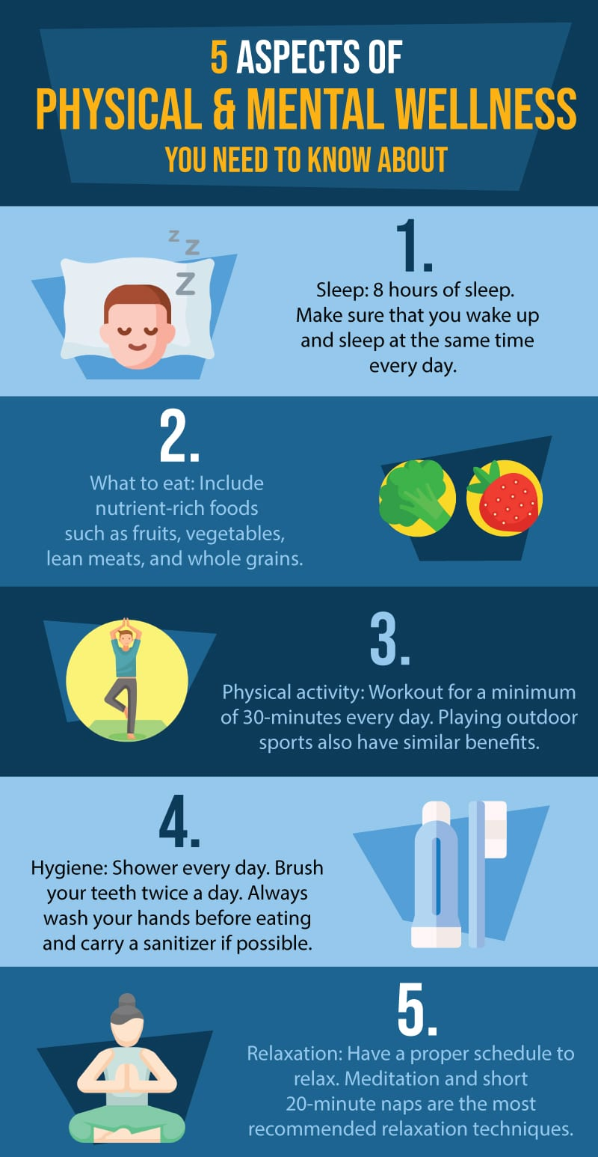](https://www.rtor.org/2015/07/09/physical-wellness/)

[Key Aspects of Physical Wellness](https://www.rtor.org/2015/07/09/physical-wellness/)

#### “A wise man/woman ought to realize that health is his/her most valuable possession” – Hippocrates

Consumer Safety

[United States Consumer Product Safety Commission](http://www.cpsc.gov/)

Contact Us

<https://doa.wi.gov>

E-Mail

[Jake.Lowell@Wisconsin.gov](mailto:jake.lowell@wisconsin.gov)