*[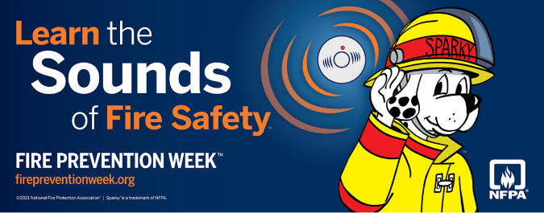](https://www.nfpa.org/fpw)*

Volume 8, Number 10

October 2021

In This Issue:

**Learn the Sounds of Fire Safety**

**Security Leaders De-Escalation Tips**

|  |
| --- |
| Safety Net(work)  Produced by Department of Administration Bureau of State Risk Management  Produced by Department of Administration Bureau of State Risk Management |

Safety Spotlight:

[Drive Safely Work Week](https://trafficsafety.org/road-safety-resources/public-resources/drive-safely-work-weektm-campaign/)

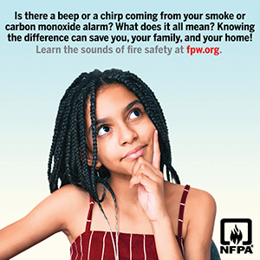

Workers Comp

556

Claims

FY22 YTD

[Fire Prevention Week](https://www.nfpa.org/fpw)

“Hear a Beep, Get On Your Feet!”

Get out and stay out! Call 9-1-1 from outside.

Quote of the Month:

Five Minutes for Safety:

140

135

Claims

FY21 YTD YTD

Since 1922, the National Fire Protection Association (NFPA) has sponsored the public observance of Fire Prevention Week (FPW). FPW is observed each October in commemoration of the [Great Chicago Fire](https://youtu.be/VZhvbmqYniA), which began on October 8, 1871, and caused devastating damage.

In a fire, mere seconds can mean the difference between a safe escape and a tragedy. It’s important for everyone of all ages to take some time every October during FPW to make sure they understand how to stay safe in case of a fire ([Fire Safety Minute Plan Your Home Fire Escape!](https://www.youtube.com/watch?v=wC7WV4cSdJk)).

This year’s FPW campaign, [“Learn the Sounds of Fire Safety!”](https://www.nfpa.org/Events/Events/Fire-Prevention-Week/About) works to educate everyone about the different sounds the smoke and carbon monoxide alarms make. Knowing what to do when an alarm sounds will keep everyone safe. When an alarm makes noises – a beeping sound or a chirping sound – you must take action.

2021 FPW provides several resources and talking points on learning the sounds of fire safety:

* [2021 FPW Tip Sheet: Learn the Sounds of Fire Safety](https://www.nfpa.org/-/media/Files/FPW/Safety-tip-sheets/2021/FPW21ThemeSafetyTipSheet.ashx)
* [Additional FPW Safety Tip Sheets](https://www.nfpa.org/Events/Events/Fire-Prevention-Week/Safety-Tip-Sheets)
* [Education Materials](https://www.nfpa.org/Events/Events/Fire-Prevention-Week/Educate)

Lost Time

FY22 YTD

Lost Time

FY21 YTD

542

[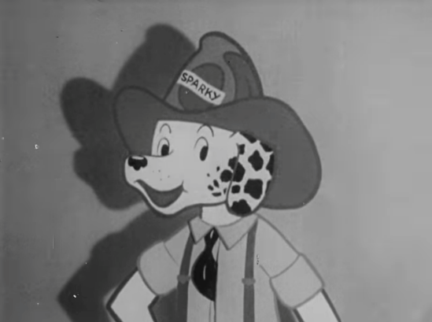](https://popicon.life/sparky-the-fire-dog-5-facts-everyone-should-know-about-nfpas-iconic-mascot/)[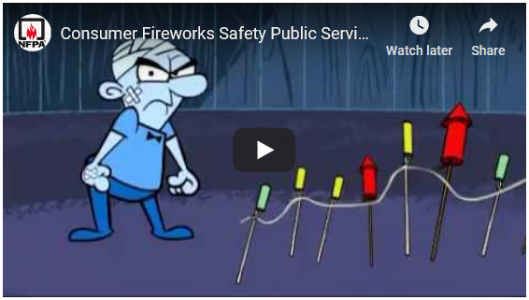](https://youtu.be/PcFuIEwbITA)

**Sparky The Fire Dog:**

[**Five Facts Everyone Should Know About NFPA’s Iconic Mascot**](https://popicon.life/sparky-the-fire-dog-5-facts-everyone-should-know-about-nfpas-iconic-mascot/)

Consumer Safety

[United States Consumer Product Safety Commission](http://www.cpsc.gov/)

Contact Us

<https://doa.wi.gov>

E-Mail

[Jake.Lowell@Wisconsin.gov](mailto:jake.lowell@wisconsin.gov)

|  |
| --- |
|  |

According to [Security Magazine](https://www.securitymagazine.com/articles/95754-top-de-escalation-strategies-and-training-for-security-leaders), “75% of all violence that occurs in any workplace occurs in a healthcare environment,” and “De-escalation happens multiple times a day,” reported by Director of security at Michigan Medicine, a healthcare complex at the University of Michigan.

The point of de-escalation is to minimize risk by turning down the heat before a situation can boil over. Security professions reporting to Security Magazine highlighted a couple key areas to success:

1. **Communication:** It’s all about finding common ground with the person in distress. “You need to listen to the person, find out the reasons why they’re so upset, or at least give them some empathy and respect. You’re not condoning the disruptive behavior, but you do have to have some empathy, some listening skills,” the fundamental idea is that people who upset typically have an underlying reason for their actions. Train staff to never stop talking. Always keep our verbals going. “When we de-escalate, we’re actively listening to what that person is saying. We’re watching for those verbal cues that may indicate what they’re thinking. Sometimes we just allow them to vent. It helps them feel validated, that somebody is actually listening to what they have to say.”
2. **Building Relationships:** “Treat the location as a community: Every floor is a neighborhood, and every neighborhood has different issues. To deal with the issues of the neighborhood, you have to build trust.” To build trust, staff make the rounds, introducing themselves to patients and staff in advance of any incidents. “To build a relationship, to reduce anxiety and build trust. That means we have to proactively go out and engage people.” In any sector, whether retail, transportation or corporate settings, security staff can make personal connections and broker a level of familiarity as part of their routine duties. Then, when an incident does arise, there is already a basis of goodwill in place, which in turn makes it easier to de-escalate.
3. **De-Escalation training** (best practices to emphasize/incorporate):
   * **Body language:** Train on physical presentation. “If you walk into a situation with an upset person and you’re face to face with them, it can be confrontational. Teach staff to approach to the side, with appropriate distance, and it has to be relaxed,” “Also teach them to blade their body, to bring a shoulder forward so that you are less of a target and less confrontational. Then, you have your hands out in front of you, palms up: That’s universal for non-threatening, all over the world.”
   * **Added resources:** De-escalation works best when security personnel come to the situation armed with additional resources, such as phone numbers or information for additional services or agencies. “Carry around a pamphlet with social worker information and other resources in the area,” “Try to [steer people] to more meaningful or better services.”
   * **Redirect:** A key de-escalation technique is the “redirect,” a strategy for helping an agitated person reframe their actions and attitude. “That might mean you take them out of the environment, you take a quick walk to change their environment. ‘Could I get you a cup of coffee, or a glass of water right now?’ When you refocus their attention, you’re often able to get to the root cause of the problem.”

Security Leaders De-Escalation Tips