*[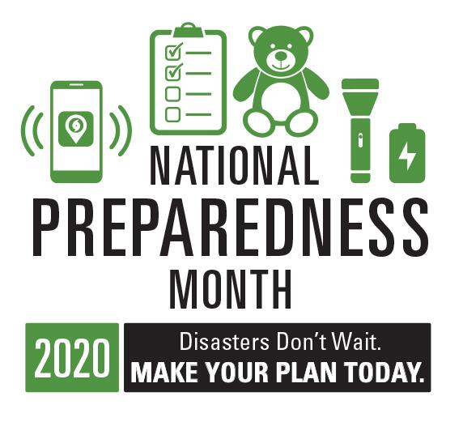](https://www.ready.gov/september)*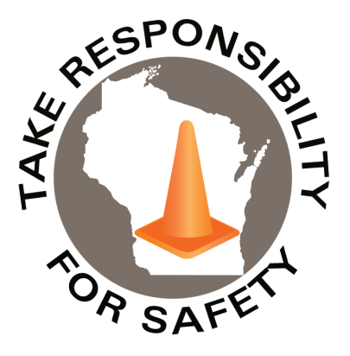

Volume 7, Number 9

September 2020

In This Issue:

**National Preparedness Month**

**Jefferson County Area Safety Network**

|  |
| --- |
| Safety Net(work)  Produced by Department of Administration Bureau of State Risk Management  Produced by Department of Administration Bureau of State Risk Management |

Safety Spotlight:

[National Child Passenger Safety Week](https://www.trafficsafetymarketing.gov/get-materials/child-safety/child-passenger-safety-week)

Workers Comp

322

Claims

FY21 YTD

[Fall Prevention Awareness](http://stopfalls.org/news-events/fall-prevention-awareness-week/)

“By failing to prepare, you are preparing to fail.”

-Benjamin Franklin

Quote of the Month:

Five Minutes for Safety:

109

71

Claims

FY20 YTD YTD

Launched in February 2003, [Ready](https://www.ready.gov/about-us) is a National public service campaign designed to educate and empower the American people to prepare for, respond to and mitigate emergencies, including natural and man-made disasters. National Preparedness Month (NPM) is recognized each September to promote family and community disaster planning now and throughout the year. As our nation continues to respond to COVID-19, there is no better time to be involved this September!

The 2020 theme is: **“Disasters Don’t Wait. Make Your Plan Today.”**

**Week 1 September 1-5:**[**Make A Plan**](https://www.ready.gov/plan)

Talk to your friends and family about how you will communicate before, during, and after a disaster. Make sure to update your plan based on the Centers for Disease Control recommendations due to the coronavirus.

**Week 2 September 6-12:**[**Build A Kit**](https://www.ready.gov/kit)

Gather supplies that will last for several days after a disaster for everyone living in your home. Don’t forget to consider the unique needs each person or pet may have in case you have to evacuate quickly. Update your kits and supplies based on recommendations by the Centers for Disease Control.

**Week 3 September 13-19:**[**Prepare for Disasters**](https://www.ready.gov/be-informed)

Limit the impacts that disasters have on you and your family. Know the risk of disasters in your area and check your insurance coverage. Learn how to make your home stronger in the face of storms and other common hazards and act fast if you receive a local warning or alert.

**Week 4 September 20-26:**[**Teach Youth About Preparedness**](https://www.ready.gov/kids)

Talk to your kids about preparing for emergencies and what to do in case you are separated. Reassure them by providing information about how they can get involved.

<https://www.ready.gov/september>

Lost Time

FY21 YTD

Lost Time

FY20 YTD

453

[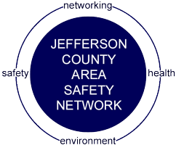](https://jeffersonsafetynetwork.org/join-our-network/)[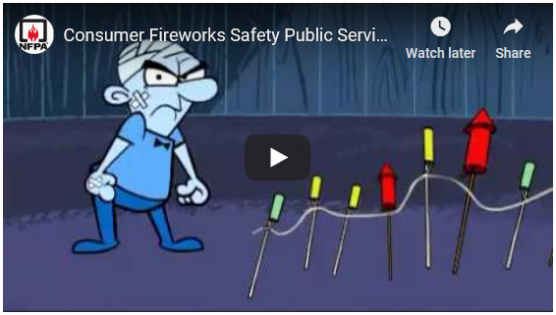](https://youtu.be/PcFuIEwbITA)

Consumer Safety

[United States Consumer Product Safety Commission](http://www.cpsc.gov/)

Contact Us

<https://doa.wi.gov>

E-Mail

[Jake.Lowell@Wisconsin.gov](mailto:jake.lowell@wisconsin.gov)

|  |
| --- |
|  |

The Jefferson County Area Safety Network (JCASN) is now in its 27th year and the Network’s membership and participation at the bi-monthly programs continues to grow, making the JCASN one of the largest and most active Local Chapter Safety Councils in Wisconsin!

The JCASN is a non-profit organization that was organized in 1994 by a group of local business professionals who shared a common interest for learning more about workplace safety and health issues facing their businesses. These individuals felt that Jefferson County workplaces needed a specific venue in which to share ideas, discuss problems, network with one another and learn how to deal with these important workplace safety issues that they faced. Hence the birth of the JCASN to serve as the local venue for the promotion of safety and health education, and also to provide a means by which local employers and employees could come together to share common issues and ideas…to network!

The JCASN program year runs September to May. This year, the topic subjects selected were all recommended by JCASN members during the previous program year. Meetings are typically held on the second Thursday of the month. This year JCASN will be hosting five (5) meetings, the meetings will be held in September, November, January, March and May (see Program Calendar for dates). Historically, meetings have been held in-person typically in Jefferson, Wisconsin. Out of an abundance of caution for safety of JCASN members, JCASN meetings for the 2020-21 year will be held virtually!! And as JCASN will not be meeting in person, JCASN has decided to suspend all fees for this year!! For updates check out the JCASN website <https://jeffersonsafetynetwork.org/>. If you are interested in more information or would like to join the JCASN mailing list, please reach out to the JCASN Secretary [Bridget.Monahan@forthc.com](mailto:Bridget.Monahan@forthc.com).

**Tentative Jefferson County Area Safety Network 2020-21 Calendar of Events**

**September 10th, 2020** **OSHA Update: What’s on the Horizon**

1:00 – 2:30 p.m. Presenter: Mary Bauer, Compliance Assistance Specialist, OSHA

**November 12th, 2020** **WI Work Comp Case Law Update**

8:30 – 10:00 a.m. Presenter: Attorney Paul Riegel

**January 14th, 2021** **Adult Learning/Developing Effective Training Tips**

8:30 – 10:00 a.m. Presenter: Dr. Todd W. Loushine, UW-Whitewater Professor

**March 11th, 2021** **TBD**

TBD Presenter: TBD

**May 13th, 2021** **Spotlight on Safety Initiatives**

8:30 – 10:00 a.m. Presenter: Dave Anderson, Anderson 360 Solutions

Additional very exciting news! The “Western” Wisconsin Regional Safety Councils & Associations graciously invited collaboration efforts with the JCASN. Many other Wisconsin Regional Safety Councils & Associations are offering similar “virtual” educational opportunities this coming year. Many of these opportunities will be “free” and open to other Wisconsin Regional Safety Councils including the JCASN. Wisconsin Indianhead Technical College (WITC) has graciously offered to create a “one-stop shop” regional promo event web page. As events get scheduled, the WITC web site will be updated; so please be sure to check back regularly for additional opportunities!:

<https://www.witc.edu/continuing-education-and-training/conferences-and-events/regional-safety-council-virtual-programming>

Jefferson County Area Safety Network