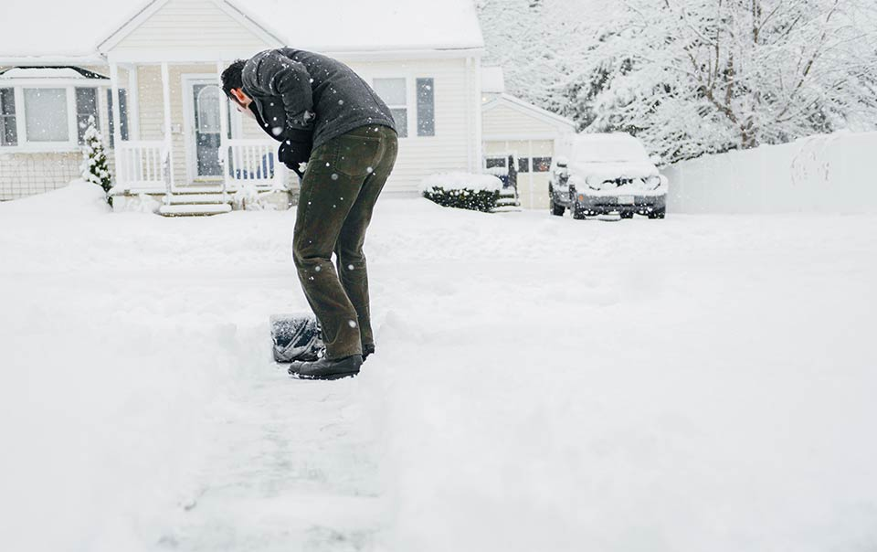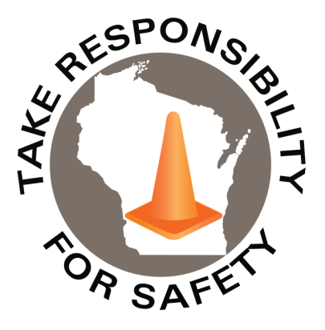

December 2020

Volume 7, Number 12

In This Issue:

**Snow Shoveling Safety**

**Holiday Safety**

|  |
| --- |
| Safety Net(work)  Produced by Department of Administration Bureau of State Risk Management  Produced by Department of Administration Bureau of State Risk Management |

Safety Spotlight:

[National Handwashing Awareness Week](http://www.henrythehand.com/news-events/national-handwashing-awareness-week/)

Snow Shoveling Safety

According to the Consumer Product Safety Commission, more than 110,000 people sought medical treatment for snow-removal injuries, including as many as 28,000 to the emergency room, in the U.S. in 2016. Shoveling can put strain on the lower & upper back, shoulders and elbow muscles, especially when the snow is wet. Additional risks also include frostbite, hypothermia and even cardiovascular.

[Consumer Reports](https://www.consumerreports.org/health-wellness/snow-shoveling-safety-tips/) provides some tips on how to stay safe while removing snow (if you have cardiovascular disease – or have other problems that might interfere with safe shoveling – get your doctor’s okay before taking on the task):

**Prepare properly.** The AHA recommends not eating a big meal – which may put further stress on your heart – before shoveling. Skip the alcohol, too. It can dull your perception of the cold and the amount of strain your body is under. And before you head outside, warm up with ten minutes of light exercise, such as walking. Gentle stretches as well, to limber up muscles and joints may also be beneficial.

**Dress warmly.** Opt for several loose layers, and a water-resistant coat and boots, along with a hat, scarf, and mittens or gloves to protect your extremities from the cold. Try to keep your gloves dry as you shovel (dampness limits their ability to insulate your hands).

**Take it slow.** Pace yourself while you work. When you can, push snow along the ground to get it out of the way, rather than lifting it. Instead of a large shovel, use a smaller one, whose lighter load will be easier to lift. If you’re using a larger shovel, fill it only partially with snow before lifting. And take frequent breaks to rest, warm yourself up inside, and rehydrate.

**Use good form.** When you lift snow, use the power in your legs instead of your back to avoid injury. Squat with your knees wide and your back straight; don’t bend at the waist. Rather than tossing snow off to the side or behind your shoulder, walk it over to where you want to dump the snow.

**Fall-proof yourself.** Wear shoes or boots with slip-resistant soles or add traction with slip-on ice cleats, available at sporting goods stores. Once your walkway is clear, consider putting down salt or sand or both.

**Stay alert for signs of trouble.** If you start to feel muscle pain, it’s smart to stop shoveling and rest. Stay alert for chest pain or pressure which are possible signs of heart attack and call 911 immediately.

**“Wet snow is considerably heavier than dry, fluffy snow. In fact, six inches of wet snow is equal to the weight of about 38 inches of dry snow.”**

**-Post by** [**Sneller**](https://www.snellersg.com/snow-safety-why-3-different-kinds-of-snow-plows-exist/)

785

Claims

FY21 YTD

[Safe Toys & Gifts Month](https://preventblindness.org/safe-toy-checklist/)

Workers Comp

Quote of the Month:

Five Minutes for Safety:

257

187

Claims

FY20 YTD YTD

Lost Time

FY21 YTD

Lost Time

FY20 YTD

1,164

Holiday Safety

According to the [United States Consumer Product Safety Commission (CPSC)](https://www.cpsc.gov/Safety-Education/Safety-Education-Centers/holiday-safety), on average there are about 200 decorating-related injuries each day during the holiday season, with about half the incidents involving falls. In the 2018 holiday season alone, about 17,500 people were treated in emergency rooms due to holiday decorating-related injuries. From 2015 to 2017, on average, there were about 100 Christmas tree fires and about 1,100 candle fires (in November and December), resulting in 20 deaths, 160 injuries and nearly $50 million in property damage each year.

[State Farm](https://www.statefarm.com/simple-insights/residence/simple-holiday-safety-tips) provides some simple holiday decorating tips to help prevent falls:

* Never use furniture as a ladder.
* Follow the 1-to-4 rule for extension ladders: for every four feet the ladder rises, move the base out one foot from the structure.
* Always keep three points of contact on the ladder: two hands and one foot, or two feet and one hand.

[Consumer Reports](https://www.consumerreports.org/cro/news/2011/12/12-tips-for-safer-holiday-home-decorating/index.htm) also provides 12 safety tips to keep your holiday home safe:

1. **Check for freshness when buying a live Christmas tree.** A fresh tree is green, its needles are hard to pull from branches, and don’t break when bent between your fingers. The bottom of a fresh tree is sticky with resin and, when tapped on the ground, the tree should not lose many needles.
2. **Keep trees away from heat sources.** Fireplaces, vents, and radiators can rapidly dry out live trees and increase the risk of flammability. Be sure to keep the tree stand filled with water and monitor water levels daily. Place the tree out of the way of foot traffic, and do not blook doorways with the tree.
3. **Check for a “Fire Resistant” label when buying an artificial tree.** It indicates the fake tree is more resistant to catching fire. But still exercise caution since an artificial tree, like a live evergreen, can still catch fire.
4. **Avoid sharp, weighted, or breakable decorations when trimming a tree with children.** Keep trimmings with small removable parts or ones that resemble food or candy out of children's reach to avoid choking dangers.
5. **Keep burning candles within sight.** Extinguish all candles before you go to bed, leave the room, or leave the house.
6. **Keep candles on a stable, heat-resistant surface.** Chose a place where kids and pets cannot reach or knock over burning candles. Lit candles should also be placed away from flammable items—trees, decorations, curtains and furniture.
7. **Use only lights that have been tested by nationally-recognized laboratories, such as UL.** Decorative indoor and outdoor lights must meet strict requirements. UL's red holographic label signifies that the light decorations meets safety requirements for indoor and outdoor usage. UL's green holographic label signifies the lights are safe for indoor use only.
8. **Check each set of lights for damage.** Discard decorative light sets with broken or cracked sockets, frayed or bare wires, or loose connections. Do not use electric lights on a metallic tree.
9. **Check each extension cord to make sure it is rated for the intended use.** Indoor extension cords should not be used for outside lights.
10. **Check outdoor lights for labels** showing that the lights have been certified for outdoor use, and only plug them into a ground-fault circuit interrupter (GFCI)-protected receptacle or a portable GFCI.
11. **"Fire salts" should be used with care.** The salts, which produce colored flames when thrown into lit fireplaces, contain heavy metals that can cause intense gastrointestinal irritation and vomiting if swallowed. Keep them away from children.
12. **Do not burn wrapping papers in the fireplace.** A flash fire may result as wrappings ignite suddenly and burn intensely.

Consumer Safety

[United States Consumer Product Safety Commission](http://www.cpsc.gov/)

Contact Us

<https://doa.wi.gov>

E-Mail

[Jake.Lowell@Wisconsin.gov](mailto:jake.lowell@wisconsin.gov)

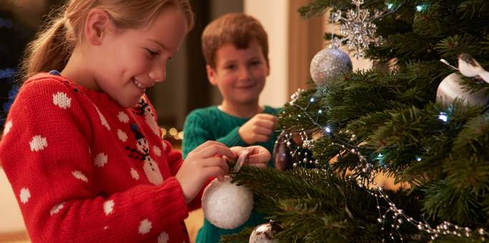

[**The 12 Days of Safety from the National Safety Council**](https://media.defense.gov/2018/Dec/18/2002074068/-1/-1/0/181218-F-HG337-001.JPG)

[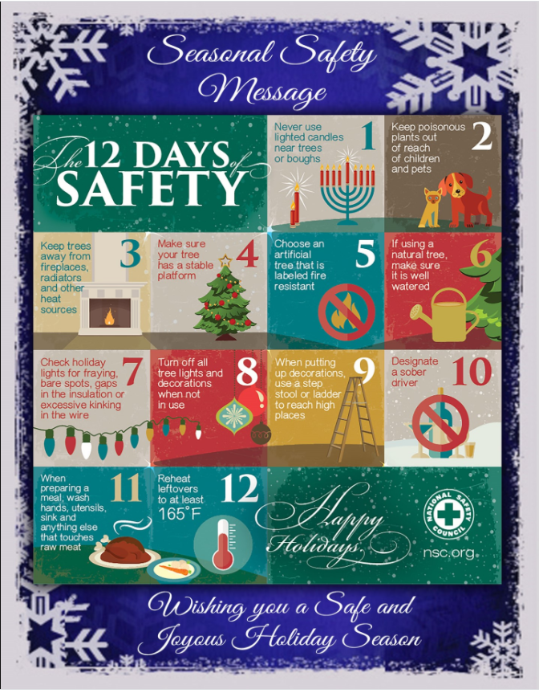](https://media.defense.gov/2018/Dec/18/2002074068/-1/-1/0/181218-F-HG337-001.JPG)