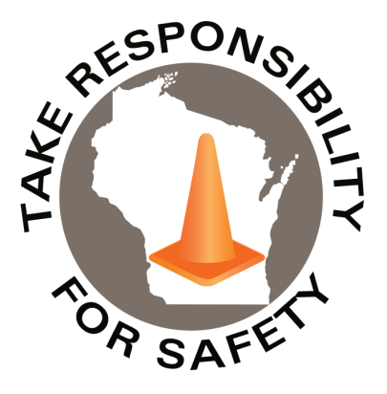

In This Issue:

**That Ice Isn’t Very Nice**

**Buzzed Driving Is Drunk Driving**

**That Ice Isn’t Very Nice**

As a leading cause of injury over the past five fiscal years, the State of Wisconsin has paid $32,849,782 on Slip, Trip, and Fall coded workers compensation claims – representing 31% of total paid.

With temperatures now fluctuating above and below 32 degrees Fahrenheit, left over puddles may create icy conditions that aren’t very nice. Consumer Reports and State Farm provide some tips for de-icing:

* Mix ice melt with sand. It helps reduce the amount of ice melt you use and provides extra traction.
* Spread the mix evenly in layers. Spread a thin layer before the bad weather and then a second thin layer afterwards.
* Consider rock salt. Regular rock salt works at temperatures above five degrees Fahrenheit.
* Use ice melt with calcium chloride when it’s below five degrees Fahrenheit. It can melt ice in temperatures as low as -25 degrees Fahrenheit.
* Scoop up the extra salt. After the ice melts, scoop up any excess and throw it away.

And don’t forget to wear footwear with good heel traction as many slips occur when the heel slides forward! Industry safety experts suggest replacing shoes, when two pennies can be placed on an area of the shoe’s sole that has been worn smooth.

**Ctrl + Click the hyperlinks below to read further:**

<https://www.statefarm.com/simple-insights/family/winter-sidewalk-safety>

<https://www.consumerreports.org/exterior-maintenance-repairs/best-ice-melt-how-to-use-ice-melt/>

Volume 7, Number 3

March 2020

|  |
| --- |
| Safety Net(work)  Produced by Department of Administration Bureau of State Risk Management  Produced by Department of Administration Bureau of State Risk Management |

Safety Spotlight:

[National Ladder Safety Month](https://www.laddersafetymonth.com/About/National-Ladder-Safety-Month)

“My mother once told me that even though things look bad, there’s a rainbow around every corner.”

-Sid, Ice Age Continental Drift

1,758

Claims

FY20 YTD

[Basic Ladder Safety](https://www.americanladderinstitute.org/page/BasicLadderSafety)

Workers Comp

Quote of the Month:

Five Minutes for Safety:

463

375

Claims

FY19 YTD YTD

Lost Time

FY20 YTD

Lost Time

FY19 YTD

1,927

[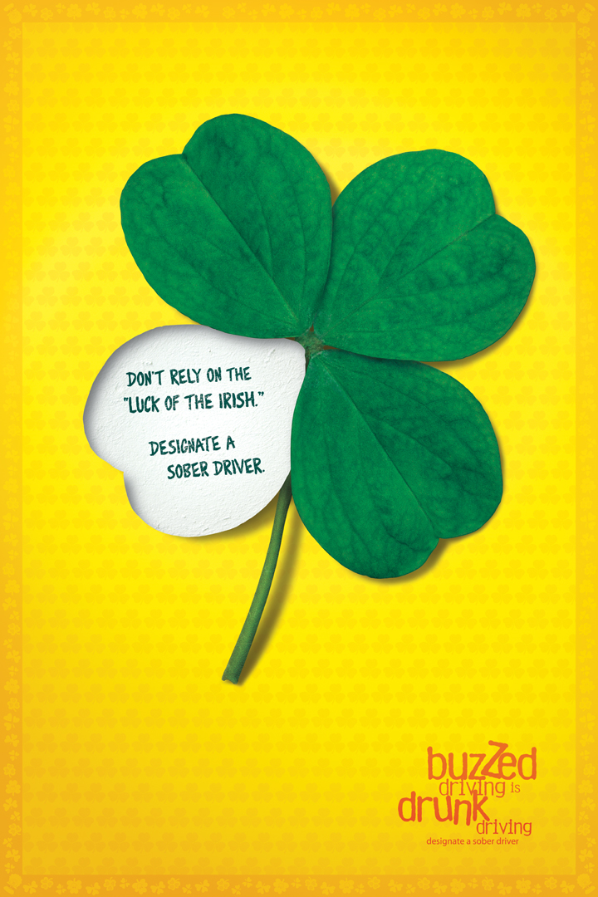](https://www.trafficsafetymarketing.gov/get-materials/drunk-driving/drive-sober-or-get-pulled-over/saint-patricks-day)

**Buzzed Driving Is Drunk Driving**

**As stated by the Traffic Safety Marketing:**

The St. Patrick’s Day holiday – March 17, 2020 – is one of the biggest drinking nights of the year, and this, unfortunately, means more drunk drivers on the roads. Drunk driving accounts for nearly one-third of vehicle-related fatalities in the United States. This St. Patrick’s Day weekend, remember: *Buzzed Driving Is Drunk Driving*. If you plan to go out and enjoy the evening with alcohol, make sure and refrain from driving. Consider these facts:

* St. Patrick’s Day is one of the deadliest holidays on our nation’s roads. During 2014-2018 St. Patrick’s Day holiday period (6 p.m. March 16 to 5:59 a.m. March 18), **249** lives were lost due to drunk-driving crashes. In 2018, drunk driving killed more than 10,000 people in our country, and every single one of those deaths was preventable. Arrange for a sober driver to ensure you get home safely.
* Drug-impaired driving is an increasing problem on our nation’s roads. It is illegal to drive while drug-impaired, period. It’s essential for drivers to understand: *If You Feel Different, You Drive Different*.
* On average, a DUI could set you back $10,000 in attorney’s fees, fines, court costs, lost time at work, higher insurance rates, car towing, and more.
* If you’re caught drinking and driving, you could face jail time, lose your driver’s license and your vehicle. Imagine trying to explain that to your friends, family or place of employment.

Always remember to plan ahead, if you will be celebrating. Plan for a sober driver to take you home or use public transportation or a ride service to get home safely. Make sure and watch out for others too, take their keys away and help make arrangements to get them home safely.

**Ctrl + Click hyperlink below to learn more:**

<https://www.trafficsafetymarketing.gov/get-materials/drunk-driving/saint-patricks-day>

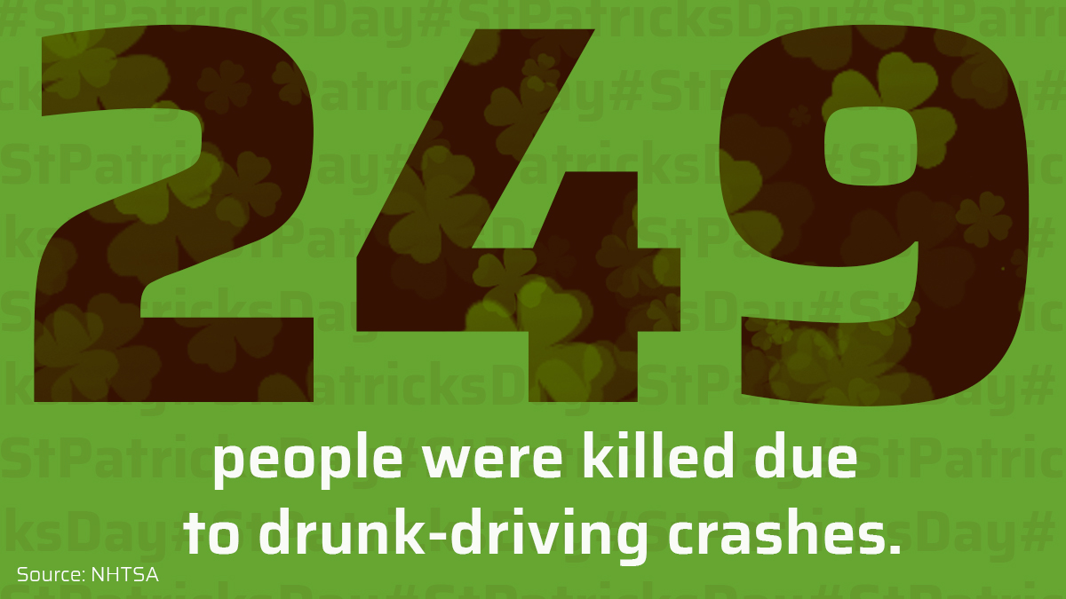

Consumer Safety

[United States Consumer Product Safety Commission](http://www.cpsc.gov/)

Contact Us

<https://doa.wi.gov>

E-Mail

[Jake.Lowell@Wisconsin.gov](mailto:jake.lowell@wisconsin.gov)