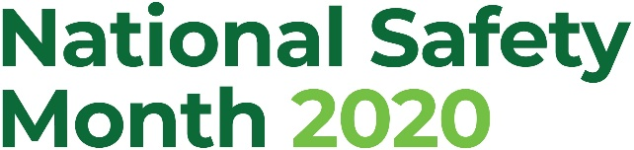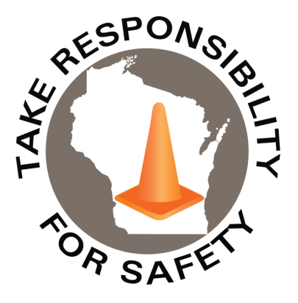

Volume 7, Number 6

June 2020

In This Issue:

**National Safety Month**

**Enjoying a Fire-Safe Grilling Season**

|  |
| --- |
| Safety Net(work)  Produced by Department of Administration Bureau of State Risk Management  Produced by Department of Administration Bureau of State Risk Management |

Safety Spotlight:

[National CPR & AED Awareness Week](http://cpr.heart.org/AHAECC/CPRAndECC/Programs/CPRAEDAwarenessWeek/UCM_475579_CPR-and-AED-Awareness-Week.jsp)

2,159

Claims

FY20 YTD

[Heat Safety Tips](http://www.nws.noaa.gov/om/heat/index.shtml)

Workers Comp

You’ve got to get good habits of working hard so that when that play comes up during the regular season that you’re able to complete it and do it the right way.

-“Mr. Tiger” Al Kaline

Quote of the Month:

Five Minutes for Safety:

621

451

Claims

FY19 YTD YTD

Observed annually in June, National Safety Month focuses on reducing leading causes of injury and death at work, on the roads and in our homes and communities.

[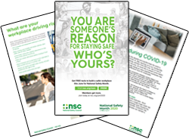](https://www.nsc.org/pages/nsm-public-materials?utm_campaign=COM%20522951%20Registrants&utm_medium=email&_hsmi=88699313&_hsenc=p2ANqtz-9pAQKhSb_Baj9l-mTBg5NOO2DiXQyYv6epWSFaQFGgDMk8wxohRyauODY4WS9BdKxXf7APPxccX5hP2E0vrM7tjI15EQ&utm_content=88699313&utm_source=hs_email)

[(Hyperlink to access free downloadable resources)](https://www.nsc.org/pages/nsm-public-materials?utm_campaign=COM%20522951%20Registrants&utm_medium=email&_hsmi=88699313&_hsenc=p2ANqtz-9pAQKhSb_Baj9l-mTBg5NOO2DiXQyYv6epWSFaQFGgDMk8wxohRyauODY4WS9BdKxXf7APPxccX5hP2E0vrM7tjI15EQ&utm_content=88699313&utm_source=hs_email)

Download and share these materials provided by the National Safety Council (control click on image above to access downloadable resources) to help keep each other safe this June and beyond, from the workplace to anyplace. Areas of focus:

* + - * SAFER (Safe Actions for Employee Returns – Post Quarantine)
      * Mental Health
      * Building a Safety Culture
      * Ergonomics
      * Driving

The Department of Administration – Bureau of State Risk Management secures annual statewide membership through the Wisconsin Safety Council. Memberships include exclusive National Safety Council (NSC) Safety Month materials such as: 5-minute safety talks, videos, posters, checklists, and quizzes. Please contact [Jake.Lowell@Wisconsin.gov](mailto:Jake.Lowell@Wisconsin.gov) from the Bureau of State Risk Management – Safety & Loss Control for assistance accessing exclusive materials.

Lost Time

FY20 YTD

Lost Time

FY19 YTD

2,577

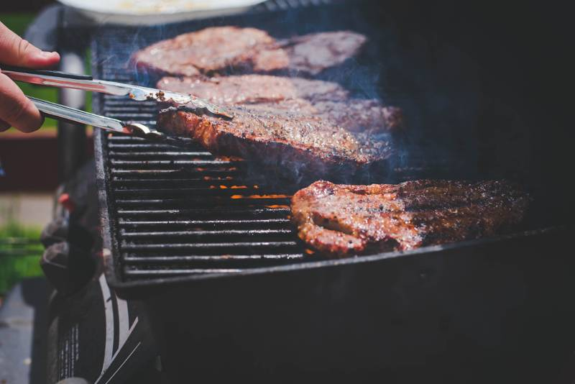[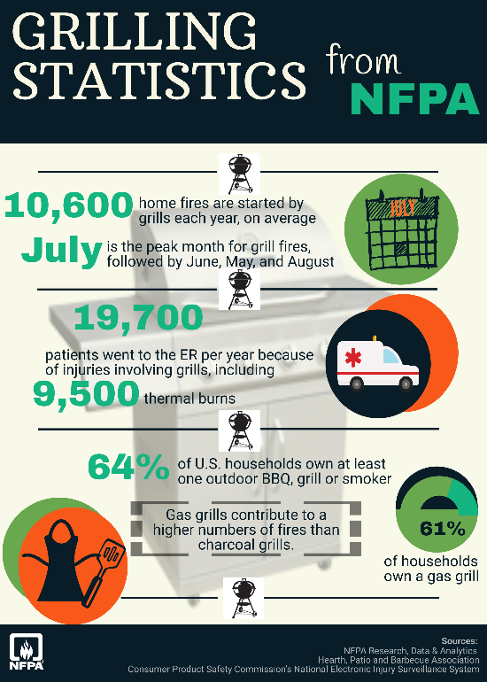](https://www.nfpa.org/-/media/Images/Infographics/Grilling-Infographic2020BIG.png)

Consumer Safety

[United States Consumer Product Safety Commission](http://www.cpsc.gov/)

Contact Us

<https://doa.wi.gov>

E-Mail

[Jake.Lowell@Wisconsin.gov](mailto:jake.lowell@wisconsin.gov)

|  |
| --- |
|  |

The National Fire Protection Association (NFPA) reports July (18%) is the peak month for grilling fires, followed by June (15%), May (13%), and August (12%). According to NFPA data, cooking equipment is the leading cause of U.S. home fires overall, annually contributing to nearly half (49 percent) of all home fires. NFPA estimates over the past five years, an [annual average of 10,600 home fires involving grills, hibachis, or barbecues](https://www.nfpa.org/News-and-Research/Data-research-and-tools/US-Fire-Problem/Home-Grill-Fires), which resulted in 10 civilian deaths, 160 civilian injuries, and $149 million in direct property damage. Five of every six grills involved in home fires were fueled by gas (84 percent), while 12 percent used charcoal or another solid fuel. Gas grills were involved in an average of 8,900 home fires per year, including 3,900 structure fires and 4,900 outdoor fires annually. Leaks or breaks were primarily a problem with gas grills. Additionally, the grill had not been cleaned in more than one-quarter (29%) of home grill structure fires. The leading origin for structure fires involving grills was an exterior balcony or open porch, and 44 percent of the property damage from grill structure fires resulted from fires that started there.

NFPA offers these [tips and recommendations](https://www.nfpa.org/Public-Education/Fire-causes-and-risks/Seasonal-fire-causes/Grilling) for enjoying a fire-safe grilling season:

* For propane grills, check the gas tank for leaks before use ([Watch NFPA’s video on how to check for leaks](https://www.youtube.com/watch?v=mpDhUssEgP0&feature=youtu.be)).
* Keep your grill clean by removing grease or fat build-up from the grills and in trays below the grill.
* Place the grill well away from the home, deck railings, and out from under eaves and overhanging branches.
* Always make sure your gas grill lid is open before lighting it.
* Keep children and pets at least three feet away from the grilling area.
* If you use starter fluid when charcoal grilling, only use charcoal starter fluid. Never add charcoal fluid or any other flammable liquids to the fire. When you have finished grilling, let the coals cool completely before disposing in a metal container.
* Never leave your grill unattended when in use.

Enjoying a Fire-Safe Grilling Season