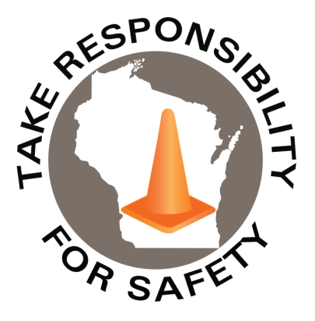

**Free** for state, municipal, public school and tribal government employees

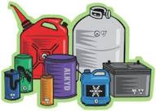

In This Issue:

**Hazardous Materials Awareness**

**& Waste Disposal Training**

**Proper Handling of Used Batteries**

Volume 7, Number 2

February 2020

|  |
| --- |
| Safety Net(work)  Produced by Department of Administration Bureau of State Risk Management  Produced by Department of Administration Bureau of State Risk Management |

Safety Spotlight:

[American Heart Month](https://newsroom.heart.org/events/february-2020-american-heart-month-and-go-red-for-women)

**REGISTER online at** [**seminars.veoliaes.com/seminars**](http://seminars.veoliaes.com/seminars)

|  |  |  |
| --- | --- | --- |
| Thursday  Wednesday | February 27 March 11 | Mendota Conference Center, Madison  UW-Milwaukee at Waukesha |
| Thursday | March 12 | Mendota Conference Center, Madison |
| Tuesday | March 17 | UW-Stevens Point at Wausau |
| Wednesday | March 18 | UW-Green Bay |
| Tuesday | March 24 | Volk Field, Camp Douglas ***(NO WALK-INS)*** |
| Wednesday | March 25 | UW-Eau Claire |
| Friday | March 27 | UW-Parkside, Kenosha |
| Wednesday | April 1 | UW-Whitewater |
| Thursday | April 9 | Mendota Conference Center, Madison |

**2020 Wisconsin Hazardous Materials Awareness**

**& Waste Disposal Training**

Employees working at state-owned or operated facilities or employees of municipalities, tribal governments, public K-12 schools, technical colleges and universities, need to be thoroughly familiar with proper waste handling and emergency procedures relevant to their facilities operations.

The Bureau of State Risk Management sponsors this **free** training to familiarize, refresh and engage the audience with photos, videos and activities to explain requirements and best management practices for waste handling, storage, disposal and recycling. Some example products include: fluorescent lamps, batteries, laboratory chemicals, oils, antifreeze, paints, thinners, cleaners, corrosives & poisons.

# Who should attend?

* Employees who work with hazardous chemicals
* Facility operations, maintenance, buildings and grounds management
* Employees involved with vehicle and equipment maintenance
* Employees who manage waste storage areas
* Laboratory workers who generate waste solvents or other chemical waste
* Stock/supply-area workers who order, receive or store chemical products
* **Supervisors who oversee personnel with the duties listed above**

**Training sites and dates:**

“Take care of your body. It’s the only place you have to live.”

-Jim Rohn

1,532

Claims

FY20 YTD

[Household Hazardous Waste](https://dnr.wi.gov/topic/waste/householdhw.html)

Workers Comp

Quote of the Month:

Five Minutes for Safety:

380

323

Claims

FY19 YTD YTD

Lost Time

FY20 YTD

Lost Time

FY19 YTD

1,636



**Proper Handling of Used Batteries**

According to the Wisconsin Department of Natural Resources (WDNR), batteries used in many household and office products, as well as motor vehicle batteries, contain a variety of heavy metals and other materials that can be harmful to human health and the environment if not handled properly. Many of these materials can be recovered and reused by specialized recyclers. Please see [WDNR batteries topic webpage](https://dnr.wi.gov/topic/recycling/batteries.html) for more information or better yet check with your supervisor and come to the [2020 Wisconsin Hazardous Materials and Waste Awareness Training](https://seminars.veoliaes.com/seminars). Don’t let this be you…

[Fire ignites at Ecomaine facility](https://youtu.be/INSyryM_NTU)

[Are lithium-ion batteries too dangerous?](https://youtu.be/nc8uN6iZUiE)

Double-click to enlarge WDNR posters shown below

Consumer Safety

[United States Consumer Product Safety Commission](http://www.cpsc.gov/)

Contact Us

<https://doa.wi.gov>

E-Mail

[Jake.Lowell@Wisconsin.gov](mailto:jake.lowell@wisconsin.gov)