*[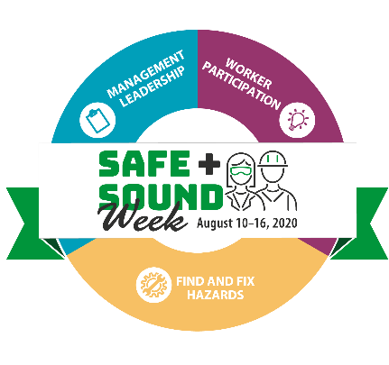](https://www.osha.gov/safeandsound/)*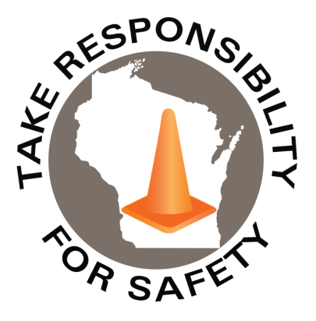

Volume 7, Number 8

August 2020

In This Issue:

**Recognize Your Safety Successes!**

**Plan Your Safe + Sound Events**

|  |
| --- |
| Safety Net(work)  Produced by Department of Administration Bureau of State Risk Management  Produced by Department of Administration Bureau of State Risk Management |

Safety Spotlight:

[Drive Sober or Get Pulled Over](http://www.trafficsafetymarketing.gov/LaborDayWeekend)

Workers Comp

114

Claims

FY21 YTD

[National Stop on Red Week](http://ncsrsafety.org/stop-on-red/)

“I work safely because my health and well-being are important and I have four amazing kids who depend on me.”

-Corina

Quote of the Month:

Five Minutes for Safety:

56

23

Claims

FY20 YTD YTD

Recognize Your Safety Successes!

OSHA encourages America’s workplaces to commit to workplace safety and health by participating in Safe + Sound week. The nationwide event recognizes the successes of workplace safety and health programs and offers information and ideas on how to keep America’s workers safe. The year-round campaign also encourages every workplace to have a safety and health program that includes management leadership, worker participation, and a systematic approach to finding and fixing hazards.

Wherever you are, take a step in the right direction!

Participate in Safe + Sound Week August 10 – 16, 2020!:

<https://www.osha.gov/safeandsound/>

[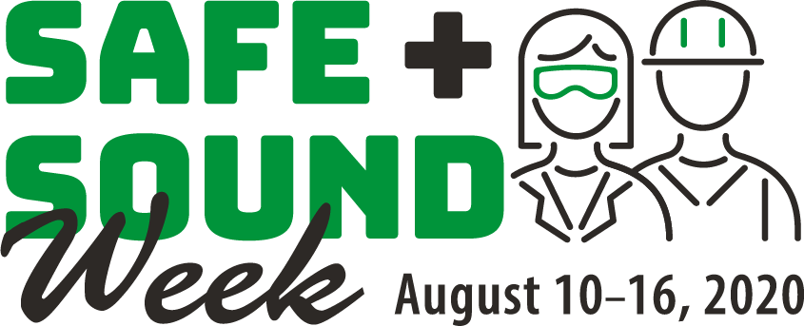](https://www.osha.gov/safeandsound/)

Lost Time

FY21 YTD

Lost Time

FY20 YTD

201

[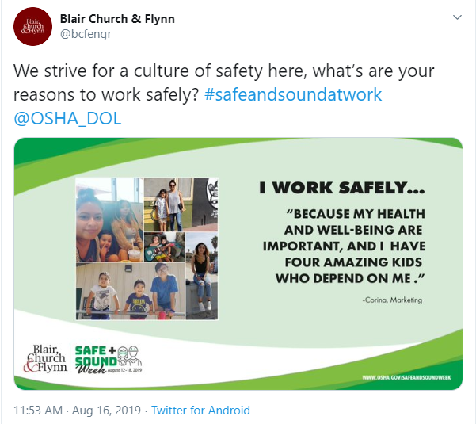](https://twitter.com/bcfengr/status/1162407028708368384)[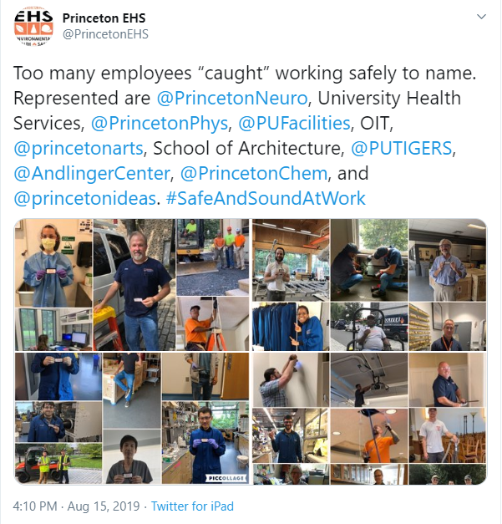](https://twitter.com/AmericanTireDis/status/1161274995907223554)[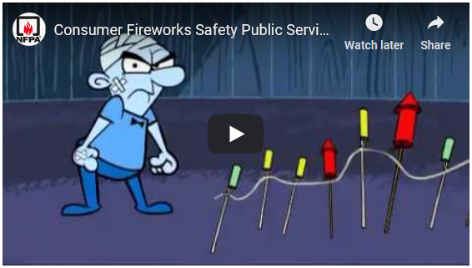](https://youtu.be/PcFuIEwbITA)

**Why do you work safely?** Blair, Church & Flynn asked their workers to share their reasons.

**Take it one step farther and ask:** **Why are you safe 24/7?** Kids depend on us being safe outside of work too!

**Raise awareness.** American Tire Distributors publicly displayed why safety matters in their workplace.

**Spot safety in your workplace!** Princeton EHS recognized employees working safely.

Consumer Safety

[United States Consumer Product Safety Commission](http://www.cpsc.gov/)

Contact Us

<https://doa.wi.gov>

E-Mail

[Jake.Lowell@Wisconsin.gov](mailto:jake.lowell@wisconsin.gov)

|  |
| --- |
|  |

There are many ways to participate in Safe + Sound Week; so OSHA recommends picking what works best for each individual location! Some highlighted example activities are provided below. [This page](https://www.osha.gov/safeandsoundweek/plan_and_promote.html#plan) provides additional examples and materials to help promote activities in the workplace and online.

Plan Your Safe + Sound Events