STATE OF WISCONSIN

COMMUNITY DEVELOPMENT BLOCK GRANT
COMMUNITY DEVELOPMENT PROGRAM

INCOME SURVEY GUIDE
REVISED 09/14/2019

Division of Energy, Housing and Community Resources
https://doa.wi.gov/Pages/LocalGovtsGrants/CommunityDevelopmentPrograms.aspx

CDBG COMMUNITY DEVELOPMENT PROGRAM

CONTACT INFORMATION

Mailing Address: Wisconsin Department of Administration
Division of Energy, Housing and Community Resources
Bureau of Community Development
101 E. Wilson St., 9th Floor
P.O. Box 7970
Madison, WI 53707-7970

Telephone: David Pawlisch, Director
Bureau of Community Development
(608) 261-7538

Email: DOACDBG@Wisconsin.gov

PLEASE NOTE:
The CDBG Community Development Program Income Survey Guide may be downloaded from the Bureau of Community Development section on the Division of Energy, Housing and Community Resources (DEHCR) website at https://doa.wi.gov/Pages/LocalGovtsGrants/CommunityDevelopmentPrograms.aspx. Please download the electronic document prior to conducting your survey to ensure that you are referencing the most up-to-date version of the guide.

Table of Contents
1.0 Reasons for Conducting an Income Survey 4
2.0 Guidelines and Resources 5
2.01 DEHCR Acceptance of Data 5
2.02 Determining the Service Area/Survey Area 6
2.03 Families in Service Area 7
2.04 Survey Types 9
Census Survey 9
Random Sample Survey 9
2.05 Margin of Error / Response Rate 10
2.06 Survey Content 15
2.07 Income Limits/LMI Levels 15
2.08 Income Defined 16
2.09 Survey Publicity and Distribution 16
2.10 Surveying Residential Facilities Exclusively Housing Limited Clientele 16
2.11 Tabulating Survey Results 18
2.12 Income Survey Area Mapping 18
3.0 Income Survey Recordkeeping and Document Submissions 19
3.01 Submission to DEHCR for Pre-Approval and/or with CDBG Application 19
3.02 Additional Documents to Maintain in the Income Survey File 20
4.0 References 21
5.0 Appendices 23
5.01 Appendix A 24
Income Survey Template 24
5.02 Appendix B 25
Income Survey Announcement Letter Template 25
5.03 Appendix C 26
Income Survey Data Forms 26
Form 1A: Census Survey: Income Survey Results Income Tabulation Form – EXAMPLE 27
Form 1B: Random Sample Survey: Income Survey Results Income Tabulation Form – EXAMPLE 30
Form 2: Income Survey Income Level Responses Form – EXAMPLE 33
Form 3: Income Survey Race/Ethnicity Responses Form – EXAMPLE 34
Form 4: Income Survey Distribution Contact List Form – EXAMPLE 35
Form 5: Income Survey Distribution Efforts Tracking Form – EXAMPLE 36
Form 6: Random Sample Survey Methodology Forms - EXAMPLE 37
Form 7: Limited Clientele Data Form – EXAMPLE 39
Form 8: Multi-Jurisdiction LMI Calculation Form – EXAMPLES 40
5.04 Appendix D 43
Service Area/Project Area Map Examples 43
5.05 Appendix E 51
Income Survey Packet 51

CDBG INCOME SURVEY GUIDE

Conducting an income survey for a Community Development Block Grant (CDBG) application may be necessary to determine the number and percentage of Low-to-Moderate Income (LMI) individuals living in the geographic area that will benefit from the project (i.e., the Service Area). A survey is needed when local government or census block group/tract LMI Summary Data (LMISD) published by the U.S. Department of Housing and Urban Development (HUD) are not available or not sufficient. The purpose of this guide is to provide the necessary information for conducting an income survey in the Service Area of a potential CDBG project and for submitting the required documentation for a CDBG Application to ensure the survey activity meets CDBG program standards and requirements.

1.0 Reasons for Conducting an Income Survey

Two key reasons for conducting an income survey are listed below.

      - Conduct a survey to provide data that the applicant believes are more accurate than the HUD LMISD.
The HUD LMISD are based on data drawn from the U.S. Census American Community Survey (ACS) 5-Year Estimates. Downloadable Microsoft Excel spreadsheets with the HUD LMISD for local governments and census block groups/tracts are available at:
https://www.hudexchange.info/manage-a-program/acs-low-mod-summary-data.
Refer to the “Data Sets” section of this webpage for local government and census block group/tract data.

If the HUD LMISD indicate the population is below but near 51.00% LMI, if the margin of error (MOE) of the HUD LMISD is very high, or if local social and/or economic factors have changed significantly in recent years, then it may be worthwhile to conduct an income survey to determine if the Service Area LMI percentage is higher than indicated by the HUD LMISD.

  - Conduct a survey to obtain LMI data otherwise not available for the Service Area of the potential CDBG project.
If the Service Area is not coterminous with or does not include the majority of residents living within the area census block group(s)/tract(s) boundaries; or includes only a portion of residents living within the unit of general local government (UGLG) boundaries, then the HUD LMISD are not available or usable for the Service Area. A survey is required to calculate the percentage of LMI persons among the beneficiaries living in the Service Area.

If the Service Area includes an area for which HUD LMISD are available/usable, but also includes an area for which HUD LMISD are not available/usable, then the area for which no LMISD are available/usable must be surveyed. The HUD LMISD and income survey data must be compiled in aggregate to calculate the LMI percentage for the full Service Area. Refer to Appendix C and Form 8 in the Income Survey Data Forms document referenced in this guide for the required form and examples for tabulating the LMI percentage for a multi-jurisdictional Service Area using HUD LMISD for multiple jurisdictions and for using a combination of HUD LMISD and survey data for multiple jurisdictions.

2.0 Guidelines and Resources

2.01 DEHCR Acceptance of Data

For data from an income survey to be accepted by the Division of Energy, Housing and Community Resources (DEHCR) for calculating the LMI percentage for the Service Area, the following criteria must be met*:

* These terms are subject to change, contingent upon compliance with any policy updates released by the U.S. Department of Housing and Urban Development (HUD). Consulting with DEHCR to check for updates prior to submitting documents with a CDBG Application is strongly advised.

FOR CDBG PUBLIC FACILITIES (CDBG-PF) COMPETITIVE APPLICATIONS ONLY:

- The income survey data, results and related documentation must be pre-approved by DEHCR prior to application and a pre-approval/certification letter from DEHCR must be submitted with the UGLG’s CDBG-PF competitive application. All required income survey documentation as specified in the most current Income Survey Guide (refer to Appendix E: Income Survey Packet) must be submitted to DEHCR for review and pre-approval no later than February 15th of the year in which the UGLG seeks to apply for the CDBG-PF competitive application funds.
  - CDBG-PF Applicants that do not submit all required income survey documentation to DEHCR by the February 15th deadline will not be eligible to use the income survey results to qualify a project for the CDBG-PF competitive application round in that year.
  - If DEHCR determines the survey data, results and/or documentation are invalid, incomplete, or not in compliance with the income survey requirements of the intended application year, then the UGLG will not be eligible to use the survey results to qualify a project for the CDBG-PF competitive application in that year.
  - DEHCR strongly advises UGLGs to submit income survey documentation early to potentially allow for time to make adjustments and revisions as necessary based on DEHCR’s feedback from the review. UGLGs that submit survey documentation on February 15th will not be given an opportunity to make any changes to the submission – DEHCR will make a determination on compliance and acceptance based on the materials received and as presented. UGLGs that submit survey documentation prior to February 15th may be given an opportunity to make changes to the submission, contingent upon DEHCR’s availability to review the materials and provide feedback to the UGLG prior to February 15th, which will be dependent upon staff availability and the number of submissions received for pre-approval at that time. DEHCR will review income survey documentation on a first-come-first-served basis.

FOR ALL CDBG APPLICATIONS:

- The income survey must have been initiated (first distributed) no more than five (5) years prior to the intended application date, and completed within a reasonable period of time that is determined by DEHCR to be methodologically sound (generally within 3-6 months, and within the same HUD income limits year and calendar year when practical, depending on when the survey was first initiated – DEHCR will review alternative methods on a case-by-case basis);

- The HUD income limits in effect at the time the survey was initiated for the county in which the beneficiaries reside must be the income thresholds used/listed on the survey form;

- No significant demographic, economic, and non-economic changes in the Service Area occurred since the survey was conducted;

- The survey data calculations must be deemed by DEHCR to be valid and methodologically sound, including but not limited to not exceeding margin of error (MOE) limits as specified by DEHCR and HUD; and following the guidance and requirements specified in the Income Survey Guide;

- All required survey data and documents must be submitted to DEHCR in the Income Survey Packet (Appendix E) format specified in this guide; and

- All requirements deemed applicable by DEHCR for verifying the survey results are valid and methodologically sound, as set forth in the most current Income Survey Guide (at the time of CDBG application submission), must be met.

When conducting an income survey, important considerations with regard to the Service Area, survey types, margin of error/response rate requirements, LMI levels, survey content, survey publicity, and results data calculation and reporting must be made, as described in the sections that follow.

2.02 Determining the Service Area/Survey Area

To determine the Service Area, which will be the Survey Area, the impact of the project and the benefits to residents must be considered. Service Area/Survey Area determinations must be made on a case-by-case basis with several factors considered. Consultation with DEHCR staff is strongly advised prior to finalizing the Service Area/Survey Area determination.

Common considerations for determining if the project will have community-wide benefit (and therefore the Service Area/Survey Area encompasses the entire community) include:
- Does the project have a community-wide focus (e.g., creating a Comprehensive Plan, Economic Development Plan or Downtown Revitalization Plan; completing downtown business district infrastructure improvements; improving a wastewater treatment facility that serves the entire community; building a community center that can be presumed to be serving the entire community, etc.)?

- Is any area of the downtown/central location of the municipality, where goods/services generally utilized by all community residents as a whole are provided, impacted by the improvements being made? If so, to what extent?

- Is a local government building, school, main hospital/medical facility, library, central community center, central park, or other similar facility generally utilized by all community residents as a whole either the focus of the proposed CDBG project or located in the area being improved as part of the proposed CDBG project? If so, to what extent will users benefit from the improvements?

- Is the facility/are the facilities being built or improved for the proposed CDBG project of primary service/benefit to the entire community or only portions/sections of the community?

The extent of the impact and benefit to all residents in the community is considered when making a determination of whether the proposed CDBG project is deemed to have community-wide benefit.

Common considerations for determining which residences/families will be primary beneficiaries of a project when the project is deemed to not have community-wide benefit (e.g., neighborhood-specific street, utility, sidewalk, park or other facility improvements that benefit only residents in the immediate area in which the work will be performed/improvements will be made [i.e., the Project Area]) include:

- Who are the users or customers of the facilities (e.g., utility customers, residences located in a fire district, residences in the immediate area of the neighborhood-specific facility, etc.)?

- How will the improvements impact the residences in the Project Area?

- Which residences and/or driveways are located on the street(s) being improved?

- Which families/residences use the street(s) being improved as a primary route to/from their homes, and to what extent?

- Which residences are connected to the utility services or other infrastructure being improved?

- Will the street and/or utility service and/or other infrastructure improvements have a benefit to any residence that is not located on the section(s) of the street(s) being improved and/or is not directly connected to the utility service(s) or other infrastructure being improved? If so, to what extent?

The extent of the impact and benefit to the residents living in or near the Project Area is considered when making a determination of whether the proposed CDBG project is deemed to have primary or secondary benefit to those area residents.

2.03 Families in Service Area

The U.S. Department of Housing and Urban Development (HUD) requires a measure of families and population (all individual residents) in the Service Area in order to meet the LMI National Objective.

- “Family” includes all definitions listed in 24 CFR 5.403. The family may include but is not limited to the following, regardless of actual or perceived sexual orientation, gender identity, or marital status:
- A single person who may be defined, in 24 CFR 5.403, as an elderly person, displaced person, disabled person, near-elderly person, or any other single person; or
- A group of persons residing together, and such group includes but is not limited to:
- A family with or without children (a child who is temporarily away from the home because of placement in foster care is considered a member of the family); or
- Person(s) living in a household for which the relationship is defined, in 24 CFR 5.403, as an elderly family; a near-elderly family; a disabled family; a displaced family; and, the remaining member of a tenant family.

- “Household” means all persons who occupy a housing unit. A household may consist of persons living together or any other group of related or unrelated persons who share living arrangements, regardless of actual or perceived sexual orientation, gender identity, or marital status (pursuant 24 CFR 570.3). A “housing unit” is an individual family residential living space or living unit, such as an individual house, one-half of a duplex housing structure, one condominium unit of a multi-family condominium structure, one apartment in an apartment building, one resident room in a nursing home, etc.

- Multiple families may reside within a household (e.g., two persons without a familial relationship living in the same house or apartment, two persons without a familial relationship living in the same room at a nursing home, etc.). Persons occupying the same household without a familial relationship are to be counted as separate families.

- The HUD measure requires surveying families that will benefit from the proposed activity.

- The number of LMI individuals is extracted from the family data gathered through the survey. The number of LMI individuals in the families that respond to the survey is used to determine the LMI percentage in the Service Area. The LMI percentage must be at least 51.00% or greater to meet the LMI National Objective.

After the Service Area is defined, the number of families living in the Service Area must be determined or estimated to estimate the number of surveys that must be conducted/distributed. If the exact number of families in the Service Area is not known, methods must be incorporated to obtain or estimate the number of families. Estimating the total population (the number of persons living in the Service Area) may also be necessary when tabulating the survey results. The method of determining the number of families and the total population in the Service Area will depend upon the data available.

- Estimating Number of Families: An initial estimate of the number of families living in the Service Area may be based on the number of households in the Service Area. Resources for determining or estimating the number of households in the area include U.S. Census data (use the most recent U.S. Census American Community Survey 5-Year Estimates number of occupied households data); area maps of residential neighborhoods; other records such as utility service customer lists, tax rolls, and telephone directories; and/or going door-to-door. Each of these methods for determining or estimating the number of families in an area has some limitations associated with it (e.g., census data only allow for estimations and are limited to a past point in time; area maps do not show how many families are living in each residence; telephone directories exclude people without phones or who exclusively use cell phones; tax rolls identify property owners, but not residents, etc.). The characteristics of the Service Area need to be considered when choosing a resource. Using multiple sources for estimating the number of families in the Service Area is typically necessary.

- Distribution to Families: While a list of households may be used to compile an estimate of the number of families in the Service Area for the purpose of estimating the overall survey numbers and sample size, the survey itself needs to be addressed to families. Each family in each household should complete a survey.

- Vacant and/or Non-Residential Properties: Vacant residential living units and properties that are non-residential in nature, such as those with only business/commercial structures and/or governmental operations/services buildings, are not counted as families in the Service Area and are not surveyed. If a property is both residential and commercial, such as a home-based business, the property remains counted as a family in the Service Area and must be surveyed.

- Part-time/Seasonal Residents: Part-time/seasonal residents do not need to be ‘counted’ as beneficiaries and be included in the income survey if the proposed project is deemed by DEHCR to have “incidental” benefit to the part-time/seasonal residents. If the part-time/seasonal residents are deemed to receive more than incidental benefit, then they must be surveyed. Refer to HUD CPD Notice 14-013 for additional guidance at: https://www.hudexchange.info/resources/documents/Notice-CPD-14-013-Guidelines-for-Conducting-Income-Surveys-LMI-CDBG-Activity.pdf.
If the part-time/seasonal residents are included in the survey, the survey should be distributed to both their local part-time/seasonal residence and their permanent residence to help ensure the survey is received. Applicants are strongly advised to seek approval from DEHCR regarding determinations for part-time/seasonal residents prior to proceeding with a survey.

- Documenting Family Population Methodology: Demonstrate in the survey methodology a concerted effort to identify the actual number of families in the Service Area.

2.04 Survey Types

Census Survey

A Census Survey includes the entire population that will benefit from the proposed activity (i.e., 100% of the families in the Service Area).

- The survey must be distributed to all families deemed to be the primary beneficiaries of the proposed project or to be living in the Service Area (i.e., all beneficiary families must be given the opportunity to respond to the survey – none can be excluded).

- To calculate the LMI percentage of the Service Area using Census Survey results data, the number of persons in all LMI families among respondents is divided by the estimated total number of persons in the entire Service Area (i.e., all persons in the responding families plus the estimated number of persons in all non-responding families); then multiplied by 100. Non-responding families must be presumed to be non-LMI persons. If the response rate is less than 100%, then the total population of the Service Area must be estimated. The methodology specified on the Form 1A: Census Survey: Income Survey Results Income Tabulation Form (in Appendix C and the Income Survey Data Forms document referenced in this guide) for calculating the LMI percentage and estimating the total population must be used.

- Maintain all records of survey distribution and the results of follow-up survey solicitation attempts, including denoting which families were contacted and their responses (whether they responded, did not respond, etc.). Refer to Form 1A through Form 8 in the Income Survey Data Forms document for guidance on the data tracking and recordkeeping required.

Random Sample Survey

A Random Sample Survey uses a subset of the population chosen on a random basis to make assumptions about the entire population in the Service Area.

- To calculate the LMI percentage for the Service Area using Random Sample Survey results data, the number of persons in all LMI families among respondents is divided by the total number of persons in all responding families; then multiplied by 100 to get the LMI percentage of the survey sample. The LMI percentage of the survey sample is applied to the entire Service Area population. The total population of the Service Area must be estimated. The methodology specified on the Form 1B: Random Sample Survey: Income Survey Results Income Tabulation Form (in Appendix C and the Income Survey Data Forms document referenced in this guide) for calculating the LMI percentage and estimating the total population must be used.

- Maintain all records of survey distribution and the results of follow-up survey solicitation attempts, including denoting which families were contacted and their responses (whether they responded, did not respond, etc.). Refer to Form 1B through Form 8 in the Income Survey Data Forms document for guidance on the data tracking and recordkeeping required.

2.05 Margin of Error / Response Rate

The minimum margin of error/response rate standard for income surveys is based on the margin of error (MOE), i.e., the confidence interval. For the survey response rate and data to be accepted, the MOE of the survey results must be no greater than +/-10.00 or no greater than the MOE of the HUD LMISD for the Service Area (if HUD LMISD are available for the Service Area), whichever is lower. The confidence level standard of 90% must be applied when calculating the MOE/confidence interval.

To determine the MOE for the HUD LMISD (if available for the Service Area/Survey Area) access the following HUD LMISD websites and documents:

Local Governments (community-wide municipality data): https://www.hudexchange.info/programs/acs-low-mod-summary-data/acs-low-mod-summary-data-local-government/
[Document Name: ACS 2011-2015 Low-Mod Margin of Error for Places. Filter data first by State (Column B: Stusab) to see only Wisconsin data. Refer to Column H: moe_lowmod_pct for MOE.]

Census Blocks/Tracts (census block/tract data): https://www.hudexchange.info/programs/acs-low-mod-summary-data/acs-low-mod-summary-data-block-groups-places/
[Document Name: ACS 2011-2015 All Block Groups. Filter data first by State (Column C: Stusab) to see only Wisconsin data. Refer to Column P: MOE_LowmodPct for MOE.]

The Sample Size Calculator and Margin of Error Calculator provided by Survey Monkey may be accessed on the following websites:

Sample Size Calculator:
https://www.surveymonkey.com/mp/sample-size-calculator/

Margin of Error Calculator:
https://www.surveymonkey.com/mp/margin-of-error-calculator/

The SurveyMonkey.com calculators are to be used for estimating and calculating the MOE for an income survey. The Sample Size Calculator is used to make an initial estimate of the sample size needed for the survey responses when initiating a survey. Both the Sample Size Calculator and Margin of Error Calculator are used for estimating the MOE of responses to date while conducting the survey and upon verifying the total number of families in the Service Area and finalizing the survey results.

Refer to Examples #1-#3 [Figures 1-3] that follow for using the Survey Monkey Sample Size Calculator and Survey Monkey Margin of Error Calculator to estimate and calculate the minimum response rate required and MOE for an income survey.

Example #1 below depicts using the Sample Size Calculator to determine the minimum number of responses needed for a survey of 100 families in a Service Area for which no HUD LMISD exists. The user enters the Population Size (estimated number of families in the Service Area), and Confidence Level (minimum 90% allowed) and the MOE percentage of 10.00 (i.e., the maximum MOE allowed for income surveys in a Service Area for which no LMISD exists). The number of responses required is automatically calculated and appears. Example #1 reflects 41 families must be in the survey sample (i.e., 41 responses must be received) for a population of 100 families to not exceed a +/-10.00 MOE.

Example #1 (Figure 1) – Survey Monkey Sample Size Calculator used to determine the response rate required using the most precise margin of error (to two decimal places) required per HUD LMISD standards when no HUD LMISD exists for the Service Area [and therefore the MOE of the income survey must be no greater than 10.00%]:

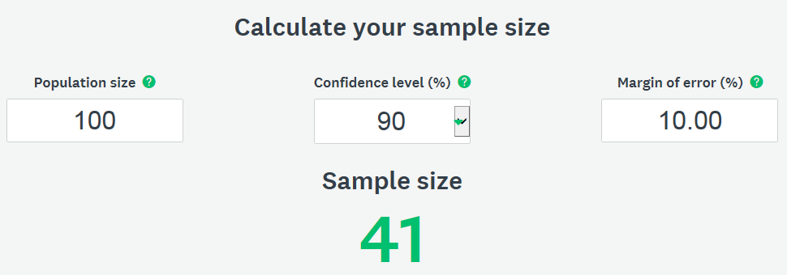
Figure 1: Survey Monkey MOE Calculator Example #1Census Survey
https://www.surveymonkey.com/mp/sample-size-calculator/

Example #2 on the next page depicts using the Sample Size Calculator to determine the minimum number of responses needed for a survey of 100 families in a Service Area for which HUD LMISD does exist and the MOE for the applicable HUD LMISD is +/-7.45. The MOE for the income survey results must not exceed the MOE of the HUD LMISD for the Service Area. The user enters the Population Size (estimated number of families in the Service Area), and Confidence Level (minimum 90% allowed) and the MOE percentage of 7.45 (i.e., the MOE of the HUD LMISD for the Service Area, which sets the standard for the income survey). The number of responses required is automatically calculated and appears. Example #2 reflects 56 families must be in the survey sample (i.e., 56 responses must be received) for a population of 100 families to meet a +/-7.45 MOE.

Example #2 (Figure 2) – Survey Monkey Sample Size Calculator used to determine the response rate required using the most precise margin of error (to two decimal places) required per HUD LMISD standards when HUD LMISD does exists for the Service Area and the MOE of the HUD LMISD is 7.45% [and therefore the MOE of the income survey must be no greater than 7.45%]:

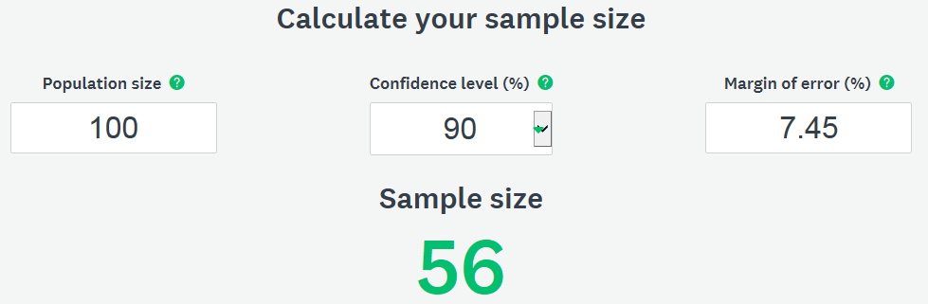
Figure 2: Survey Monkey MOE Calculator Example #2Census Survey
https://www.surveymonkey.com/mp/sample-size-calculator/

Example #3 below depicts using the Margin of Error Calculator to estimate the MOE to the nearest whole number percentage for the number of surveys received for a survey of 100 families in a Service Area. This calculation is not precise in that it does not provide the exact margin of error to two decimal places. The Sample Size Calculator must be used to verify that the survey results meet the HUD MOE standards. The user enters the Population Size (estimated number of families in the Service Area), and Confidence Level (minimum 90% allowed) and the Sample Size (number of responding families), and the MOE percentage is automatically calculated and appears. Example #3 reflects responses from 22 families out of 100 families total in the Service Area would result in a +/-16 MOE, which does not meet the HUD standards.

Calculations for Example #3 (Figure 3) – Used to estimate the margin of error (rounded to the nearest whole number percentage) of the responses to date for an income survey [Note: The number of responses required will be based on the HUD LMISD MOE standard percentage factored to two decimal places as shown in Examples #1 and #2]:

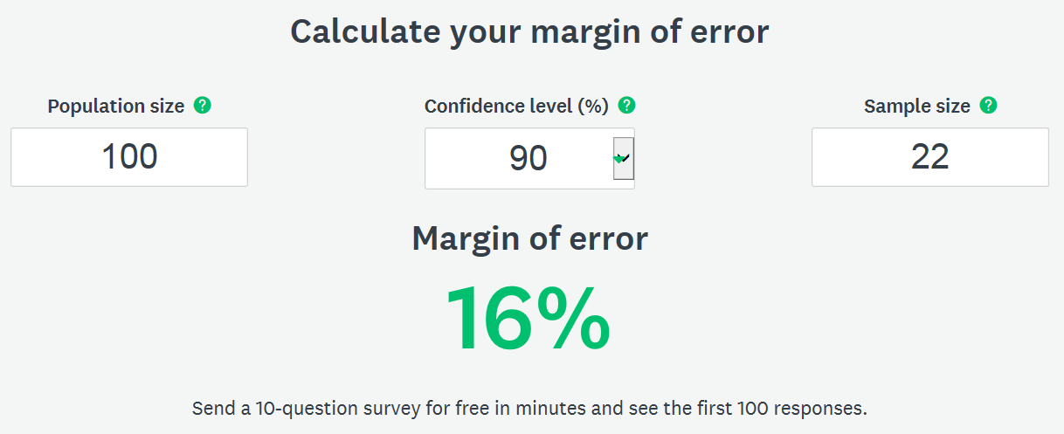
Figure 3: Survey Monkey MOE Calculator Example #3Census Survey
https://www.surveymonkey.com/mp/margin-of-error-calculator/

When initiating the survey, the number of families in the Service Area is estimated based on the number of residential living units or addresses in the Service Area.

As survey responses are received, the population number may change due to discovering some units are vacant or non-residential and/or discovering more than one family lives in a residential living unit. The Population size in the Survey Monkey Sample Size Calculator and Margin of Error Calculator must be adjusted accordingly to determine the sample size needed and estimated margin of error.

MOE/RESPONSE RATE CONSIDERATIONS FOR CENSUS SURVEYS:

- Additional responses may be needed for Census Surveys because per HUD standards and as reflected in the Form 1A: Census Survey: Income Survey Results Income Tabulation Form (example shown in Appendix C and the Income Survey Data Forms document referenced in this guide), for Census Surveys all non-respondents are presumed to be non-LMI; and the LMI percentage for the Service Area is based on the ratio of LMI persons among respondents in comparison with the total population of respondents and non-respondents.

- In addition, for Census Surveys, DEHCR must also review and approve the results as having acceptable representation from throughout the Service Area among the responses received, in addition to ensuring the margin of error standard is met.

Additional responses beyond the sample size number generated with the Sample Size Calculator and Margin of Error Calculator are typically necessary for Census Surveys, particularly for large populations, to meet the requirements for broad service area representation among survey respondents and to reach the 51.00% LMI threshold (due to non-respondents for Census Surveys being presumed to be and counted as non-LMI).

MOE/RESPONSE RATE CONSIDERATIONS FOR RANDOM SAMPLE SURVEYS:

- A limit of oversampling (i.e., surveying more than the minimum number of families required to be in the survey sample) of up to 20% is allowed for a Random Sample Survey. Using Example #1 shown previously in this guide, 41 families are selected as the original sample, only an additional 8 families, may be included in the survey [calculation: 41 x .20 = 8, rounding down to not exceed 20%], and those 8 oversample families’ responses may only be used in calculating the survey results if there are non-respondents among the original survey sample group. Scientific methodology must be used in replacing non-responding families in the original sample with responding families in the oversample (i.e., the lowest numbered non-responding family in the original sample is replaced with the response of the lowest numbered responding family in the oversample; the second lowest numbered non-responding family in the original sample is replaced with the response of the second lowest numbered responding family in the oversample; etc.). Refer to the example in Appendix C and in the Income Survey Data Forms document referenced in this guide.

The sample of families to survey must be randomly selected for Random Sample Surveys. To randomly select the sample, numbers must be assigned to all families/housing units in the Service Area. Use the random number assignment generator by Research Randomizer at https://www.randomizer.org/ to randomly select the families for the original sample and oversample groups. Form 6 – Part 1-2 and Form 6 – Part 3: Random Sample Methodology Forms in the Income Survey Data Forms document must be completed and submitted to DEHCR for all Random Sample Surveys. Refer to the example in Appendix C and in the Income Survey Data Forms document referenced in this guide.

[Note: The example provided in this guide and the Income Survey Data Form for using Randomizer.org is for generating random numbers for all families/living units in the Service Area/Survey Area. Another option is to generate random numbers for the original sample and oversample separately. However, additional random number generator operations may be required when using that option if residences in the original sample or oversample are vacant and additional residences need to be added to either sample. The example provided by DEHCR allows for one operation of randomizing numbers and expanding the samples without additional operations.]

- Distributing the survey to the oversample families/housing units only after the distribution and results from surveying the original sample are complete is recommended. However, distributing the survey to both the original sample and oversample at the same time is acceptable as long as the responses/data from the oversample are only used upon the determination that oversample responses are needed to replace the original sample non-responding families. The methodology summarized in this section of this guide for using the data from oversample respondents in place of original sample non-respondents must be followed.

- No additional surveying beyond the original sample and oversample may be conducted except when during the surveying process a housing unit in the original sample or oversample is verified as vacant or the estimated number of families in the Service Area increases to a level that allows for increasing the sample size.

  - If a housing unit is verified as vacant, then an additional family/housing unit may be added from the randomized number list to the overall survey sample, given a vacant housing unit is not counted as a family in the population or survey sample numbers. Using Example #1 shown previously, if the housing unit assigned #1 was verified as vacant, then the family/housing unit assigned #42 from the oversample replaces housing unit #1 in the original sample; and then another family/housing unit may be added to the oversample (i.e., family/housing unit assigned #50, the first number assigned beyond the oversample, would be moved to the oversample group). Adjustment to the total estimated number of families living in the Service Area would also then need to be made.

[Note: Unlike vacant housing units, occupied housing units that are non-respondent are still counted as families in the population and survey sample numbers. Occupied housing unit non-responses from the original sample may be replaced by occupied housing unit oversample responses for the data results tabulation, but this replacement does not constitute adding another family to the oversample.]

  - If one or more housing units among the original sample (or among the oversample, if oversample data are to be used) is/are verified as having multiple families living in the unit(s), adjustment to the total estimated number of families living in the Service Area needs to be made. An increase in the estimated number of families in the Service Area (i.e., the population number in the MOE calculation) may potentially increase the sample size and oversample numbers. Contact DEHCR for guidance on making adjustments to the sample size (if deemed necessary) and data results tabulation when multiple families are living in a household among the original sample and/or oversample groups.

- Efforts to distribute the survey to all families/households in the original sample (and oversample, if used/needed as replacement for any families in the original sample) and the methods used (e.g., door-to-door interviews, telephone calls, survey mailing, web-based distribution, etc.) must be documented. Refer to Form 1B through Form 8 in the Income Survey Data Forms document for guidance on the data tracking and recordkeeping required.

2.06 Survey Content

The survey content required for Wisconsin CDBG Community Development project grants is presented in the Income Survey Template in Appendix A in this guide.

- At a minimum, the survey must include the questions about family size, total family income, and race/ethnicity.

- Avoid language that refers to the CDBG program, or “low-income” or “low- and moderate-income” based requirements in the survey instrument, cover sheet, cover letter, and publicity about the survey.

- A listing of survey respondents and non-respondents must be maintained with survey records. Apply a survey code system to allow for tracking the respondents while maintaining confidentiality. Apply the random sample randomizer number assignment to each survey form for Random Sample Surveys or assign a random numeric or alpha-numeric code to each Census Survey or Random Sample Survey form, which cannot be easily decoded by someone viewing the completed surveys. Do not collect street address information on the Income Survey Form.

- Note that survey responses must be maintained as confidential information but survey responses cannot be “anonymous.” No language in the income survey form or correspondence should suggest anonymity. The raw survey data for individual families and addresses are reported to DEHCR (as reflected in the required Income Survey Data Forms document referenced in this guide). Suggested language regarding the confidentiality of responses is provided in the Income Survey Template in Appendix A.

2.07 Income Limits/LMI Levels

To collect income data from survey respondents, the HUD Section 8 income limits for the particular county must be added in the income table on the survey form. These change each year and are specific to each county. The income limits in effect on the date the survey is first distributed/administered must be used. If the Service Area covers more than one county, a survey instrument for each county listing the appropriate income levels must be used. Each family included in the survey is to receive an Income Survey Form with the income table for the county in which the family lives.

Access the limits for counties in Wisconsin on the HUD website by following these seven steps:
  - Go to http://www.huduser.org/portal/datasets/il.html
  - Locate and select the current or most recent year that appears
  - Select the "Click Here for FY <most recent publication year> IL Documentation" icon
  - On next page: Under “First select a state” select "Wisconsin - WI;" then select the county in which the Service Area resides
  - Click the "View County Calculations" icon when it appears as the county is selected.
  - The income summary appears for the County/Area. The "Low (80%) Income Limits" are the threshold limits for low-to-moderate income (LMI) to include in the income table on the Income Survey Form.

2.08 Income Defined

Income earned by all adult family members residing at the address (including any related, dependent persons over 65 or working dependent children over age 18) must be counted in the annual family income determination. An individual’s Adjusted Gross Income (AGI), as defined for purposes of reporting under Internal Revenue Service (IRS) Tax Form 1040 for individual Federal annual income tax purposes, from the most recent tax year, is used for income reporting. The income may be self-reported by the family and the collection of income documentation is not required.

2.09 Survey Publicity and Distribution

The survey may be conducted through mail, telephone, in-person door-to-door interviews, and/or web-based methods. Each type of survey distribution has limitations, which should be corrected by using more than one method of distribution (e.g., distribute the survey using web-based and/or mail services; then follow up with telephone and/or door-to-door interviews). Refer to Form 2 through Form 8 in the Income Survey Data Forms document for guidance on the data tracking and recordkeeping required.

Publicizing when the survey will be conducted, how it will be conducted, and why it will be conducted can significantly increase the response rate. Providing information regarding the reason for conducting the survey also can make people less hesitant about answering questions regarding personal income information. Be aware of the following guidelines and restrictions for publicizing the survey initiative:

- Stating the survey is being conducted to apply for CDBG funds specifically or to find out how many low-to-moderate income (LMI) persons are in the area is prohibited.

- Providing some general information is acceptable, such as indicating that a current estimate of incomes in the Service Area is necessary in order to apply for grant funds.

- Avoid creating any bias in the survey results by including information that could lead respondents to answer the survey questions in a particular way.

- An example of an introductory letter that may be sent prior to conducting a survey is provided in Appendix B. It may be adapted to fit the needs of the survey plan (for mailing, telephone calls, door-to-door interviews, etc.), and may be adapted to be sent in the same mailing with the survey.

2.10 Surveying Residential Facilities Exclusively Housing Limited Clientele

- For residential living facilities exclusively housing persons in one or more Low- and Moderate-Income Clientele (LMC) groups, which are groups presumed to be at least 51.00% LMI according to HUD guidelines, the UGLG may obtain a letter on facility letterhead signed by or an email directly sent from an authorized representative of the facility, with verification that the facility exclusively serves one or more LMC groups and with the required resident/family and housing unit information, in lieu of surveying residents individually in the facility. Qualifying LMC groups are listed below:
- Abused children
- Elderly persons (age 62 and older)
- Battered spouses
- Homeless persons
- Severely disabled adults
- Illiterate adults
- Persons living with AIDS
- Migrant farm workers
- LMI individuals/families

Acceptance of a letter/email from the residential facility in lieu of individual income surveys of the families/living units is contingent upon the required documentation and information being provided; and a determination that it may be reasonable to presume that, based on the nature of the facility and typical status of residents, the residents of the facility are among the presumed 51.00% LMI persons in their associated LMC group(s).*

- The resident/family and housing unit information that must be obtained from the residential facility to be accepted in lieu of individual resident/family surveys includes the following:
  - A letter from an authorized representative from the facility with a description of the nature of the facility and the clientele housed/served, to verify that the facility exclusively houses/serves persons in one or more LMC groups;
  - The occupancy data of the facility through completion of Form 7: Limited Clientele Residential Living Facility Family Data in the Income Survey Data Forms document (refer to the example in Appendix C and the Income Survey Data Forms document); and
  - The basis for the income limits used for housing subsidy qualification (to verify consistency with the HUD Section 8/CDBG LMI income limits) only if the LMC group(s) housed/served include(s) LMI persons/families who are receiving housing at the facility contingent upon low-income-based qualification.

NOTE: The data reported in Form 7 must also be incorporated/reported in Forms 2-6 in the Income Survey Data Forms document. Form 7 is used to report the facility data while Forms 2-6 are designed to report family data for ALL families in the Service Area/Survey Area, including those in residential facilities for Limited Clientele and all other residences.

- Each family, including one-person families, living in the residential facility are counted as one family in the Service Area population calculation and listed individually on the income survey distribution and response tracking records.

- Generally, families living in residential facilities exclusively housing/serving persons in LMC groups are presumed to be and recorded as LMI families, as it is generally reasonable to presume they are among the presumed 51.00% LMI persons in their associated LMC group.*

*LMC CONDITIONAL NOTE: Typical facilities exclusively housing members of LMC groups are nursing homes (serving seniors and severely disabled adults), HUD Section 8 housing, and transitional housing for homeless persons. Residents in these types of facilities generally may be presumed to be LMI persons. If the residential facility is of a different nature that caters to high-income clientele and requires a high personal income to qualify for housing (e.g., luxury senior housing), then it cannot be reasonably presumed that the residents living in the facility are among the 51.00% LMI persons in their associated LMC group, and therefore an income survey of the residents would be required to verify income status.

2.11 Tabulating Survey Results

- The Form 1A: Census Survey: Income Survey Results Income Tabulation Form and Form 1B: Random Sample Survey: Income Survey Results Income Tabulation Form are provided in the Income Survey Data Forms document referenced in this guide. Examples are provided in Appendix C in this guide and the Income Survey Data Forms document. Select the appropriate form based on the type of survey conducted.

- Determine the percentage of LMI individuals/persons in the Service Area through calculations using the family survey data and the appropriate tabulation form.
If the survey did not include 100% of the Service Area and have a 100% response rate, then the total Service Area population (i.e., number of all persons living in the Service Area) must be estimated. The population may be determined or estimated using one of the methods listed on the survey results tabulation forms in Appendix C and Income Survey Data Forms document referenced in this guide, contingent upon being deemed methodologically sound by DEHCR. Refer to the survey results tabulation forms to determine which method may be most appropriate for the survey tabulation.

- If combining income survey data with HUD LMISD to determine the LMI percentage of a multi-jurisdictional Service Area, then the number of LMI persons and total population for each jurisdiction must be compiled in aggregate to calculate the LMI percentage. Refer to the Form 7: Multi-Jurisdiction LMI Calculation Form and examples in the Income Survey Data Forms document and the examples in Appendix C in this guide for guidance on tabulating the LMI percentage for a multi-jurisdictional Service Area using a combination of survey data and HUD LMISD. Form 7 and the jurisdiction maps referenced in the Income Survey Packet (Appendix E) and in the Income Survey Data Forms document must be submitted to DEHCR.

2.12 Income Survey Area Mapping

Maps of the Project Area and the income Survey Area (i.e., Service Area) must be submitted to DEHCR. More than one map may be required to illustrate the boundaries of the Project Area, location of the project activities, boundaries of the Survey Area, location of the residential addresses included in the income survey, and identification of responding and non-responding family residences, vacant residences, and business/non-residential properties.*

*Survey responses should be recorded on the Survey Area Map when practical. For surveys involving a large number of residences, tracking responses on the Survey Area map may not be practical. At minimum, the Survey Area Map(s) must show the boundaries of the Survey Area(s) and location in relation to the Project Area. Refer to the Project Area Map and Service Area/Survey Area Map guidance and examples in Appendix D in this guide.

3.0 Income Survey Recordkeeping and Document Submissions

3.01 Submission to DEHCR for Pre-Approval and/or with CDBG Application

The income survey documents specified in Appendix E: Income Survey Packet in this guide must be submitted to DEHCR for any pre-approval/certification and with the CDBG Application if the documents were not pre-approved prior to CDBG Application submission.
- Applicable documents listed in Items #1 and #2 in the Income Survey Packet are required for ALL CDBG Applications, regardless of pre-approval/certification.
- The DEHCR certification letter is submitted in lieu of documents listed in Items #3 and #4 in the Income Survey Packet if the UGLG received pre-application certification of the survey documents.
- The survey documents must be submitted to DEHCR in the Income Survey Packet format with the cover sheets provided. Review additional important notices regarding submission below and in Appendix E: Income Survey Packet and the Income Survey Data Forms document referenced in this guide.

Important Notices regarding Submissions to DEHCR:

- UGLGs are required to submit all income survey documentation to DEHCR on/in 8 ½” x 11” sized pages/format, regardless if the submission is for a pre-approval or with the CDBG Application.

- If the complete packet of income survey documentation was submitted and approved by DEHCR prior to application, only the applicable documents listed for Income Survey Packet Items #1-#2 and the DEHCR approval/certification letter need to be submitted with a CDBG Application.

- Applicants for the CDBG-PF annual competitive awards must have income surveys pre-approved/certified prior to application, due to DEHCR no later than February 15th of the application year. Pre-approval/certification is strongly advised for all other CDBG program applicants.

- The UGLG must submit the Income Survey Data Forms in PDF or hardcopy format (depending on whether the survey documentation is submitted for pre-approval or with a CDBG Application via email or mail) and in Microsoft Excel format via email to DOACDBG@wisconsin.gov.

3.02 Additional Documents to Maintain in the Income Survey File

The following income survey documents must be maintained in the UGLG’s income survey file, available for review during the project or monitoring activities upon the UGLG receiving a CDBG award:

- Copies of all completed income surveys returned by responding families
- Copies of all income surveys and related correspondence returned as “undeliverable” due to residential vacancy or a move
- Copies of all correspondence with DEHCR regarding the review of the income survey documentation and methodology prior to submittal of the CDBG Application

4.0 References

American Community Survey 5-Year 2011-2015 Low and Moderate Income Summary Data (LMISD). (2019). Office of Policy Development and Research. Washington, DC: U.S. Department of Housing and Urban Development HUD Exchange.
https://www.hudexchange.info/programs/acs-low-mod-summary-data/ [RE: LMISD Overview]
https://www.hudexchange.info/programs/acs-low-mod-summary-data/acs-low-mod-summary-data-local-government/ [RE: Current HUD Local Government LMISD]
https://www.hudexchange.info/programs/acs-low-mod-summary-data/acs-low-mod-summary-data-block-groups-places/ [RE: Current HUD Census Block Group/Tract LMISD]

American Community Survey 5-Year 2011-2015 Low and Moderate Income Summary Data (LMISD) Area Map Viewer. (2019). Office of Policy Development and Research. Washington, DC: U.S. Department of Housing and Urban Development.
https://hud.maps.arcgis.com/apps/webappviewer/index.html?id=ffd0597e8af24f88b51b7e7f326bedd

Basically CDBG for States. (2014, July). U.S. Department of Housing and Urban Development. Washington, DC: U.S. Department of Housing and Urban Development HUD Exchange. https://www.hudexchange.info/resource/269/basically-cdbg-for-states/

Bureau of Community Development. State of Wisconsin Department of Administration, Division of Energy, Housing and Community Resources.
https://doa.wi.gov/Pages/LocalGovtsGrants/CommunityDevelopmentPrograms.aspx#

Electronic Code of Federal Regulations – Title 24: Housing and Urban Development. Washington, D.C.: U.S. Government Publishing Office.
http://www.ecfr.gov/cgi-bin/text-idx?tpl=/ecfrbrowse/Title24/24tab_02.tpl
24 CFR 570.3 [RE: Definitions for family and income]
24 CFR 570.483(b)(1)(i) [RE: Survey requirements and determining Service Area]
24 CFR 570.490(a)(1) [RE: Recordkeeping – race, ethnicity, and gender composition of beneficiaries]
24 CFR 5.403 [RE: Definitions of family]

Guide to National Objectives and Eligible Activities for State CDBG Program. (2014, December). U.S. Department of Housing and Urban Development. Washington, DC: U.S. Department of Housing and Urban Development.
https://www.hudexchange.info/resource/2179/guide-national-objectives-eligible-activities-state-cdbg-programs/

Income Limits. Office of Policy Development and Research. Washington, DC: U.S. Department of Housing and Urban Development.
https://www.huduser.gov/portal/datasets/il.html

Office of Community Planning and Development Notice CPD-05-06. (2005, July 26). U.S. Department of Housing and Urban Development. Washington, DC: U.S. Department of Housing and Urban Development.
https://apps.hud.gov/offices/adm/hudclips/notices/cpd/05cpdnotices.cfm

Office of Community Planning and Development Notice CPD-14-10. (2014, June 10). U.S. Department of Housing and Urban Development. Washington, DC: U.S. Department of Housing and Urban Development.
http://portal.hud.gov/hudportal/documents/huddoc?id=14-10cpdn.pdf

Office of Community Planning and Development Notice CPD-14-013. (2014, September 23). U.S. Department of Housing and Urban Development. Washington, DC: U.S. Department of Housing and Urban Development.
https://www.hudexchange.info/resources/documents/Notice-CPD-14-013-Guidelines-for-Conducting-Income-Surveys-LMI-CDBG-Activity.pdf

Office of Community Planning and Development Notice CPD-19-02. (2019, March 15). U.S. Department of Housing and Urban Development. Washington, DC: U.S. Department of Housing and Urban Development.
https://www.hudexchange.info/resource/5794/notice-cpd1902-low-and-moderate-income-summary-data-updates/

Research Randomizer Random Sample Number Generator (accessed 2019, March 21).
https://www.randomizer.org/

State CDBG Grant Administrator Training: Module 14. (2009, May). PowerPoint presentation for grant administrators created by U.S. Department of Housing and Urban Development. Washington, DC: U.S. Department of Housing and Urban Development. https://www.hudexchange.info/trainings/courses/state-cdbg-grant-administrators-training1/

SurveyMonkey.com Margin of Error Calculator (accessed 2019, March 21).
https://www.surveymonkey.com/mp/margin-of-error-calculator/

Trochim, W.M.K. (2001). The Research Methods Knowledge Base. (2nd ed.). Cincinnati, OH: Atomic
Dog Publishing.

U.S. Census American FactFinder Community Facts – 2013-2017 American Community Survey 5-Year Estimates (accessed 2019, March 21).
https://factfinder.census.gov/faces/nav/jsf/pages/index.xhtml

5.0 Appendices

The documents referenced in this section include templates and examples of documents that must be used for CDBG income surveys or may be applicable and modified as needed. The templates provided by DEHCR may only be modified as specified in this guide and the template instructions.

5.01 Appendix A

Income Survey Template
<Survey Number>
Dear Community Resident:

The <Municipality> is conducting a survey of its citizens to obtain income information which will help us decide whether to apply for grant funds to make infrastructure improvements. If we do not receive adequate survey responses, we will not be eligible to apply for this assistance. Your participation in this survey is voluntary.
Please complete one survey per family in the household. If there is more than one family in the household, contact <Contact Name, Title, Department/Firm> at <Contact Phone Number> or <Contact Email> to request additional copies of the survey. Return this survey by <Due Date> by <Instructions for Returning Survey [e.g., Returning Survey Using a Postage Paid Envelope Provided, and/or Other Method(s)]>. Survey data will be collected and compiled by <Contracted Firm Name or “the” Municipality Employee Title and Municipality Name>. Survey results will be tabulated in summary form for <Municipality Type> officials. Individual responses will be kept confidential.
Sincerely,

<Chief Elected Official’s Signature>
<Chief Elected Official’s Name and Title> <Date>

[MUNICIPALITY NAME]
INCOME SURVEY

Does more than one family live in this household? _____ Yes _____ No

FAMILY ANNUAL INCOME INFORMATION
Locate your family size in the left. Use an “X” to indicate if you are below or above the income level for your family size.
FAMILY SIZE | FAMILY ANNUAL INCOME LEVEL |  | BELOW |  | ABOVE
1 | $00,000 [add income limit]
2 | $00,000 [add income limit]
3 | $00,000 [add income limit]
4 | $00,000 [add income limit]
5 | $00,000 [add income limit]
6 | $00,000 [add income limit]
7 | $00,000 [add income limit]
8 or More | $00,000 [add income limit]
FAMILY RACE/ETHNICITY INFORMATION
Indicate the race/ethnicity information for each family member or select the “Prefer Not to Answer” option below.
 |  | Number in Family with Race/Ethnicity Shown on the Left: |  | Number in Family with Race/Ethnicity Shown on the Left Who are Hispanic:
White
Black/African American
Asian
American Indian/ Alaskan Native
Native Hawaiian/ Pacific Islander
Amer. Indian/ Alaskan Native & White
Asian & White
Black/African Amer. & White
Amer. Indian/ Alaskan Nat. & Black/ African Amer.
Other Multi-Racial
Prefer Not To Answer
<Survey Return Instructions (Repeated) and Due Date>

5.02 Appendix B

Income Survey Announcement Letter Template (Optional)

[Municipality Letterhead]

<Date>

<Resident Full Name>
<Resident Street Address>
<Resident City, State, Zip>

RE: Community Income Survey for Grant Application - <Optional: Add Project Focus, e.g., “Sanitary Sewer Main Upgrades and Street Reconstruction on Wisconsin Street”>
Resident of: <Resident Street Address (In Project Area), City, State, Zip>

Dear Resident:

The <Municipality> plans to apply for a grant to help fund <Project Focus, e.g., “sanitary sewer main upgrades and street reconstruction on Wisconsin Street.”> A grant can help reduce the burden of the costs at the local level for the project.

The grant application process includes an income survey of <Municipality> residents in the Project Area. Each family in the area in which we will be conducting the improvements is asked to complete a survey. The information gathered from the survey will help determine if the <Municipality Type, e.g., Town/Village/City/County> will apply for grant funds. The <Municipality> is required to obtain completed surveys from a high percentage of families, so your participation is very important.

You will soon receive the survey in the mail. Please complete your survey and mail it to the <Municipality Type> in the envelope provided by <Date>. If you have more than one family in your household, you may contact <Contact Name>, <Contact Title>, at <Contact Information (Mailing Address, Phone, and/or Email Address) >, to request additional copies of the survey.

The response to individual surveys will be strictly confidential. If you have any questions, please contact <Contact Name>, <Contact Title>, at <Contact Information (Mailing Address, Phone, and/or Email Address)>.

Thank you for your assistance with this important survey.

Sincerely,

<Add CEO Signature>

<Chief Elected Official Full Name>, <Title>
<Municipality>

5.03 Appendix C

Income Survey Data Forms

The Income Survey Data Forms #1-8 referenced in this guide and the Income Survey Packet (Appendix E) are on the pages that follow. The forms are found in the Income Survey Data Forms document (in Microsoft Excel) provided by DEHCR on the Bureau of Community Development website at:
https://doa.wi.gov/Pages/LocalGovtsGrants/CommunityDevelopmentPrograms.aspx [under the “Resources” section].

Form 1A: Census Survey: Income Survey Results Income Tabulation Form – EXAMPLE

If the UGLG administered a Census Survey, the UGLG must complete Form 1A in the Income Survey Data Forms (Microsoft Excel) document on the Bureau of Community Development website (under the “Resources” section). Submit Form 1A within the Excel document provided (send in Excel format) via email to DEHCR with the other required income survey documentation listed in the Income Survey Packet (Appendix E in this guide).

The example of the contents of Form 1A are shown on the following pages; and in Form 1A Ex. in the Income Survey Data Forms (Microsoft Excel) document.

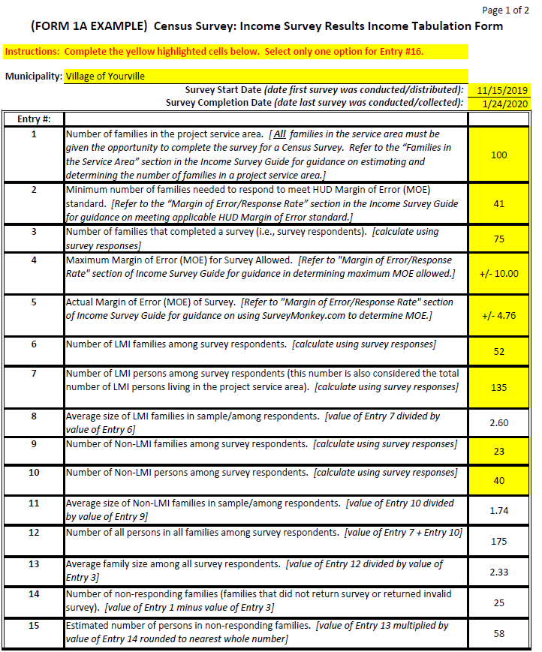
(continued on next page)
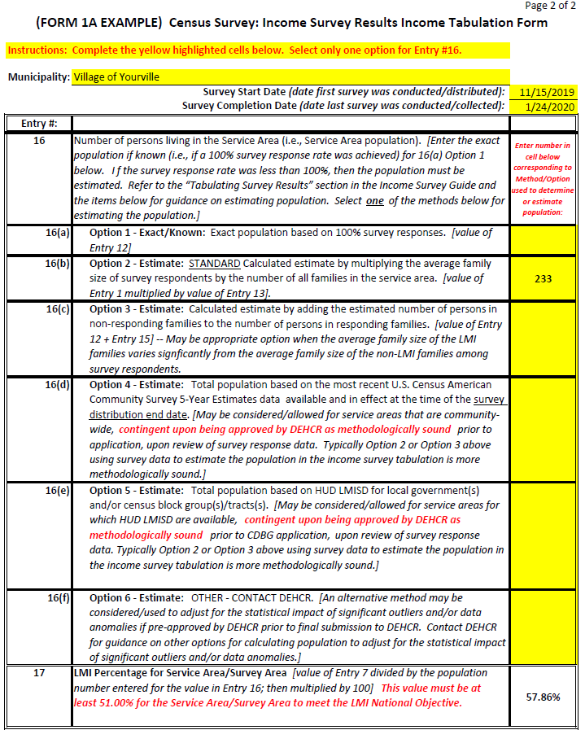

Form 1B: Random Sample Survey: Income Survey Results Income Tabulation Form – EXAMPLE

If the UGLG administered a Random Sample Survey, the UGLG must complete Form 1B in the Income Survey Data Forms (Microsoft Excel) document on the Bureau of Community Development website (under the “Resources” section). Submit Form 1B within the Excel document provided (send in Excel format) via email to DEHCR with the other required income survey documentation listed in the Income Survey Packet (Appendix E in this guide).

The example of the contents of Form 1B are shown on the following pages; and in Form 1B Ex. in the Income Survey Data Forms (Microsoft Excel) document.

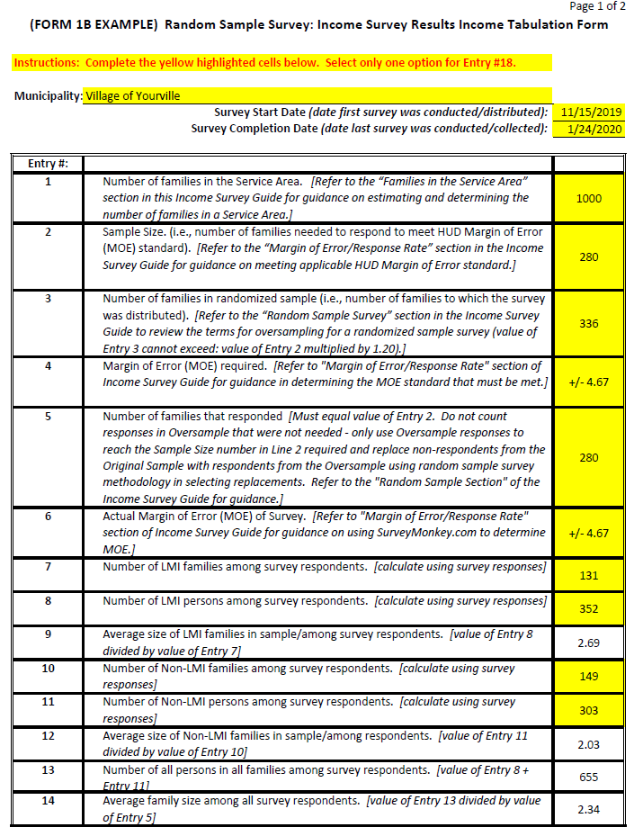

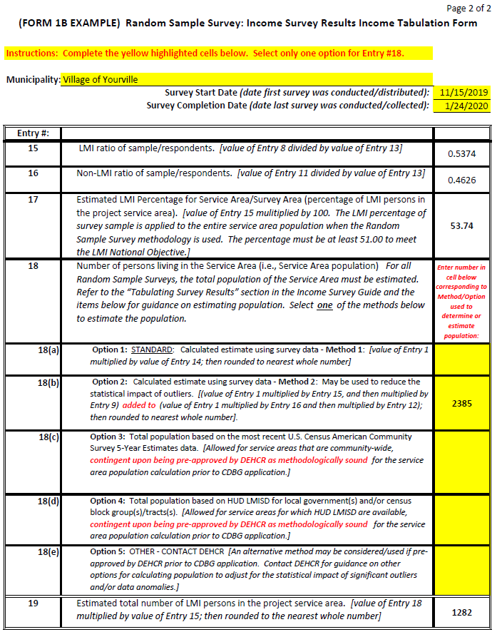

Form 2: Income Survey Income Level Responses Form – EXAMPLE

The example of the contents of Form 2 are shown below; and in Form 2 Ex. in the Income Survey Data Forms (Microsoft Excel) document.

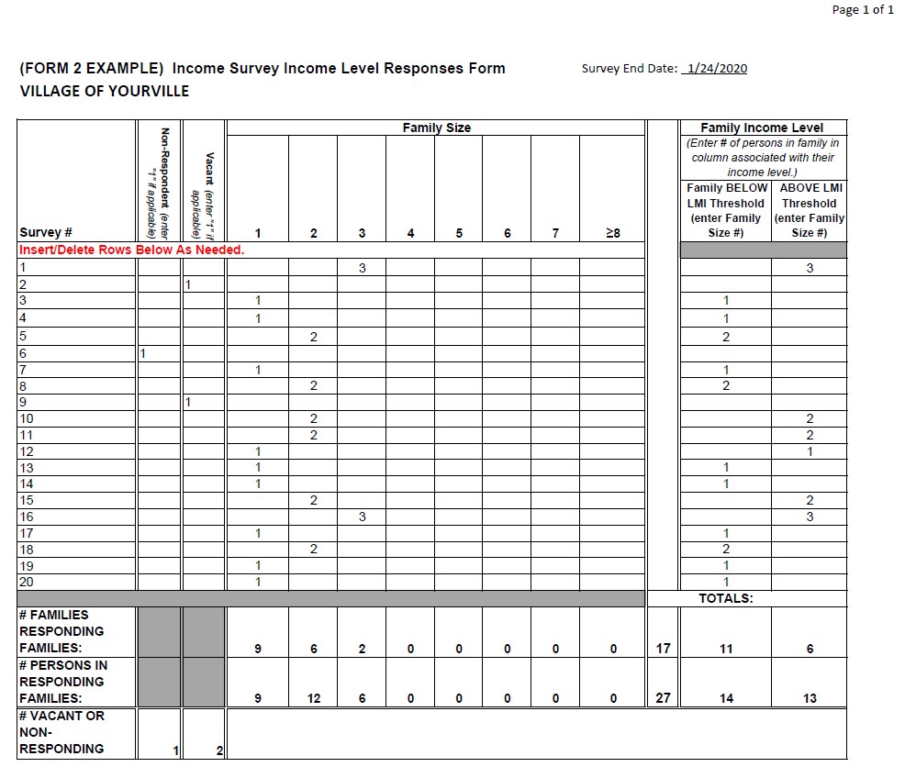

Form 3: Income Survey Race/Ethnicity Responses Form – EXAMPLE

The example of the contents of Form 3 are shown below; and in Form 3 Ex. in the Income Survey Data Forms (Microsoft Excel) document.

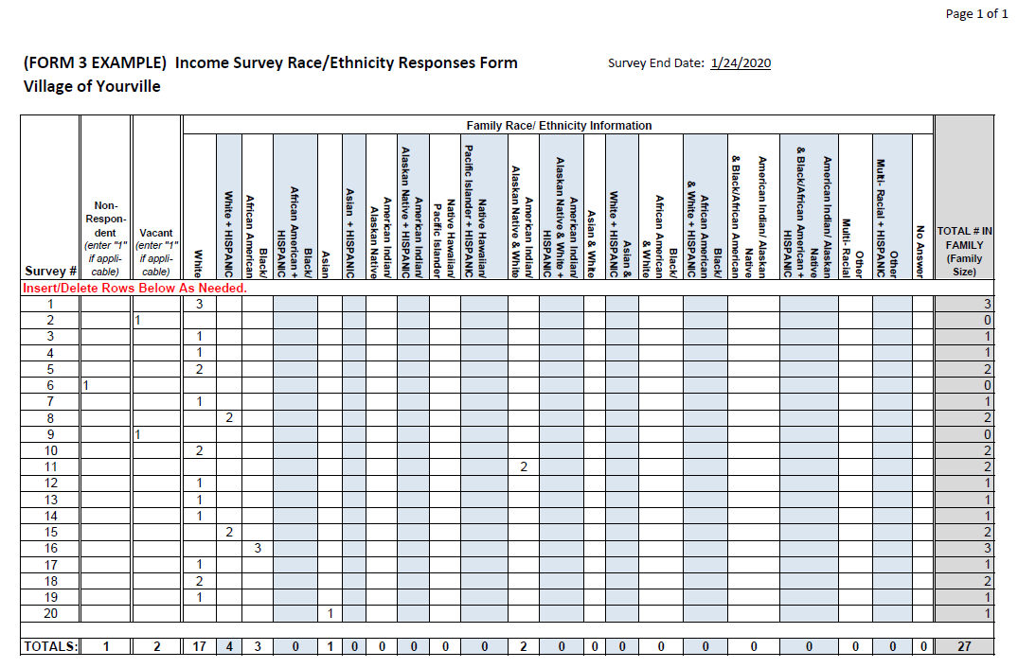

Form 4: Income Survey Distribution Contact List Form – EXAMPLE

The example of the contents of Form 4 are shown below; and in Form 4 Ex. in the Income Survey Data Forms (Microsoft Excel) document.

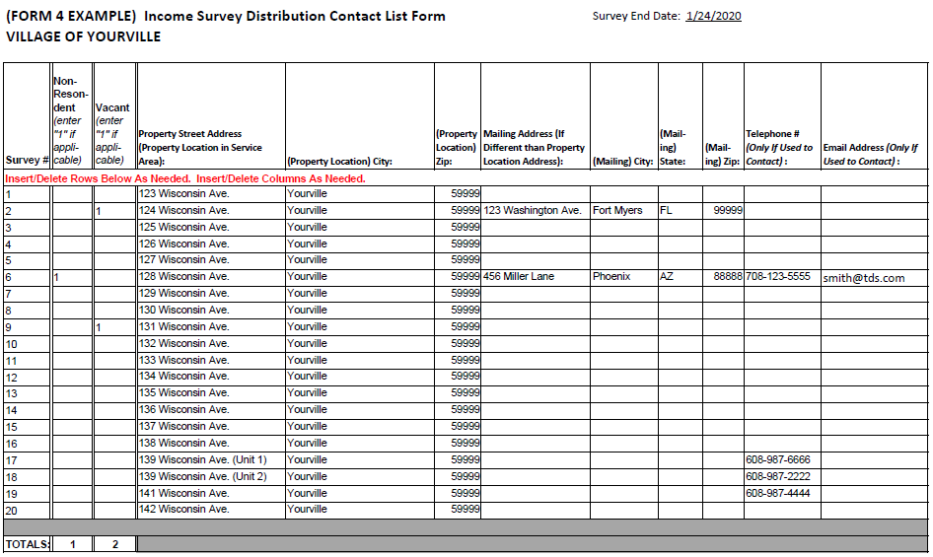

This example is representative of survey distribution made through a combination of mailings, door-to-door/in-person, telephone and email. If the survey distribution method is another form, the contact information used for the alternative method must be on record.

Form 5: Income Survey Distribution Efforts Tracking Form – EXAMPLE

The example of the contents of Form 5 are shown below; and in Form 5 Ex. in the Income Survey Data Forms (Microsoft Excel) document.

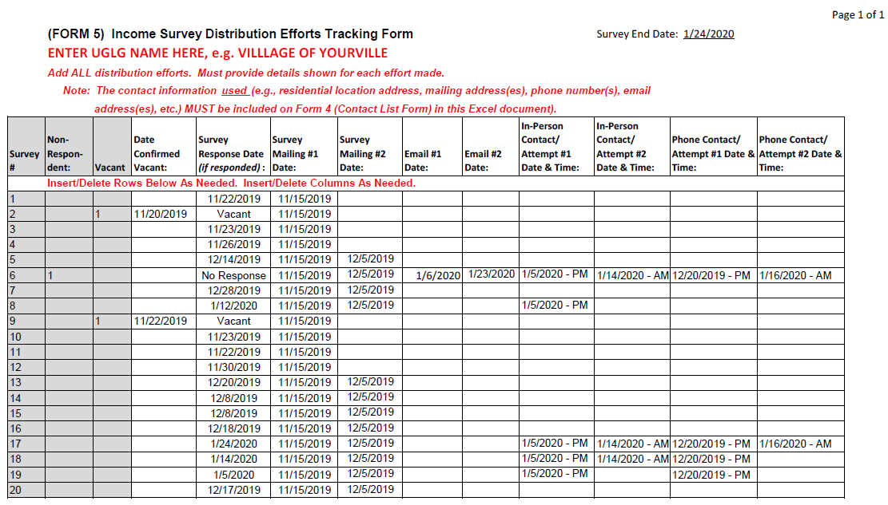

Form 6: Random Sample Survey Methodology Forms - EXAMPLE

If the UGLG administered a Random Sample Survey, the UGLG must complete and submit Form 6 (Part 1-2 and Part 3) in the Income Survey Data Forms (Microsoft Excel) document.

The example of the contents of Form 6 – Part 1-2 and Form 6 – Part 3 are shown below and on the next page; and in Form 6 – Part 1-2 Ex. and Form 6 – Part 3 Ex. in the Income Survey Data Forms (Microsoft Excel) document.

Form 6 – Part 1-2 Example:

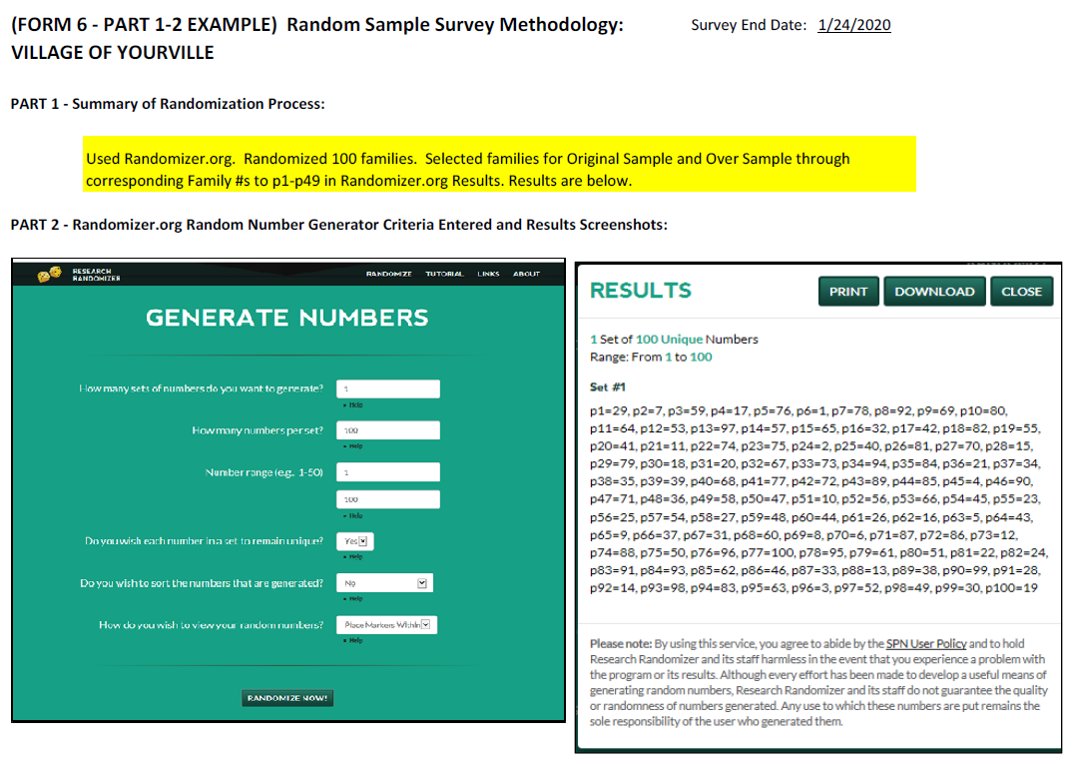

Form 6 – Part 3 Example (Partial – Page 1 of 5):

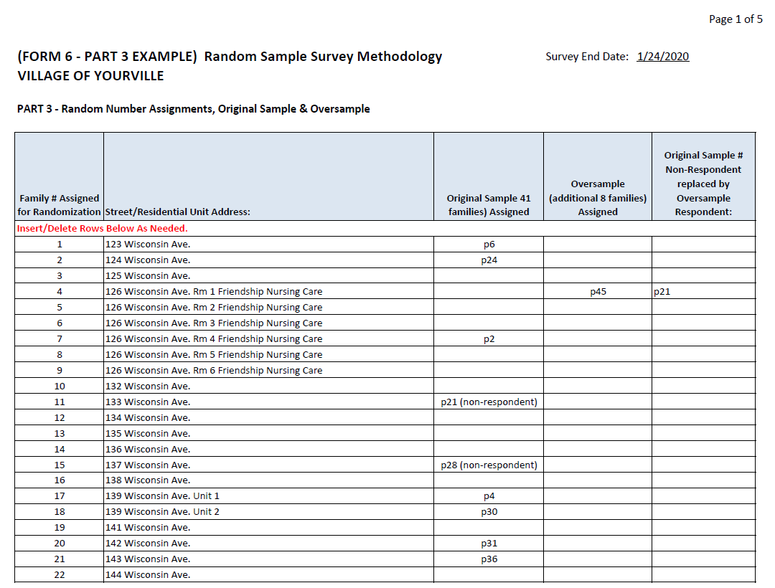

Form 7: Limited Clientele Data Form – EXAMPLE

The example of the contents of Form 7 are shown below; and in Form 7 Ex. in the Income Survey Data Forms (Microsoft Excel) document.

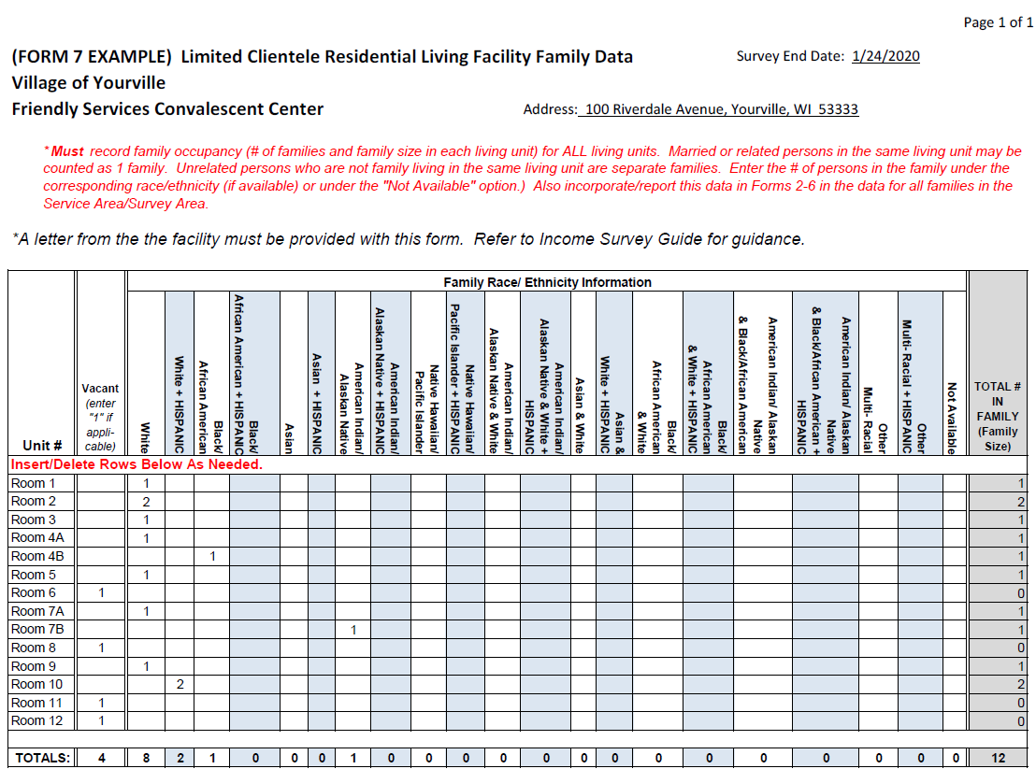

Form 8: Multi-Jurisdiction LMI Calculation Form – EXAMPLES

For Calculating LMI Percentage for Service Area using a Combination of Income Survey Data and HUD LMISD(Multiple Survey Areas or Jurisdictions ONLY)

The content and examples for Form 8 are shown below and on the following pages; and in Form 8 Ex. in the Income Survey Data Forms (Microsoft Excel) document.

Form 8 (Blank):
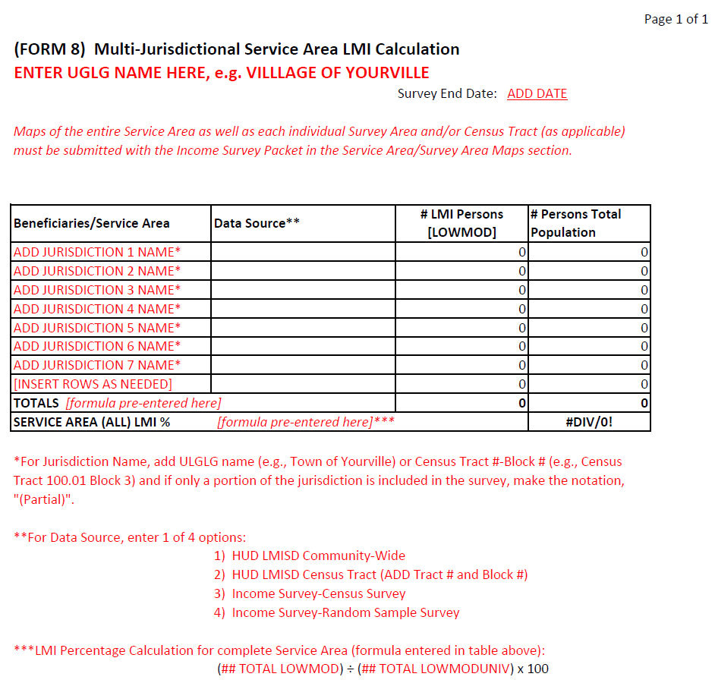

Form 8 (Example 1):

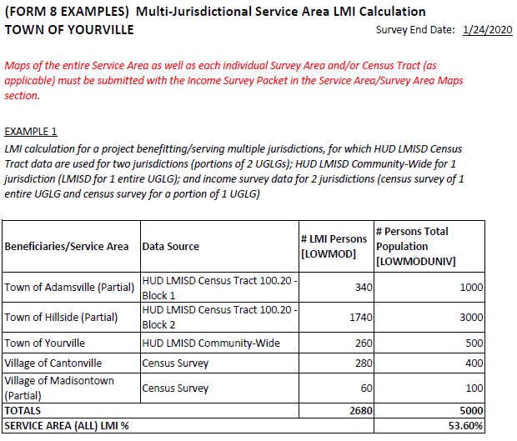

Form 8 (Example 2):

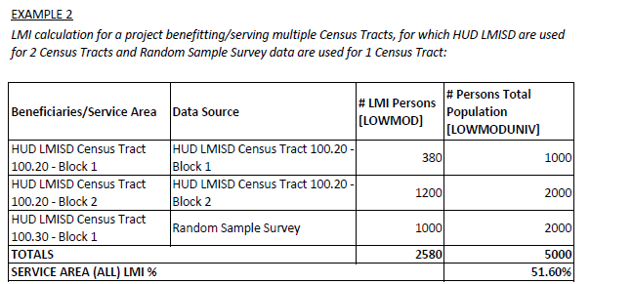

5.04 Appendix D

Service Area/Project Area Map Examples

Maps of the Project Area (i.e., the area in which the project activities/construction will occur) and Service Area (i.e., the area in which all primary beneficiaries reside; also known as the Survey Area) must be submitted with the CDBG Application. More than one map may be required to illustrate the Project Area, location and types of the project activities, location of the residential addresses included as primary beneficiaries (i.e., families included in the income survey), and identification of income survey respondents, non-respondents, and vacant and business/non-residential properties.

Examples #1-#6 on the following pages illustrate the types of information to include on the Project Area Map(s) and Service Area/Survey Area Map(s).

Maps of water and sanitary sewer mains/systems in the Project Area and Service Area are required for water/sanitary sewer projects to allow DEHCR to confirm the primary beneficiaries of the project.

Note: Income survey responses are recorded in the Income Survey Data Forms provided by DEHCR, and when practical, recorded on the Survey Area Map(s). For surveys involving a large number of residences, tracking responses on the Survey Area Map(s) may not be practical. However, DEHCR must be able to associate family residences and non-residential properties listed on the Income Survey Data Forms with the locations on the Survey Area Map(s). At minimum, the Service Area/Income Survey Area boundaries must be clearly marked on the Service Area/Survey Area Map(s). Refer to Appendix C in this guide for Income Survey Data Forms guidance.

Map Example #1: Project Area/Survey Area Map with Response Type Tracking

Combination Map: Project Area Map with Project Activity Locations and Survey Area Map with Residential Address Locations and Response Type Tracking.

Mark respondents, non-respondents, and confirmed vacant and business/non-residential properties on the Survey Area map. Track the data from the responses (i.e., income and race/ethnicity data) on a separate tracking sheet. Refer to Appendix C in this guide for the required Income Survey Data Forms that must be completed and submitted. Mark the types of work being completed in the Service Area on the Project Area Map(s) and/or the Survey Area Map.]

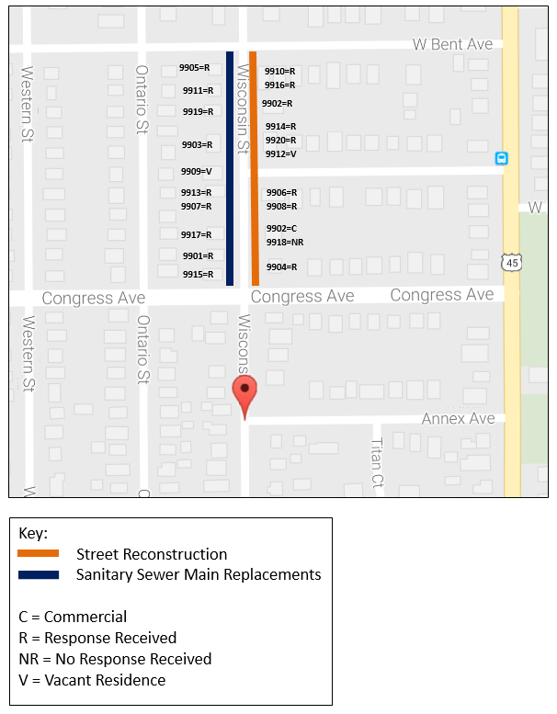

Map Example #2: Survey Area Map – Aerial View

Survey Area Map with Survey Area Boundaries Identified in Satellite View

This Survey Area Map illustrates the boundaries around the Service Area/Survey Area. The Income Survey Data Forms referenced in Appendix C must also be submitted with this map.

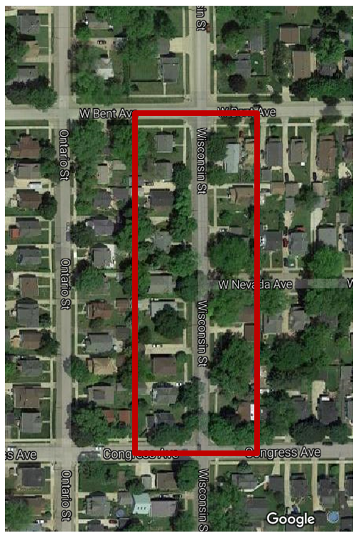

Map Examples: Project Area Maps – Utility Systems

Utility system maps must be submitted with the Project Area Map(s) and Service Area/Survey Area Map(s) for projects involving wastewater treatment facility, lift station, well, water main and/or sanitary sewer main upgrades to illustrate the system components, facility locations, water/sewer main sizes, main connections, etc., which are reviewed to verify the scope of work and the primary beneficiary households (i.e., families to be surveyed).

Wastewater treatment facility, lift station, and well projects are often deemed to have community-wide benefit unless multiple treatment facilities/lift stations/wells are serving the community residences. Various factors are considered such as main sizes, flow direction, looping and other system components when determining the primary beneficiaries of a water/sanitary sewer main improvements project.

One or more Project Area Maps illustrating utility components, similar to Examples #3-#6 on the following pages in this guide, are to be submitted with the Income Survey Packet and the applicant’s CDBG Application Attachments.

Map Examples #3: Project Area Map – Utility System

Project Area Map: Illustration of Utility System Showing System Components, Wastewater Treatment Facility and Lift Station Locations, and Sanitary Sewer Mains

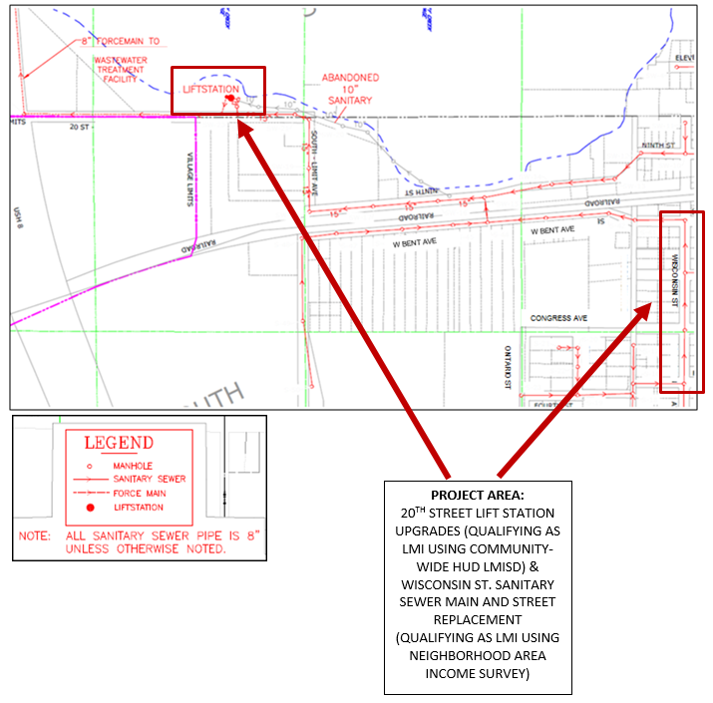

Map Example #4: Project Area Map – Water & Sanitary Sewer Systems

Project Area Map: Illustration of Water and Sanitary Sewer Mains/Services in Project Area

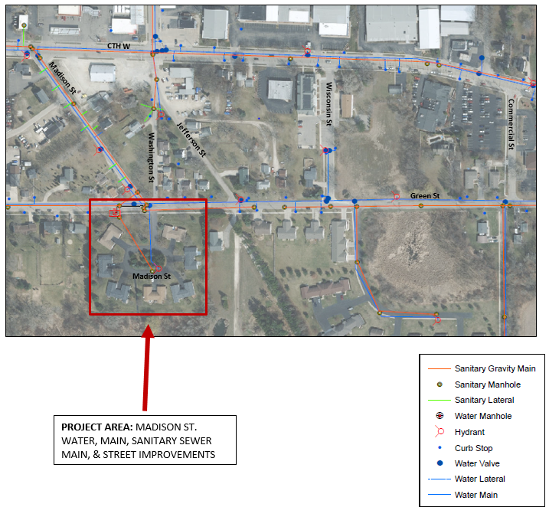

Map Example #5: Project Area Map – Water Distribution System

Project Area Map: Illustration of Water Distribution System in Project Area

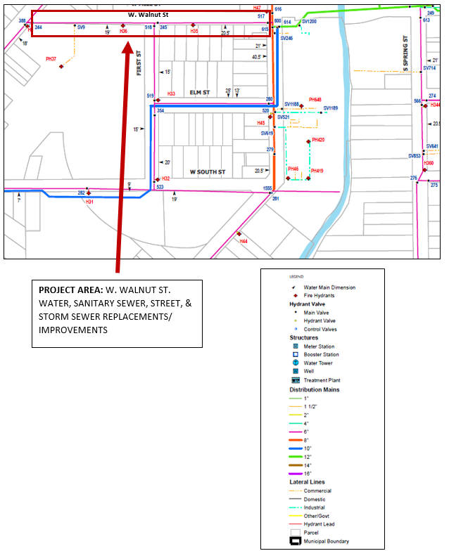
Map Example #6: Project Area Map – Sanitary Sewer Distribution System

Project Area Map: Illustration of Sanitary Sewer Distribution System in Project Area

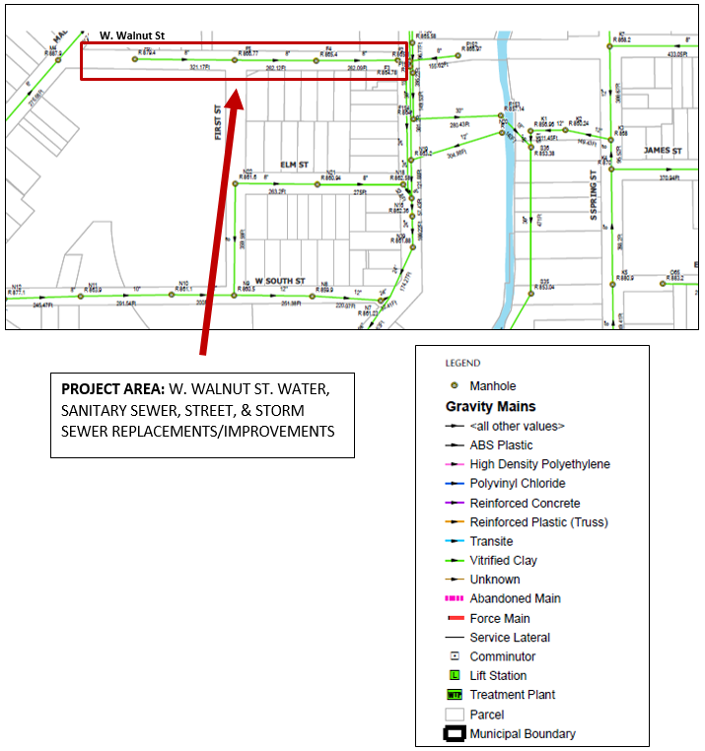

5.05 Appendix E

Income Survey Packet

The income survey documentation that must be submitted to DEHCR for review and approval (either as pre-approval/certification or with the CDBG Application) is to include all items listed on the packet cover pages that follow (excluding items specified as not applicable to some types of surveys or survey methodology/efforts). Submit all items in the format specified with the cover pages provided in this packet template. The Income Survey Data Forms must be emailed in both hardcopy or PDF format (depending on whether the submission is by mail or email) and Microsoft Excel format to DEHCR (printable on 8 ½” x 11” paper).

INCOME SURVEY PACKET

UGLG Name: Survey Distribution Start Date:
Survey Distribution End Date:

      - PROJECT DESCRIPTION / SERVICE AREA DESCRIPTION

Required for all income survey document submissions for income survey pre-approvals/ certifications and with CDBG Applications.

- If the survey documentation is for a specific project (such as with a CDBG Application submission), then check the appropriate box and enter the Project Description on the next page. The Project Description in the Income Survey Packet must be consistent with the project description listed in the UGLG’s CDBG Application (if this packet is being submitted with/for a CDBG Application).

- If no specific project is identified and the UGLG seeks approval of the income survey data for a specific Service Area only, then check the appropriate box and enter the Service Area Description on the next page, describing the location and the boundaries of the Service Area for which the survey data are being submitted.

- An income survey pre-approval/certification from DEHCR will be accepted with a CDBG Application to verify the LMI National Objective is being met only if the Service Area for the proposed project in the UGLG’s CDBG Application is deemed to be identical to the Service Area/Survey Area on which DEHCR’s income survey pre-approval/certification was based. The determination will be made based on the project descriptions (in the CDBG Application and Income Survey Packet), Project Map(s), and Survey Area/Service Area Map(s).

Click on the box to check the applicable option.

☐ Project Description with the scope of work and identification of the primary beneficiaries for the proposed project, including:
- Type(s) of activities that will be completed for the proposed project;
- Geographic location(s) of the activities that will be completed for the proposed project; and
- Factors considered in determining the Service Area/Survey Area (i.e., the residents considered to be primary beneficiaries of the proposed project).

OR

☐ Service Area Description with location and boundary details [for submissions for pre-approval of the income survey data and documents for a specific Service Area only – not for a specific project].

INCOME SURVEY PACKET

UGLG Name:

PROJECT DESCRIPTION / SERVICE AREA DESCRIPTION:

[Enter Text Here]

INCOME SURVEY PACKET

UGLG Name:

      - SERVICE AREA/SURVEY AREA MAP(S)

Required for all income survey document submissions for income survey pre-approvals/ certifications and with CDBG Applications.

Click on the box to check items included within this Income Survey Packet.

☐ Map(s) of Project Area with project location, type of work being completed on each street (if applicable), and Service Area/beneficiary area boundaries marked (Project Area Map examples are provided in Appendix D of the Income Survey Guide) [Required if the income survey documentation submission is for a specific project or CDBG Application.]

☐ Map(s) of Income Survey Area/Service Area with Survey Area boundaries marked. If practical, mark the residences surveyed; and responding, non-responding and vacant residences and business/non-residential properties. At minimum the Survey Area boundaries and location in relation to the Project Area must be marked on the Survey Area/Service Area Map(s), and the survey response information for each residential address must be provided in the required Income Survey Data Forms shown in Appendix C in the Income Survey Guide. Survey/Service Area Map examples are provided in Appendix D in the Income Survey Guide) [Required for ALL income survey documentation submissions.]

INCOME SURVEY PACKET

UGLG Name:

      - INCOME SURVEY FORM & LETTER/CORRESPONDENCE/NOTICES

Required for income survey pre-approval submissions to DEHCR; and for all CDBG Applications unless the UGLG has received an income survey pre-approval/certification letter from DEHCR for the income survey. Submit the DEHCR certification letter with the CDBG Application in lieu of the other documents listed for this packet item (Packet Item #3).

Click on the box to check items applicable and included within this Income Survey Packet.

☐ DEHCR Income Survey Certification Letter [Submit with CDBG Application]

OR

☐ Income Survey Form used to conduct the survey

☐ Income Survey Letter and/or other related correspondence sent to or made available to residents regarding the survey distribution and/or collection process [Applicable ONLY IF letters, notices and/or announcements were used to advertise the income survey initiative]

Note: The Income Survey Template in Appendix A of the Income Survey Guide is to be used to develop the income survey form. An Income Survey Announcement Letter Template is provided in Appendix B of the Income Survey Guide.

INCOME SURVEY PACKET

UGLG Name:

      - INCOME SURVEY DATA FORMS

Required for income survey pre-approval submissions to DEHCR; and for all CDBG Applications unless the UGLG has received an income survey pre-approval/certification letter from DEHCR for the income survey. Submit the DEHCR certification letter with the CDBG Application in lieu of the other documents listed for this packet item (Packet Item #4).

Income Survey Data Forms submissions prior to CDBG application for DEHCR pre-approval/certification:

- Submit all applicable Income Survey Data Forms contained in the Income Survey Data Forms document (in Microsoft Excel) provided by DEHCR on the Bureau of Community Development website at:
https://doa.wi.gov/Pages/LocalGovtsGrants/CommunityDevelopmentPrograms.aspx
[under the “Resources” section].

These forms are also listed on the pages that follow. Submission for pre-approvals must include emailing PDF copies of the forms within this Income Survey Packet in the format specified (using the cover pages) and also the complete Microsoft Excel version of the Income Survey Data Forms to DOACDBG@wisconsin.gov.

- If the Income Survey Packet is approved, the UGLG will receive an approval/certification letter from DEHCR. The DEHCR certification letter must be submitted with the CDBG Application in lieu of Packet Items #3 and #4. The UGLG should not resubmit documents in Packet Items #3 and #4 if the UGLG received DEHCR’s approval/certification letter for the survey.

Pre-application approval is required for all CDBG Public Facilities (CDBG-PF) annual competitive applications for which an income survey is used to verify meeting the LMI National Objective. The pre-application submission is due no later than February 15th of the application year. Later submissions will not be considered for the application year. Early submissions will be reviewed on a first-come-first-served basis.

For all other CDBG programs, pre-application approval is optional/recommended. Submissions will be reviewed on a first-come-first-served basis and pre-approvals are contingent upon staff availability and the number of submissions made at the same time. If time does not allow for DEHCR’s full review prior to application, the UGLG must submit the complete Income Survey Packet with the CDBG Application and DEHCR will review the documentation as part of the full CDBG Application review.

Income Survey Data Forms submissions with the CDBG Application (without DEHCR pre-approval/certification):

This option is not available to CDBG-PF annual competitive applications (for which pre-approval/certification is required). It is an option for all other CDBG programs.

- Submit the documents listed on the next page as part of the full Income Survey Packet with the CDBG Application, including hardcopies or PDFs (depending on whether the CDBG Application is submitted by email or by mail) of the documents with the Income Survey Packet; and also submitting the complete Income Survey Data Forms Microsoft Excel document via email to DOACDBG@wisconsin.gov.

INCOME SURVEY PACKET

4. INCOME SURVEY DATA FORMS UGLG Name:

INCOME SURVEY DATA FORMS INCLUDED IN INCOME SURVEY PACKET:

Click on the box to check items applicable and included within this Income Survey Packet.

☐ DEHCR Income Survey Certification Letter (with CDBG Applications only)

OR

☐ Form 1A: Census Survey Income Survey Income Results Tabulation Form (required for Census Surveys only)

☐ Form 1B: Random Sample Survey Income Results Tabulation Form (required for Random Sample Surveys only)

☐ Form 2: Income Level Responses Form (required for ALL surveys)

☐ Form 3: Income Survey Race/Ethnicity Responses Form (required for ALL surveys)

☐ Form 4: Income Survey Distribution Contact List Form (required for ALL surveys)

☐ Form 5: Income Survey Distribution Efforts Tracking Form (required for ALL surveys)

☐ Form 6 Part 1-2: Random Sample Survey Methodology – Methodology Summary and Randomizer.org Screenshots (required for Random Sample Surveys only)

☐ Form 6 Part 3: Random Sample Survey Methodology – Original Sample/Oversample Records (required for Random Sample Surveys only)

☐ Form 7: Limited Clientele Residential Unit/Family Data Form (required only for surveys that included obtaining Limited Clientele data from the authorized facility representative in lieu of surveying the residents of the facility. Refer to Section 2.10 Surveying Residential Facilities Exclusively Housing Limited Clientele in this guide for the specifications.)

☐ Form 7 Attachment – Facility Letter: Letter from the Limited Clientele residential facility (required only for surveys that included obtaining Limited Clientele data from the authorized facility representative in lieu of surveying the residents of the facility. Refer to Section 2.10 Surveying Residential Facilities Exclusively Housing Limited Clientele in this guide for the specifications.)

☐ Form 7 Attachment - Income Qualification Information: The income limits or basis for income qualification used for housing subsidy qualification (to verify consistency with the HUD Section 8/CDBG LMI income limits) only if the LMC group(s) housed/served include(s) LMI persons/families who are receiving housing at the facility contingent upon low-income-based qualification.

☐ Form 8: Multi-Jurisdictional Service Area LMI Calculation Form (required only for UGLGs combining income survey data for some jurisdictions with HUD LMI Summary Data for other jurisdictions to calculate the LMI percentage for a multi-jurisdictional Service Area. Note: The jurisdiction map(s) must be provided as part of the Service Area/Survey Area Map(s) section.)

