STATE OF WISCONSIN

COMMUNITY DEVELOPMENT BLOCK GRANT
COMMUNITY DEVELOPMENT PROGRAM

INCOME SURVEY GUIDE
REVISED 04/01/2019

Division of Energy, Housing and Community Resources
https://doa.wi.gov/Pages/LocalGovtsGrants/CommunityDevelopmentPrograms.aspx

CDBG COMMUNITY DEVELOPMENT PROGRAM

CONTACT INFORMATION

Mailing Address: Wisconsin Department of Administration
Division of Energy, Housing and Community Resources
Bureau of Community Development
101 E. Wilson St., 6th Floor
P.O. Box 7970
Madison, WI 53707-7970

Telephone: David Pawlisch, Director
Bureau of Community Development
(608) 261-7538

Email: DOACDBG@Wisconsin.gov

PLEASE NOTE:
The CDBG Community Development Program Income Survey Guide may be downloaded from the Bureau of Community Development section on the Division of Energy, Housing and Community Resources (DEHCR) website at https://doa.wi.gov/Pages/LocalGovtsGrants/CommunityDevelopmentPrograms.aspx. Please download the electronic document prior to conducting your survey to ensure that you are referencing the most up-to-date version of the guide.

Table of Contents
Reasons for Conducting an Income Survey 4
Guidelines and Resources 5
Determining the Service Area/Survey Area 5
Families in Service Area 7
Survey Types 8
Census Survey 8
Random Sample Survey 10
Survey Content 12
Income Limits/LMI Levels 13
Income Defined 13
Survey Publicity and Distribution 13
Surveying Residential Facilities Exclusively Housing Limited Clientele 14
Tabulating Survey Results 15
Income Survey Area Mapping 16
Income Survey Recordkeeping and Document Submissions 17
Documents to Submit with the CDBG Application 17
Additional Documents to Maintain in the Income Survey File 18
References 19
Appendix A 21
Income Survey Template 21
Appendix B 22
Income Survey Announcement Letter Template 22
Appendix C 23
Income Survey Results Tabulations & Multi-Jurisdiction LMI Calculations 23
Census Survey: Income Survey Results Income Tabulation Form – EXAMPLE 24
Census Survey: Income Survey Results Income Tabulation Form 25
Random Sample Survey: Income Survey Results Income Tabulation Form – EXAMPLE 26
Random Sample Survey: Income Survey Results Income Tabulation Form 27
Income Survey Results Race/Ethnicity Tabulation Form – EXAMPLE 28
Income Survey Results Race/Ethnicity Tabulation Form 29
Multi-Jurisdiction LMI Calculation Worksheet – EXAMPLES 30
Appendix D 31
Income Survey Tracking List Examples (Data to Maintain) 31
Appendix E 35
Service Area/Project Area Map Examples 35

CDBG INCOME SURVEY GUIDE

Conducting an income survey for a Community Development Block Grant (CDBG) application may be necessary to determine the number and percentage of Low-to-Moderate Income (LMI) individuals living in the geographic area that will benefit from the project (i.e., the Service Area). A survey is needed when local government or census block group/tract LMI Summary Data (LMISD) published by the U.S. Department of Housing and Urban Development (HUD) are not available or not sufficient. The purpose of this guide is to provide the necessary information for conducting an income survey in the service area of a potential CDBG project, to ensure the survey activity meets CDBG Community Development Program standards and requirements.

Reasons for Conducting an Income Survey

Two key reasons for conducting an income survey are listed below.

      - Conduct a survey to provide data that the applicant believes are more accurate than the HUD LMISD.
The HUD LMISD are based on data drawn from the U.S. Census American Community Survey (ACS) 5-Year Estimates. Downloadable Microsoft Excel spreadsheets with the HUD LMISD for local governments and census block groups/tracts are available at:
https://www.hudexchange.info/manage-a-program/acs-low-mod-summary-data.
Refer to the “Data Sets” section of this webpage for local government and census block group/tract data.

If the HUD LMISD indicate the population is below but near 51.00% LMI; if the margin of error (MOE) of the HUD LMISD is very high; or if local social and/or economic factors have changed significantly in recent years, then it may be worthwhile to conduct an income survey to determine if the service area LMI percentage is higher than indicated by the HUD LMISD.

  - Conduct a survey to obtain LMI data otherwise not available for the service area of the potential CDBG project.
If the service area is not coterminous with or does not include the majority of residents living within the area census block group(s)/tract(s) boundaries; or includes only a portion of residents living within the unit of general local government (UGLG) boundaries, then the HUD LMISD are not available or usable for the service area. A survey is required to calculate the percentage of LMI persons among the beneficiaries living in the service area.

If the service area includes an area for which HUD LMISD are available/usable, but also includes an area for which HUD LMISD are not available/usable, then the area for which no LMISD are available/usable must be surveyed. The HUD LMISD and income survey data must be compiled in aggregate to calculate the LMI percentage for the full service area. Refer to Appendix D for an example for tabulating the LMI percentage for a multi-jurisdictional service area using a combination of HUD LMISD and survey data.

Guidelines and Resources
For data from an income survey to be accepted by the Division of Energy, Housing and Community Resources (DEHCR) for calculating the LMI percentage for the service area, the following criteria must be met:

- The survey was initiated (first distributed) on or after July 1, 2014 (after the HUD LMISD began being based on American Community Survey 5-Year Estimates data);
[Note: The date by which a survey must be initiated for the results to be accepted by DEHCR is subject to change, contingent upon compliance with any new policy updates released by HUD. Consulting with DEHCR to check for updates prior to submitting documents with the CDBG application is strongly advised .]

- The HUD income limits in effect at the time the survey was initiated were the income thresholds used/listed on the survey form;

- No significant demographic, economic, and non-economic changes in the service area occurred since the survey was conducted;

- The survey distribution and collection process (from start to finish) was held within a reasonable period of time that is deemed acceptable by DEHCR as methodologically sound;

- The survey data calculations are accepted as valid and methodologically sound, including not exceeding margin of error (MOE) limits as specified by DEHCR and HUD

- The survey data are submitted for the CDBG application on the most current versions (at the time of CDBG application submission) of the Income Survey Results Income Tabulation Form and Income Survey Results Race/Ethnicity Tabulation Form available in the current Income Survey Guide, with the LMI percentage calculated according to the specifications in the current Income Survey Results Income Tabulation Form; and

- All requirements deemed applicable by DEHCR for verifying the survey results are valid and methodologically sound, as set forth in the current Income Survey Guide (at the time of CDBG application submission), are met.

When conducting an income survey, important considerations with regard to the service area, survey types, LMI levels, survey content, survey publicity, and results data calculation must be made, as described in the sections that follow.

Determining the Service Area/Survey Area

To determine the service area, which will be the survey area, the impact of the project and the benefits to residents must be considered. Service area/survey area determinations must be made on a case-by-case basis with several factors considered. Consultation with DEHCR staff is strongly advised prior to finalizing service area/survey area determination.

Common considerations for determining if the project will have community-wide benefit (and therefore the service area/survey area encompasses the entire community) include:
- Does the project have a community-wide focus (e.g., creating a Comprehensive Plan, Economic Development Plan or Downtown Revitalization Plan; completing downtown business district infrastructure improvements; improving a wastewater treatment facility that serves the entire community; etc.)?

- Is any area of the downtown/central location of the municipality, where goods/services generally utilized by all community residents as a whole are provided, impacted by the improvements being made? If so, to what extent?

- Is a local government building, school, main hospital/medical facility, library, central community center, central park, or other similar facility generally utilized by all community residents as a whole either the focus of the proposed CDBG project or located in the area being improved as part of the proposed CDBG project? If so, to what extent will users benefit from the improvements?

- Is the facility/are the facilities being built or improved for the proposed CDBG project of primary service/benefit to the entire community or only portions/sections of the community?

The extent of the impact and benefit to all residents in the community is considered when making a determination of whether the proposed CDBG project is deemed to have community-wide benefit.

Common considerations for determining which residences/families will be primary beneficiaries of a project when the project is deemed to not have community-wide benefit (e.g., neighborhood-specific street, utility, sidewalk, park or other facility improvements that benefit only residents in the immediate area in which the work will be performed/improvements will be made [i.e., the project area]) include:

- Who are the users or customers of the facilities (e.g., utility customers, residences located in a fire district, residences in the immediate area of the neighborhood-specific facility, etc.)?

- How will the improvements impact the residences in the project area?

- Which residences and/or driveways are located on the street(s) being improved?

- Which families/residences use the street(s) being improved as a primary route to/from their homes, and to what extent?

- Which residences are connected to the utility services or other infrastructure being improved?

- Will the street and/or utility service and/or other infrastructure improvements have a benefit to any residence that is not located on the section(s) of the street(s) being improved and/or is not directly connected to the utility service(s) or other infrastructure being improved? If so, to what extent?

The extent of the impact and benefit to the residents living in or near the project area is considered when making a determination of whether the proposed CDBG project is deemed to have primary or secondary benefit to those area residents.

Families in Service Area

The U.S. Department of Housing and Urban Development (HUD) requires a measure of families and population (all individual residents) in the service area in order to meet the LMI National Objective.

- “Family” includes all definitions listed in 24 CFR 5.403. The family may include but is not limited to the following, regardless of actual or perceived sexual orientation, gender identity, or marital status:
- A single person who may be defined, in 24 CFR 5.403, as an elderly person, displaced person, disabled person, near-elderly person, or any other single person; or
- A group of persons residing together, and such group includes but is not limited to:
- A family with or without children (a child who is temporarily away from the home because of placement in foster care is considered a member of the family); or
- Person(s) living in a household for which the relationship is defined, in 24 CFR 5.403, as an elderly family; a near-elderly family; a disabled family; a displaced family; and, the remaining member of a tenant family.

- “Household” means all persons who occupy a housing unit. A household may consist of persons living together or any other group of related or unrelated persons who share living arrangements, regardless of actual or perceived sexual orientation, gender identity, or marital status (pursuant 24 CFR 570.3). A “housing unit” is an individual family residential living space or living unit, such as an individual house, one-half of a duplex housing structure, one condominium unit of a multi-family condominium structure, one apartment in an apartment building, one resident room in a nursing home, etc.

- Multiple families may reside within a household (e.g., two persons without a familial relationship living in the same house or apartment, two persons without a familial relationship living in the same room at a nursing home, etc.). Persons occupying the same household without a familial relationship are to be counted as separate families.

- The HUD measure requires surveying families that will benefit from the proposed activity.

- The number of LMI individuals is extracted from the family data gathered through the survey. The number of LMI individuals in the families that respond to the survey is used to determine the LMI percentage in the service area. The percentage must be at least 51.00% or greater to meet the LMI National Objective.

After the service area is defined, the number of families living in the service area must be determined or estimated to estimate the number of surveys that must be conducted/distributed. If the exact number of families in the service area is not known, methods must be incorporated to obtain or estimate the number of families. Estimating the total population (the number of persons living in the service area) may also be necessary when tabulating the survey results. The method of determining the number of families and the total population in the service area will depend upon the data available.

- An initial estimate of the number of families living in the service area may be based on the number of households in the service area. Resources for determining or estimating the number of households in the area include U.S. Census data (use the most recent U.S. Census American Community Survey 5-Year Estimates number of occupied households data); area maps of residential neighborhoods; other records such as utility service customer lists, tax rolls, and telephone directories; and/or going door-to-door. Each of these methods for determining or estimating the number of families in an area has some limitations associated with it (e.g., census data only allow for estimations and are limited to a past point in time; area maps do not show how many families are living in each residence; telephone directories exclude people without phones or who exclusively use cell phones; tax rolls identify property owners, but not residents). The characteristics of the service area need to be considered when choosing a resource. Using multiple sources for estimating the number of families in the service area may be necessary.

- While a list of households may be used to compile an estimate of the number of families in the service area for the purpose of estimating the overall survey numbers and sample size, the survey itself needs to be addressed to families. Each family in each household should complete a survey.

- Part-time/seasonal residents do not need to be ‘counted’ as beneficiaries and be included in the income survey if the proposed project is deemed by DEHCR to have “incidental” benefit to the part-time/seasonal residents. If the part-time/seasonal residents are deemed to receive more than incidental benefit, then they must be surveyed. Refer to HUD CPD Notice 14-013 at https://www.hudexchange.info/resources/documents/Notice-CPD-14-013-Guidelines-for-Conducting-Income-Surveys-LMI-CDBG-Activity.pdf for additional guidance.
If the part-time/seasonal residents are included in the survey, the survey should be distributed to both their local part-time/seasonal residence and their permanent residence to help ensure the survey is received. Applicants are strongly advised to seek approval from DEHCR regarding determinations for part-time/seasonal residents prior to proceeding with a survey.

- Demonstrate in the survey methodology a concerted effort to identify the actual number of families in the service area.

Survey Types

Census Survey

A census survey includes the entire population that will benefit from the proposed activity (i.e., 100% of the families in the service area).

- To calculate the LMI percentage of the service area using census survey results data, the number of persons in all LMI families among respondents is divided by the estimated total number of persons in the entire service area (i.e., all persons in the responding families plus the estimated number of persons in all non-responding families); then multiplied by 100. Non-responding families must be presumed to be non-LMI persons. If the response rate is less than 100%, then the total population of the service area must be estimated. The methodology specified on the Census Survey: Income Survey Results Income Tabulation Form (in Appendix C of this guide) for calculating the LMI percentage and estimating the total population must be used.

- The response rate required is based on the margin of error (MOE), i.e., the confidence interval. For the survey response rate and data to be accepted, the MOE of the survey results must be no greater than +/-10 or no greater than the MOE of the HUD LMISD for the service area (if available), whichever is lower. The confidence level standard of 90% must be applied when calculating the MOE/confidence interval. DEHCR must also review and approve the results as having acceptable representation from throughout the service area among the responses received.

A margin of error/sample size calculator such as the online tool provided by Survey Monkey at https://www.surveymonkey.com/mp/margin-of-error-calculator/ may be used to make an initial estimate of the sample size needed for the survey responses when initiating a survey; and for determining the actual MOE of the survey results data upon receiving returned surveys and compiling the data.

Refer to Figure 1 on below to view Example #1 for using the Survey Monkey Margin of Error Calculator. The example depicts determining the minimum number of responses needed for a census survey in a service area with 100 families/households. The user enters the Population Size (estimated number of families in the service area), and Confidence Level (minimum 90% allowed) and the Sample Size (number of responding families), and the MOE percentage is automatically calculated and appears. Example #1 reflects 39 families must be in the survey sample (i.e., 39 responses must be received) for a population of 100 families in a service area.

Calculations for Example #1 (Figure 1):
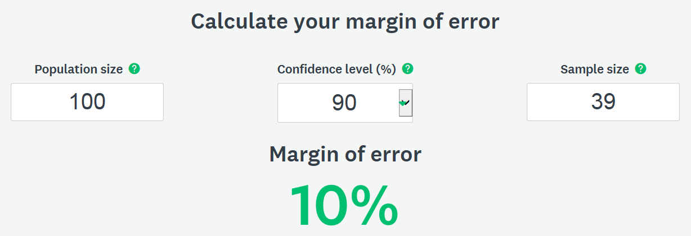
Figure 1: Survey Monkey MOE Calculator Example #1 – Census Survey
https://www.surveymonkey.com/mp/margin-of-error-calculator/

Additional responses beyond the sample size number generated with the MOE calculator are typically necessary for census surveys, particularly for large populations, to meet the requirements for broad service area representation among survey respondents and to reach the 51.00% LMI threshold. This is because all non-respondents are presumed to be non-LMI and the LMI percentage for the service area is based on the ratio of LMI persons among respondents in comparison with the total population of respondents and non-respondents when conducting a census survey.

- If a housing unit is verified as vacant, then adjustment to the total estimated number of families living in the service area would need to be made, given a vacant housing unit is not counted as a family in the service area.

- Efforts to distribute the survey to all families/housing units in the service area and the methods used (e.g., door-to-door interviews, telephone calls, survey mailing, web-based distribution, etc.) must be documented, including details of the means of data collection/survey distribution and follow-up efforts. The date(s) and method(s) of initial distribution; and date(s), day(s) of the week, approximate time(s) of the day and method(s) of follow-up to attempt to obtain additional responses must be recorded. The contact information for the method used to distribute the survey must also be kept on file (e.g., telephone numbers for survey calling, mailing addresses for mailed surveys, email addresses for emailed surveys, etc.). The street addresses for all families in the survey area must be on record so that their residential locations can be verified as being within the service area.

Maintain all records of survey distribution and the results of follow-up survey solicitation attempts, including denoting which families were contacted and their responses (whether they responded, refused to respond, were not available/not home, etc.). Refer to the data tracking sheet examples in Appendix D in this guide for the types of information to maintain.

Random Sample Survey

A random sample survey uses a subset of the population chosen on a random basis to make assumptions about the entire population in the service area.

- To calculate the LMI percentage for the service area using random sample survey results data, the number of persons in all LMI families among respondents is divided by the total number of persons in all responding families; then multiplied by 100 to get the LMI percentage of the survey sample. The LMI percentage of the survey sample is applied to the entire service area population. The total population of the service area must be estimated. The methodology specified on the Random Sample Survey: Income Survey Results Income Tabulation Form (in Appendix C of this guide) for calculating the LMI percentage and estimating the total population must be used.

- A margin of error/sample size calculator such as the online tool provided by Survey Monkey at https://www.surveymonkey.com/mp/margin-of-error-calculator/ may be used to make an initial estimate of the sample size needed for the survey responses when initiating a survey; and for determining the actual MOE of the survey results data upon receiving returned surveys and compiling the data.

Refer to Figure 2 below to view Example #2 for using the Survey Monkey Margin of Error Calculator. The example depicts determining the minimum number of responses needed for a random sample survey in a service area with 1000 families/households. The user enters the Population Size (estimated number of families/households in the service area), and Confidence Level (minimum 90% allowed) and the Sample Size (number of families in the sample/number of responding families), and the MOE percentage is automatically calculated and appears. Example #2 reflects 58 families must be in the survey sample (i.e., 58 families must be surveyed and 58 responses must be received/obtained) for a population of 1000 families in a service area.

Calculations for Example #2 (Figure 2):
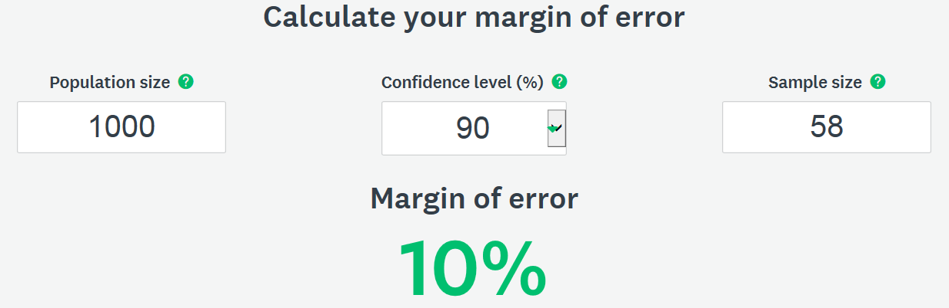
Figure 2: Survey Monkey MOE Calculator Example #2 – Random Sample Survey
https://www.surveymonkey.com/mp/margin-of-error-calculator/

- The sample of families to survey must be randomly selected. To randomly select the sample, numbers must be assigned to all families/housing units in the service area. Use an appropriate random number assignment methodology such as the random number generator by Research Randomizer at https://www.randomizer.org/. Using Example #2 on the previous page, the families/housing units assigned #1-58 using a number randomizer would be designated as the original survey sample group. Families/housing units #1-#58 must be surveyed, and responses must be obtained from these families or families in the oversample, if necessary.

- A limit of oversampling (i.e., surveying more than the minimum number of families required to be in the survey sample) of up to 20% is allowed for a random sample survey. Using Example #2 on the previous page, given 58 families are in the original sample, only an additional 11 families, specifically the families/housing units assigned #59-69, may be included in the survey [calculation: 58 x .20 = 11, rounding down to not exceed 20%], and those 11 families’ responses may only be used in calculating the survey results if there are non-respondents among the original survey sample group. Scientific methodology must be used in replacing non-responding families in the original sample with responding families in the oversample (i.e., the lowest numbered non-responding family in the original sample is replaced with the response of the lowest numbered responding family in the oversample; the second lowest numbered non-responding family in the original sample is replaced with the response of the second lowest numbered responding family in the oversample; etc.).

- Distributing the survey to the oversample families/housing units only after the distribution and results from surveying the original sample are complete is recommended. However, distributing the survey to both the original sample and oversample at the same time is acceptable as long as the responses/data from the oversample are only used upon the determination that oversample responses are needed to replace the original sample non-responding families. The methodology summarized in this section of this guide for using the data from oversample respondents in place of original sample non-respondents must be followed.

- No additional surveying beyond the original sample and oversample may be conducted except when during the surveying process a housing unit in the original sample or oversample is verified as vacant or the estimated number of families in the service area increases to a level that allows for increasing the sample size.

  - If a housing unit is verified as vacant, then an additional family/housing unit may be added from the randomized number list to the overall survey sample, given a vacant housing unit is not counted as a family in the population or survey sample numbers. Using Example #2 on the previous page, if the housing unit assigned #1 was verified as vacant, then the family/housing unit assigned #59 from the oversample replaces housing unit #1 in the original sample; and then another family/housing unit may be added to the oversample (i.e., family/housing unit assigned #70, the first number assigned beyond the oversample, would be moved to the oversample group). Adjustment to the total estimated number of families living in the service area would also then need to be made. [Note: Unlike vacant housing units, occupied housing units that are non-respondent are still counted as families in the population and survey sample numbers. Occupied housing unit non-responses from the original sample may be replaced by occupied housing unit oversample responses for the data results tabulation, but this replacement does not constitute adding another family to the oversample.]

  - If one or more housing units among the original sample (or among the oversample, if oversample data are to be used) is/are verified as having multiple families living in the unit(s), adjustment to the total estimated number of families living in the service area needs to be made. An increase in the estimated number of families in the service area (i.e., the population number in the MOE calculation) may potentially increase the sample size and oversample numbers. Contact DEHCR for guidance on making adjustments to the sample size (if deemed necessary) and data results tabulation when multiple families are living in a household among the original sample and/or oversample groups.

- Efforts to distribute the survey to all families/households in the original sample (and oversample, if used/needed as replacement for any families in the original sample) and the methods used (e.g., door-to-door interviews, telephone calls, survey mailing, web-based distribution, etc.) must be documented, including details of the means of data collection/survey distribution and follow-up efforts. The date(s) and method(s) of initial distribution; and date(s), day(s) of the week, approximate time(s) of the day and method(s) of follow-up to attempt to obtain additional responses must be recorded. The contact information for the method used to distribute the survey must also be kept on file (e.g., telephone numbers for survey calling, mailing addresses for mailed surveys, email addresses for emailed surveys, etc.). The street addresses for all families in the survey area must be on record so that their residential locations can be verified as being within the service area.

All records must be maintained of the randomization process for selecting the original sample and oversample, the assigned randomized numbers to each family/housing unit in the entire service area, methods for replacing original sample with oversample families, soliciting responses, etc.

Maintain all records of survey distribution and the results of follow-up survey solicitation attempts, including denoting which families were contacted and their responses (whether they responded, refused to respond, were not available/not home, etc.). Refer to the data tracking sheet examples in Appendix D in this guide for the types of information to maintain.

Survey Content

The survey content required for Wisconsin CDBG Community Development project grants is presented in Appendix A.

- At a minimum, the survey must include the questions about family size, total family income, and race/ethnicity.

- Avoid language that refers to the CDBG program, or ‘low-income’ or ‘low-to-moderate income’ based requirements in the survey instrument, cover sheet, cover letter, or publicity about the survey.

- A listing of survey respondents and non-respondents must be maintained with survey records. Apply a survey code system to allow for tracking the respondents while maintaining confidentiality. Apply the random sample randomizer number assignment to each survey form for random sample surveys or assign a random numeric or alpha-numeric code to each census survey form, which cannot be easily decoded by someone viewing the completed surveys. Avoid using a code that can easily be tied to the alphabetical order sequence of the family name or numerical order sequence of the street address number (i.e., avoid assigning the survey code #1 to the lowest street address number, #2 to the second lowest street address number, #3 to the third lowest street address number, etc.). Do not collect street address information on the survey form.

Income Limits/LMI Levels

To collect income data from survey respondents, the HUD Section 8 income limits for the particular county must be added in the income table on the survey form. These change each year and are specific to each county. The income limits in effect on the date the survey is first distributed/administered must be used. If the service area covers more than one county, a survey instrument for each county listing the appropriate income levels must be used. Each family included in the survey is to receive a survey form with the income table for the county in which the family lives.

Access the limits for counties in Wisconsin on the HUD website by following these seven steps:
  - Go to http://www.huduser.org/portal/datasets/il.html
  - Locate and select the current or most recent year that appears
  - Select the "Click Here for FY <most recent publication year> IL Documentation" icon
  - On next page: Under “First select a state” select "Wisconsin - WI;" then select the county in which the service area resides
  - Click the "View County Calculations" icon when it appears as the county is selected.
  - The income summary appears for the County/Area. The "Low (80%) Income Limits" are the threshold limits for low-to-moderate income (LMI) to include in the income table on the Income Survey form.

Income Defined

Income earned by all adult family members residing at the address (including any related, dependent persons over 65 or working dependent children over age 18) must be counted in the annual family income determination. An individual’s Adjusted Gross Income (AGI), as defined for purposes of reporting under Internal Revenue Service (IRS) Tax Form 1040 for individual Federal annual income tax purposes, from the most recent tax year, is used for income reporting. The income may be self-reported by the family and the collection of income documentation is not required.

Survey Publicity and Distribution

The survey may be conducted through mail, telephone, in-person door-to-door interviews, and/or web-based methods. Each type of survey distribution has limitations, which should be corrected by using more than one method of distribution (e.g., distribute the survey using web-based and/or mail services; then follow up with telephone and/or door-to-door interviews). Maintain records of all methods and family contact information used to distribute/administer the survey.

Publicizing when the survey will be conducted, how it will be conducted, and why it will be conducted can significantly increase the response rate. Providing information regarding the reason for conducting the survey also can make people less hesitant about answering questions regarding personal income information. Be aware of the following guidelines and restrictions for publicizing the survey initiative:

- Stating the survey is being conducted to apply for CDBG funds specifically or to find out how many low-to-moderate income (LMI) persons are in the area is prohibited.

- Providing some general information is acceptable, such as indicating that a current estimate of incomes in the service area is necessary in order to apply for grant funds.

- Avoid creating any bias in the survey results by including information that could lead respondents to answer the survey questions in a particular way.

- An example of an introductory letter that may be sent prior to conducting a survey is provided in Appendix B. It may be adapted to fit the needs of the survey plan (for mailing, telephone calls, door-to-door interviews, etc.), and may be adapted to be sent in the same mailing with the survey.

Surveying Residential Facilities Exclusively Housing Limited Clientele

- For residential living facilities exclusively housing persons in one or more Low- and Moderate-Income Clientele (LMC) groups, which are groups presumed to be at least 51.00% LMI according to HUD guidelines, the UGLG may obtain a letter on facility letterhead signed by or an email directly sent from an authorized representative of the facility, with verification that the facility exclusively serves one or more LMC groups and with the required resident/family and housing unit information, in lieu of surveying residents individually in the facility. Qualifying LMC groups are listed below:
- Abused children
- Elderly persons (age 62 and older)
- Battered spouses
- Homeless persons
- Severely disabled adults
- Illiterate adults
- Persons living with AIDS
- Migrant farm workers
- LMI individuals/families

Acceptance of a letter/email from the residential facility in lieu of individual income surveys of the families/living units is contingent upon the required documentation and information being provided; and a determination that it may be reasonable to presume that, based on the nature of the facility and typical status of residents, the residents of the facility are among the presumed 51.00% LMI persons in their associated LMC group(s).*

- The resident/family and housing unit information that must be obtained from the residential facility to be accepted in lieu of individual resident/family surveys includes the following:
  - A description of the nature of the facility and the clientele housed/served, to verify that the facility exclusively houses/serves persons in one or more LMC groups;
  - The number of families/living units in the facility;
  - The number of persons in each family (with living unit number/address);
  - Race/ethnicity demographic data for the members of each family (as available); and
  - The basis for the income limits used for housing subsidy qualification (to verify consistency with the HUD Section 8/CDBG LMI income limits) only if the LMC group(s) housed/served include(s) LMI persons/families who are receiving housing at the facility contingent upon low-income-based qualification.

- Each family, including one-person families, living in the residential facility are counted as one family in the service area population calculation and listed individually on the income survey distribution and response tracking records.

- Generally, families living in residential facilities exclusively housing/serving persons in LMC groups are presumed to be and recorded as LMI families, as it is generally reasonable to presume they are among the presumed 51.00% LMI persons in their associated LMC group.*

*LMC CONDITIONAL NOTE: Typical facilities exclusively housing members of LMC groups are nursing homes (serving seniors and severely disabled adults), HUD Section 8 housing, and transitional housing for homeless persons. Residents in these types of facilities generally may be presumed to be LMI persons. If the residential facility is of a different nature that caters to high-income clientele and requires a high personal income to qualify for housing (e.g., luxury senior housing), then it cannot be reasonably presumed that the residents living in the facility are among the 51.00% LMI persons in their associated LMC group, and therefore an income survey of the residents would be required to verify income status.

Tabulating Survey Results

- Tabulation forms are provided in Appendix C for both a Census Survey and a Random Sample Survey. Select the appropriate worksheet based on the type of survey conducted.

- Determine the percentage of LMI individuals/persons in the service area through calculations using the family survey data and the appropriate tabulation form.
If the survey did not include 100% of the service area and have a 100% response rate, then the total service area population (i.e., number of all persons living in the service area) must be estimated. The population may be determined or estimated using the survey data; the most recent U.S. Census American Community Survey 5-Year Estimates data (community-specific ACS data may be searched at http://factfinder.census.gov/); or “LOWMODUNIV” population number listed in the applicable HUD LMISD (if available). Refer to the guidance on the survey tabulation forms in Appendix C of this guide in determining which method is most appropriate.

- If combining income survey data with HUD LMISD to determine the LMI percentage of a multi-jurisdictional service area, then the number of LMI persons and total population for each jurisdiction must be compiled in aggregate to calculate the LMI percentage. Refer to the Multi-Jurisdiction LMI Calculation Worksheet examples in Appendix C for tabulating the LMI percentage for a multi-jurisdictional service area using a combination of survey data and HUD LMISD. The multi-jurisdictional tabulation record must be submitted in addition to the applicable income survey results tabulation form and survey documentation with a CDBG Application.

Income Survey Area Mapping

Maps of the project area and the income survey area (i.e., service area) must be submitted with the CDBG application. More than one map may be required to illustrate the boundaries of the project area, location of the project activities, boundaries of the survey area, location of the residential addresses included in the income survey, and identification of responding and non-responding family residences, vacant residences, and business/non-residential properties.*

*Survey responses may be recorded on the income survey area map or a survey tracking list. For surveys involving a large number of residences, tracking responses on the survey area map may not be practical. Refer to Appendix D and Appendix E in this guide for income survey data tracking list examples and area map examples.

Income Survey Recordkeeping and Document Submissions

Documents to Submit with the CDBG Application

The following income survey documents must be submitted with the CDBG Application:

- Map(s) of Project Area with project location, type of work being completed on each street (if applicable), and Service Area/beneficiary area boundaries marked (project area map examples are provided in Appendix E)
- Map(s) of Income Survey Area/Service Area with survey area boundaries marked; residences surveyed marked; and responding, non-responding and vacant residences and business/non-residential properties marked or listed on a separate sheet (response tracking list examples provided in Appendix D; survey/service area map examples are provided in Appendix E)
- Multi-Jurisdiction LMI Calculation Worksheet (Applicable if the service area includes multiple local governments and/or census tracts and/or a combination of income survey data and/or HUD LMISD are used to calculate the LMI percentage for the entire service area; Multi-Jurisdiction LMI Calculation Worksheet Examples are provided in Appendix C)
- Map of Census Block Group(s)/Tract(s) (Applicable if the service area is conterminous with or benefits the majority of residences within one or more census tracts and census block group/tract maps and/or the HUD LMISD for census block groups/tracts were used to establish service area/survey area boundaries; contact DEHCR for guidance)
- Income Survey Form used to conduct the survey (survey template is provided in Appendix A)
- Income Survey Letter and/or other related correspondence sent to residents regarding the survey distribution and collection process, if applicable (survey announcement letter template is provided in Appendix B)
- Income Survey Results Income Tabulation form (Census Survey and Random Sample Survey Income Survey Results Income Tabulation Forms are provided in Appendix C)
- Income Survey Results Race/Ethnicity Tabulation form (Income Survey Results Race/Ethnicity Tabulation Form is provided in Appendix C)
- List of all families/addresses to which the survey was distributed (including both street address and mailing address, if different than the street address; any other contact information used to make contact with the family to administer the survey, such as phone numbers, email addresses, etc.); assigned survey number; and response type (e.g., respondent, non-respondent, vacant, business/non-residential property), if not already shown on the income survey map (Survey Distribution/Response Type Tracking List Example is provided in Appendix D)
- Tracking list that shows the survey response data for each survey form received from responding families (Survey Response Income Data Tracking Example and Survey Response Race/Ethnicity Data Tracking Example are provided in Appendix D) Important Note: Associate each street address/family with a survey number and record personally identifiable information such as family size, income levels and race/ethnicity information by survey number, separately from the street address or contact information. The list of survey numbers with the associated street addresses should be maintained on a separate list for greater confidentiality.
- Random sample survey methodology records, including a summary of the randomization process used to assign numbers to all families/housing units in the service area, list of random number assignments for each family/housing unit, list of the original sample and oversample families, processes and tracking for replacing original sample non-respondents with oversample respondents, and all efforts made to obtain responses from the original sample families prior to using oversample replacements
- Tracking list with all efforts made to achieve the highest response rate possible for the survey, including a listing of date(s) and method(s) of survey notice postings, survey advertisements and survey distribution; and records of follow-up attempts to obtain responses from non-respondents. Provide distribution and attempt/contact information for each address/family in the service area, with the date(s), method(s), and approximate time(s) of day of each attempt/contact (Survey Distribution Efforts Tracking Example is provided in Appendix D).

Additional Documents to Maintain in the Income Survey File

The following income survey documents must be maintained in the UGLG’s income survey file, available for review during the project or monitoring activities upon the UGLG receiving a CDBG award:

- Copies of all completed income surveys returned by responding families
- Copies of all income surveys and related correspondence returned as “undeliverable” due to residential vacancy or a move
- Copies of all correspondence with DEHCR regarding the review of the income survey documentation and methodology prior to submittal of the CDBG application

References

American Community Survey 5-Year 2011-2015 Low and Moderate Income Summary Data (LMISD). (2019). Office of Policy Development and Research. Washington, DC: U.S. Department of Housing and Urban Development HUD Exchange.
https://www.hudexchange.info/programs/acs-low-mod-summary-data/ [RE: LMISD Overview]
https://www.hudexchange.info/programs/acs-low-mod-summary-data/acs-low-mod-summary-data-local-government/ [RE: Current HUD Local Government LMISD]
https://www.hudexchange.info/programs/acs-low-mod-summary-data/acs-low-mod-summary-data-block-groups-places/ [RE: Current HUD Census Block Group/Tract LMISD]

American Community Survey 5-Year 2011-2015 Low and Moderate Income Summary Data (LMISD) Area Map Viewer. (2019). Office of Policy Development and Research. Washington, DC: U.S. Department of Housing and Urban Development.
https://hud.maps.arcgis.com/apps/webappviewer/index.html?id=ffd0597e8af24f88b51b7e7f326bedd

Basically CDBG for States. (2014, July). U.S. Department of Housing and Urban Development. Washington, DC: U.S. Department of Housing and Urban Development HUD Exchange. https://www.hudexchange.info/resource/269/basically-cdbg-for-states/

Guide to National Objectives and Eligible Activities for State CDBG Program. (2014, December). U.S. Department of Housing and Urban Development. Washington, DC: U.S. Department of Housing and Urban Development.
https://www.hudexchange.info/resource/2179/guide-national-objectives-eligible-activities-state-cdbg-programs/

Income Limits. Office of Policy Development and Research. Washington, DC: U.S. Department of Housing and Urban Development.
https://www.huduser.gov/portal/datasets/il.html

Electronic Code of Federal Regulations – Title 24: Housing and Urban Development. Washington, D.C.: U.S. Government Publishing Office.
http://www.ecfr.gov/cgi-bin/text-idx?tpl=/ecfrbrowse/Title24/24tab_02.tpl
24 CFR 570.3 [RE: Definitions for family and income]
24 CFR 570.483(b)(1)(i) [RE: Survey requirements and determining service area]
24 CFR 570.490(a)(1) [RE: Recordkeeping – race, ethnic, and gender composition of beneficiaries]
24 CFR 5.403 [RE: Definitions of family]

Office of Community Planning and Development Notice CPD-05-06. (2005, July 26). U.S. Department of Housing and Urban Development. Washington, DC: U.S. Department of Housing and Urban Development.
https://apps.hud.gov/offices/adm/hudclips/notices/cpd/05cpdnotices.cfm

Office of Community Planning and Development Notice CPD-14-10. (2014, June 10). U.S. Department of Housing and Urban Development. Washington, DC: U.S. Department of Housing and Urban Development.
http://portal.hud.gov/hudportal/documents/huddoc?id=14-10cpdn.pdf

Office of Community Planning and Development Notice CPD-14-013. (2014, September 23). U.S. Department of Housing and Urban Development. Washington, DC: U.S. Department of Housing and Urban Development.
https://www.hudexchange.info/resources/documents/Notice-CPD-14-013-Guidelines-for-Conducting-Income-Surveys-LMI-CDBG-Activity.pdf

Office of Community Planning and Development Notice CPD-19-02. (2019, March 15). U.S. Department of Housing and Urban Development. Washington, DC: U.S. Department of Housing and Urban Development.
https://www.hudexchange.info/resource/5794/notice-cpd1902-low-and-moderate-income-summary-data-updates/

State CDBG Grant Administrator Training: Module 14. (2009, May). PowerPoint presentation for grant administrators created by U.S. Department of Housing and Urban Development. Washington, DC: U.S. Department of Housing and Urban Development. https://www.hudexchange.info/trainings/courses/state-cdbg-grant-administrators-training1/

Research Randomizer Random Sample Number Generator (accessed 2019, March 21).
https://www.randomizer.org/

SurveyMonkey.com Margin of Error Calculator (accessed 2019, March 21).
https://www.surveymonkey.com/mp/margin-of-error-calculator/

Trochim, W.M.K. (2001). The Research Methods Knowledge Base. (2nd ed.). Cincinnati, OH: Atomic
Dog Publishing.

U.S. Census American FactFinder Community Facts – 2013-2017 American Community Survey 5-Year Estimates (accessed 2019, March 21).
https://factfinder.census.gov/faces/nav/jsf/pages/index.xhtml

Appendix A

Income Survey Template
<Survey Number>
Dear Community Resident:
The <Municipality> is conducting a survey of its citizens to obtain income information which will help us decide whether to apply for grant funds to make infrastructure improvements. If we do not receive adequate survey responses, we will not be eligible to apply for this assistance. Your participation in this survey is voluntary.
Please complete one survey per family in the household. If there is more than one family in the household, contact <Contact Name, Title, Department/Firm> at <Contact Phone Number> or <Contact Email> to request additional copies of the survey. Return this survey by <Due Date> by <Instructions for Returning Survey [e.g., Returning Survey Using a Postage Paid Envelope Provided, and/or Other Method(s)]>. Survey data will be collected and compiled by <Contracted Firm Name or “the” Municipality Employee Title and Municipality Name>. Survey results will be tabulated in summary form for <Municipality Type> officials. Individual responses will be kept confidential.
Sincerely,

<Chief Elected Official’s Signature>
<Chief Elected Official’s Name and Title> <Date>

[MUNICIPALITY NAME]
INCOME SURVEY

Does more than one family live in this household? _____ Yes _____ No

FAMILY ANNUAL INCOME INFORMATION
Locate your family size in the left. Use an “X” to indicate if you are below or above the income level for your family size.
FAMILY SIZE | FAMILY ANNUAL INCOME LEVEL |  | BELOW |  | ABOVE
1 | $00,000 [add income limit]
2 | $00,000 [add income limit]
3 | $00,000 [add income limit]
4 | $00,000 [add income limit]
5 | $00,000 [add income limit]
6 | $00,000 [add income limit]
7 | $00,000 [add income limit]
8 or More | $00,000 [add income limit]
FAMILY RACE/ETHNICITY INFORMATION
Indicate the race/ethnicity information for each family member or select the “Prefer Not to Answer” option below.
 |  | Number in Family with Race/Ethnicity Shown on the Left: |  | Number in Family with Race/Ethnicity Shown on the Left Who are Hispanic:
White
Black/African American
Asian
American Indian/ Alaskan Native
Native Hawaiian/ Pacific Islander
Amer. Indian/ Alaskan Native & White
Asian & White
Black/African Amer. & White
Amer. Indian/ Alaskan Nat. & Black/ African Amer.
Other Multi-Racial
Prefer Not To Answer
<Survey Return Instructions (Repeated) and Due Date>

Appendix B

Income Survey Announcement Letter Template (Optional)

[Municipality Letterhead]

<Date>

<Resident Full Name>
<Resident Street Address>
<Resident City, State, Zip>

RE: Community Income Survey for Grant Application - <Optional: Add Project Focus, e.g., “Sanitary Sewer Main Upgrades and Street Reconstruction on Wisconsin Street”>
Resident of: <Resident Street Address (In Project Area), City, State, Zip>

Dear Resident:

The <Municipality> plans to apply for a grant to help fund <Project Focus, e.g., “sanitary sewer main upgrades and street reconstruction on Wisconsin Street.”> A grant can help reduce the burden of the costs at the local level for the project.

The grant application process includes an income survey of <Municipality> residents in the project area. Each family in the area in which we will be conducting the improvements is asked to complete a survey. The information gathered from the survey will help determine if the <Municipality Type, e.g., Town/Village/City/County> will apply for grant funds. The <Municipality> is required to obtain completed surveys from a high percentage of families, so your participation is very important.

You will soon receive the survey in the mail. Please complete your survey and mail it to the <Municipality Type> in the envelope provided by <Date>. If you have more than one family in your household, you may contact <Contact Name>, <Contact Title>, at <Contact Information (Mailing Address, Phone, and/or Email Address) >, to request additional copies of the survey.

The response to individual surveys will be strictly confidential. If you have any questions, please contact <Contact Name>, <Contact Title>, at <Contact Information (Mailing Address, Phone, and/or Email Address)>.

Thank you for your assistance with this important survey.

Sincerely,

<Add CEO Signature>

<Chief Elected Official Full Name>, <Title>
<Municipality>

Appendix C

Income Survey Results Tabulations & Multi-Jurisdiction LMI Calculations

(Pages 24-30)

Census Survey: Income Survey Results Income Tabulation Form – EXAMPLE

Municipality: Village of Yourville
Survey Start Date (date first survey was conducted/distributed): 02/04/2019
Survey Completion Date (date last survey was conducted/collected): 04/15/2019
- Number of families in the project service area.  All families in the service area must be given the opportunity to complete the survey for a Census Survey. Refer to the “Families in the Service Area” section in this Income Survey Guide for guidance on determining or estimating the number of families in a project service area. | 100
- Minimum number of families needed to respond for a valid survey  Refer to the “Census Survey” section in this Income Survey Guide to determine the minimum number of responses needed for a Census Survey. | 39
- Number of families that completed a survey (i.e., survey respondents) [calculate using survey responses] | 75
- Survey response rate [line 3 divided by line 1; then multiplied by 100; enter with two decimal places (e.g., 85.55%] | 75.00%
- Number of LMI families among survey respondents [calculate using survey responses] | 52
- Number of LMI persons among survey respondents (this number is also considered the total number of LMI persons living in the project service area) [calculate using survey responses] | 135
- Number of Non-LMI families among survey respondents [calculate using survey responses] | 23
- Number of Non-LMI persons among survey respondents [calculate using survey responses] | 40
- Number of all persons in all families among survey respondents [line 6 added to line 8] | 175
- Average family size among all survey respondents [line 9 divided by line 3; enter with two decimal places (e.g., 2.22)] | 2.33
- Number of non-responding families (families that did not respond to the survey) [line 3 subtracted from line 1] | 25
- Estimated number of persons in non-responding families [line 10 multiplied by line 11 rounded up to the nearest whole number] | 59
- Number of persons living in the project service area (i.e., project service area population)  If a 100% survey response rate was achieved, enter the number from line 9. If the survey response rate was less than 100%, the population is estimated. Refer to the “Tabulating Survey Results” section in this Income Survey Guide and the items below for guidance on estimating population. Use one of the methods below to estimate the population and check the box to indicate which method was used:  ☐ Option 1: Total population based on the most recent U.S. Census American Community Survey 5-Year Estimates data (allowed for service areas that are community-wide and contingent upon being approved by DEHCR as methodologically sound for the service area population calculation)  ☐ Option 2: Total population based on HUD LMISD for local government(s) and/or census block group(s)/tracts(s) (allowed for service areas for which HUD LMISD are available and contingent upon being approved by DEHCR as methodologically sound for the service area population calculation)  ☐ Option 3: [STANDARD] Calculated estimate by multiplying the average family size of survey respondents by the number of all families in the service area [line 1 multiplied by line 10] (appropriate when U.S. Census data and HUD LMISD do not appear to be representative of, or methodologically sound for the service area population calculation, based on survey results)  ☒ Option 4: Calculated estimate by adding the estimated number of persons in non-responding families to the number of persons in responding families [line 9 added to line 12] (appropriate when the survey response rate is well above the minimum required; and U.S. Census data and HUD LMISD do not appear to be representative of, or methodologically sound for the service area population calculation, based on survey results)  ☐ Option 5: (OTHER - CONTACT DEHCR): An alternative method may be used if pre-approved by DEHCR prior to application. Contact DEHCR for guidance on other options for calculating population to adjust for the statistical impact of significant outliers and/or data anomalies. | 234
- LMI Percentage for project service area (percentage of LMI persons in the project service area) [line 6 divided by line 13; then multiplied by 100; enter with two decimal places (e.g., 55.55%)] | 57.69 %

Census Survey: Income Survey Results Income Tabulation Form

Municipality: [ ]
Survey Start Date (date first survey was conducted/distributed): [ ]
Survey Completion Date (date last survey was conducted/collected): [ ]
- Number of families in the project service area.  All families in the service area must be given the opportunity to complete the survey for a Census Survey. Refer to the “Families in the Service Area” section in this Income Survey Guide for guidance on determining or estimating the number of families in a project service area. | [ ]
- Minimum number of families needed to respond for a valid survey  Refer to the “Census Survey” section in this Income Survey Guide to determine the minimum number of responses needed for a Census Survey. | [ ]
- Number of families that completed a survey (i.e., survey respondents) [calculate using survey responses] | [ ]
- Survey response rate [line 3 divided by line 1; then multiplied by 100; enter with two decimal places (e.g., 85.55%)] | [ ]
- Number of LMI families among survey respondents [calculate using survey responses] | [ ]
- Number of LMI persons among survey respondents (this number is also considered the total number of LMI persons living in the project service area) [calculate using survey responses] | [ ]
- Number of Non-LMI families among survey respondents [calculate using survey responses] | [ ]
- Number of Non-LMI persons among survey respondents [calculate using survey responses] | [ ]
- Number of all persons in all families among survey respondents [line 6 added to line 8] | [ ]
- Average family size among all survey respondents [line 9 divided by line 3; enter with two decimal places (e.g., 2.22)] | [ ]
- Number of non-responding families (families that did not respond to the survey) [line 3 subtracted from line 1] | [ ]
- Estimated number of persons in non-responding families [line 10 multiplied by line 11 rounded up to the nearest whole number] | [ ]
- Number of persons living in the project service area (i.e., project service area population)  If a 100% survey response rate was achieved, enter the number from line 9. If the survey response rate was less than 100%, the population is estimated. Refer to the “Tabulating Survey Results” section in this Income Survey Guide and the items below for guidance on estimating population. Use one of the methods below to estimate the population and check the box to indicate which method was used:  ☐ Option 1: Total population based on the most recent U.S. Census American Community Survey 5-Year Estimates data (allowed for service areas that are community-wide and contingent upon being approved by DEHCR as methodologically sound for the service area population calculation)  ☐ Option 2: Total population based on HUD LMISD for local government(s) and/or census block group(s)/tracts(s) (allowed for service areas for which HUD LMISD are available and contingent upon being approved by DEHCR as methodologically sound for the service area population calculation)  ☐ Option 3: [STANDARD] Calculated estimate by multiplying the average family size of survey respondents by the number of all families in the service area [line 1 multiplied by line 10] (appropriate when U.S. Census data and HUD LMISD do not appear to be representative of, or methodologically sound for the service area population calculation, based on survey results)  ☐ Option 4: Calculated estimate by adding the estimated number of persons in non-responding families to the number of persons in responding families [line 9 added to line 12] (appropriate when the survey response rate is well above the minimum required; and U.S. Census data and HUD LMISD do not appear to be representative of, or methodologically sound for the service area population calculation, based on survey results)  ☐ Option 5: (OTHER - CONTACT DEHCR): An alternative method may be used if pre-approved by DEHCR prior to application. Contact DEHCR for guidance on other options for calculating population to adjust for the statistical impact of significant outliers and/or data anomalies. | [ ]
- LMI Percentage for project service area (percentage of LMI persons in the project service area) [line 6 divided by line 13; then multiplied by 100; enter with two decimal places (e.g., 55.55%)] | [ ]

Random Sample Survey: Income Survey Results Income Tabulation Form – EXAMPLE

Municipality: Village of Yourville
Survey Start Date (date first survey was conducted/distributed): 02/04/2019
Survey Completion Date (date last survey was conducted/collected): 04/15/2019
- Number of families in the project service area  Refer to the “Families in the Service Area” section in this Income Survey Guide for guidance on determining the number of families in a project service area. | 2,000
- Minimum number of responses needed (i.e., minimum sample size) for a valid survey  Refer to the “Random Sample Survey” section in this Income Survey Guide to determine the minimum sample size (i.e., number of responses needed). | 60
- Number of families included in the randomized sample survey (i.e., Number of surveys distributed/responses solicited)  Refer to the “Random Sample Survey” section in this Income Survey Guide to review the terms for oversampling for a randomized sample survey (line 3 cannot exceed: line 2 multiplied by 1.20). | 72
- Number of families that responded to the survey (i.e., actual sample size/responses used) | 60
- Number of LMI families in sample/among respondents [calculate using survey responses] | 29
- Number of persons living in the LMI families in sample/among respondents [calculate using survey responses] | 92
- Average size of LMI families in sample/among respondents [line 6 divided by line 5; enter with two decimal places (e.g., 2.44)] | 3.17
- Number of Non-LMI families in sample/among respondents [calculate using survey responses] | 31
- Number of persons living in Non-LMI families in sample/among respondents [calculate using survey responses] | 68
- Average size of Non-LMI families in sample/among respondents [line 9 divided by line 8: enter with two decimal places (e.g., 2.22)] | 2.19
- Number of all persons in all families in sample/among respondents [line 6 added to line 9] | 160
- LMI ratio of sample/respondents [line 6 divided by line 11; calculate to 4 decimal places (e.g., .5555)] | .5750
- Non-LMI ratio of sample/respondents [line 9 divided by line 11; calculate to 4 decimal places (e.g., .4445)] | .4250
- Estimated LMI Percentage for project service area (percentage of LMI persons in the project service area) [line 12 multiplied by 100; enter with two decimal places (e.g., 55.55%)] | 57.50%
- Estimated number of persons living in the project service area (i.e., population)  Check the method used for determining the population among the options below:  ☐ Option 1: Total population based on the most recent U.S. Census American Community Survey 5-Year Estimates data (allowed for service areas that are community-wide and contingent upon being approved by DEHCR as methodologically sound for the service area population calculation)  ☐ Option 2: Total population based on HUD LMISD for local government(s) and/or census block group(s)/tracts(s) (allowed for service areas for which HUD LMISD are available and contingent upon being approved by DEHCR as methodologically sound for the service area population calculation)  ☒ Option 3: Calculated estimate using survey data:  ☒ Method 1 [STANDARD]: The total of: (line 1 multiplied by line 12, then multiplied by line 7) added to the total of: (line 1 multiplied by line 13, then multiplied by line 10); then rounded up to nearest whole number.  ☐ Method 2 (May be used to reduce the statistical impact of outliers): Determine average family size for all survey respondents (line 11 divided by line 4); then multiply line 1 by the average family size number; then round up to nearest whole number.  ☐ Option 4: [OTHER - CONTACT DEHCR] (An alternative method may be used if pre-approved by DEHCR prior to application. Contact DEHCR for guidance on other options for calculating population to adjust for the statistical impact of significant outliers and/or data anomalies. | 5,508
- Estimated total number of LMI persons in the project service area  [line 12 multiplied by line 15; then rounded to the nearest whole number] | 3,646

Random Sample Survey: Income Survey Results Income Tabulation Form

Municipality: [ ]
Survey Start Date (date first survey was conducted/distributed): [ ]
Survey Completion Date (date last survey was conducted/collected): [ ]
- Number of families in the project service area  Refer to the “Families in the Service Area” section in this Income Survey Guide for guidance on determining the number of families in a project service area. | [ ]
- Minimum number of responses needed (i.e., minimum sample size) for a valid survey  Refer to the “Random Sample Survey” section in this Income Survey Guide to determine the minimum sample size (i.e., number of responses needed). | [ ]
- Number of families included in the randomized sample survey (i.e., Number of surveys distributed/responses solicited)  Refer to the “Random Sample Survey” section in this Income Survey Guide to review the terms for oversampling for a randomized sample survey (line 3 cannot exceed: line 2 multiplied by 1.20). | [ ]
- Number of families that responded to the survey (i.e., actual sample size)  This number should be equal to or greater than line 2 to be an acceptable sample size. | [ ]
- Number of LMI families in sample/among respondents [calculate using survey responses] | [ ]
- Number of persons living in the LMI families in sample/among respondents [calculate using survey responses] | [ ]
- Average size of LMI families in sample/among respondents [line 6 divided by line 5; enter with two decimal places (e.g., 2.44)] | [ ]
- Number of Non-LMI families in sample/among respondents [calculate using survey responses] | [ ]
- Number of persons living in Non-LMI families in sample/among respondents [calculate using survey responses] | [ ]
- Average size of Non-LMI families in sample/among respondents [line 9 divided by line 8; enter with two decimal places (e.g., 2.22)] | [ ]
- Number of all persons in all families in sample/among respondents [line 6 added to line 9] | [ ]
- LMI ratio of sample/respondents [line 6 divided by line 11; calculate to 4 decimal places (e.g., .5555)] | [ ]
- Non-LMI ratio of sample/respondents [line 9 divided by line 11; calculate to 4 decimal places (e.g., .4445] | [ ]
- Estimated LMI Percentage for project service area (percentage of LMI persons in the project service area) [line 12 multiplied by 100; enter with two decimal places (e.g. 55.55%)] | [ ]%
- Estimated number of persons living in the project service area (i.e., population)  Check the method used for determining the population among the options below:  ☐ Option 1: Total population based on the most recent U.S. Census American Community Survey 5-Year Estimates data (allowed for service areas that are community-wide and contingent upon being approved by DEHCR as methodologically sound for the service area population calculation)  ☐ Option 2: Total population based on HUD LMISD for local government(s) and/or census block group(s)/tracts(s) (allowed for service areas for which HUD LMISD are available and contingent upon being approved by DEHCR as methodologically sound for the service area population calculation)  ☐ Option 3: Calculated estimate using survey data:  ☐ Method 1 [STANDARD]: The total of: (line 1 multiplied by line 12, then multiplied by line 7) added to the total of: (line 1 multiplied by line 13, then multiplied by line 10); then rounded up to nearest whole number.  ☐ Method 2 (May be used to reduce the statistical impact of outliers): Determine average family size for all survey respondents (line 11 divided by line 4); then multiply line 1 by the average family size number; then round up to nearest whole number.  ☐ Option 4: [OTHER - CONTACT DEHCR] (An alternative method may be used if pre-approved by DEHCR prior to application. Contact DEHCR for guidance on other options for calculating population to adjust for the statistical impact of significant outliers and/or data anomalies. | [ ]
- Estimated total number of LMI persons in the project service area  [line 12 multiplied by line 15; then rounded to the nearest whole number] | [ ]

Income Survey Results Race/Ethnicity Tabulation Form – EXAMPLE

Municipality: Village of Yourville
Survey Start Date (date first survey was conducted/distributed): 02/04/2019
Survey Completion Date (date last survey was conducted/collected): 04/15/2019_____

Example 1: Represents two families of 2, which totals 4 people, with 2 of the people being White who also identify as being Hispanic; and 2 of the people being Black/African American. Enter “2” in the row for “White” and “2” in the row for “Hispanic” under the row for “White”; and enter “2” in the row for “Black/African American” in the column for the family size of 2, as shown in the table below.

Example 2: Represents three families of 4, which totals 12 people, with 1 of the people being White non-Hispanic, 4 being Black/African American non-Hispanic, 3 being American Indian/Alaskan Native non-Hispanic, and 4 being Other Multi-Racial and Hispanic. Enter “1” in the row for “White”; enter “4” in the row for “Black/African American”; enter “3” in the row for “American American/Alaskan Native”; and enter “4” in the row for “Other Multi-Racial” and the row for “# Hispanic” directly below it in the column for the family size of 4, as shown in the table below.
Family Size:
Enter the # of persons in each category for each family size.
Race/Ethnicity Totals: | 1 | 2 | 3 | 4 | 5 | 6 | 7 | 8 or More
White |  | Example 1: 2 |  | Example 2: 1
# Hispanic |  | Example 1: 2
Black/African American |  | Example 1: 2 |  | Example 2: 4
# Hispanic
Asian
# Hispanic
American Indian/ Alaskan Native |  |  |  | Example 2: 3
# Hispanic
Native Hawaiian/ Pacific Islander
# Hispanic
Amer. Indian/ Alaskan Native & White
# Hispanic
Asian & White
# Hispanic
Black/African Amer. & White
# Hispanic
Amer. Indian/ Alaskan Nat. & Black/ African Amer.
# Hispanic
Other Multi-Racial |  |  |  | Example 2: 4
# Hispanic |  |  |  | Example 2: 4
No Answer

Income Survey Results Race/Ethnicity Tabulation Form

Municipality: [ ]
Survey Start Date (date first survey was conducted/distributed): [ ]
Survey Completion Date (date last survey was conducted/collected): [ ]

Family Size:
Enter the # of persons in each category for each family size.

Race/Ethnicity Totals: | 1 | 2 | 3 | 4 | 5 | 6 | 7 | 8 or More
White
# Hispanic
Black/African American
# Hispanic
Asian
# Hispanic
American Indian/ Alaskan Native
# Hispanic
Native Hawaiian/ Pacific Islander
# Hispanic
Amer. Indian/ Alaskan Native & White
# Hispanic
Asian & White
# Hispanic
Black/African Amer. & White
# Hispanic
Amer. Indian/ Alaskan Nat. & Black/ African Amer.
# Hispanic
Other Multi-Racial
# Hispanic
No Answer
Total # Persons in Each Family Size (not including Hispanic)
Total # Hispanic Persons in Each Family Size

Multi-Jurisdiction LMI Calculation Worksheet – EXAMPLES

For Calculating LMI Percentage for Service Area using a Combination of
Income Survey Data and HUD LMISD
(Multiple Survey Areas or Jurisdictions ONLY)

EXAMPLE 1
LMI calculation for a project benefitting/serving multiple jurisdictions, for which HUD LMISD are used for two jurisdictions (local governments), and census survey data are used for two jurisdictions (for one local government and the partial area of another local government):
Beneficiaries/Service Area | Data Source | # LMI Persons  [LOWMOD] | # Persons Total Population [LOWMODUNIV]
ADD UGLG 1 NAME | HUD LMISD | 340 | 1000
ADD UGLG 2 NAME | HUD LMISD | 1740 | 3000
ADD UGLG 3 NAME | CENSUS SURVEY | 260 | 500
ADD UGLG 5 NAME (PARTIAL AREA OF UGLG) | CENSUS SURVEY | 60 | 100
TOTALS |  | 2400 | 4600
SERVICE AREA (ALL) LMI % | Calculation:  (2400$÷$4600) x 100 = |  | 52.17%

EXAMPLE 2
LMI calculation for a project benefitting/serving multiple census tracts, for which HUD LMISD are used for two census tracts and random sample survey data are used for one census tract:
Beneficiaries/Service Area | Data Source | # LMI Persons  [LOWMOD] | # Persons Total Population [LOWMODUNIV]
ADD CENSUS BLOCK GROUP/TRACT I.D. 1 | HUD LMISD | 380 | 1000
ADD CENSUS BLOCK GROUP/TRACT I.D. 2 | HUD LMISD | 1200 | 2000
ADD CENSUS BLOCK GROUP/TRACT I.D. 3 | RANDOM SAMPLE SURVEY | 220 | 500
TOTALS |  | 1800 | 3500
SERVICE AREA (ALL) LMI % | Calculation:  (1800÷3500) x 100 = |  | 51.42%

Appendix D

Income Survey Tracking List Examples (Data to Maintain)

Survey Distribution/Response Type Tracking List Example*:

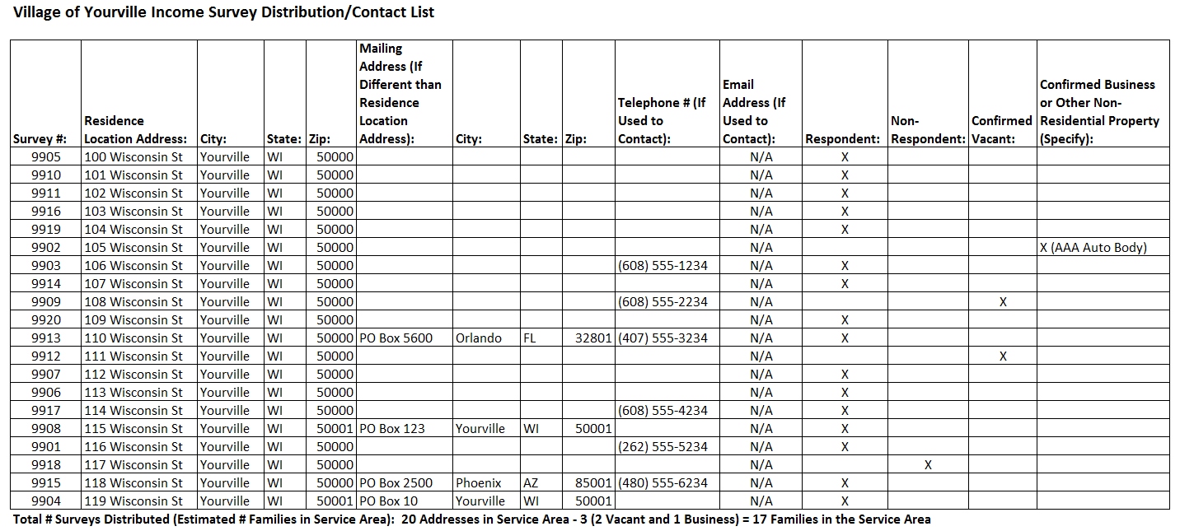

*This example is representative of survey distribution efforts made through surveying via mail, door-to-door, and telephone. If the survey distribution method is another form, the contact information used for the alternative method must be on record (e.g., email address used for email surveying methods).

Survey Response Income Data Tracking Example:

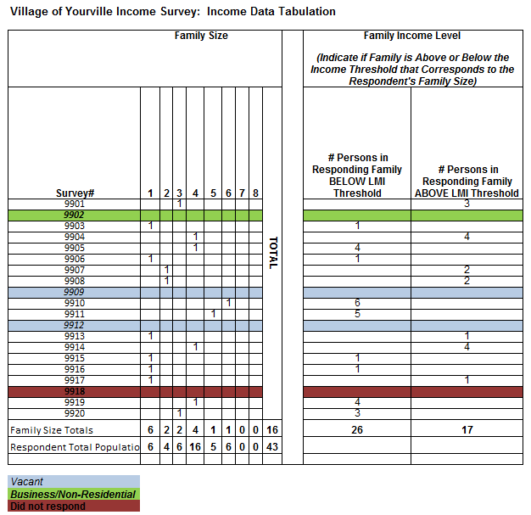

Survey Response Race/Ethnicity Data Tracking Example:

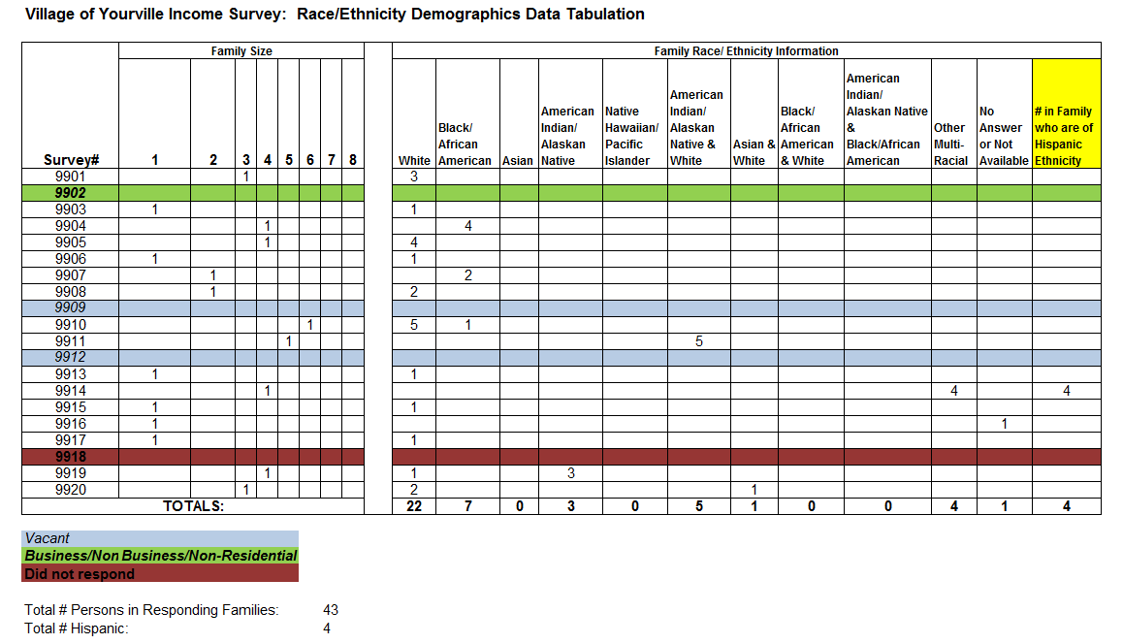

Survey Distribution Efforts Tracking Example:

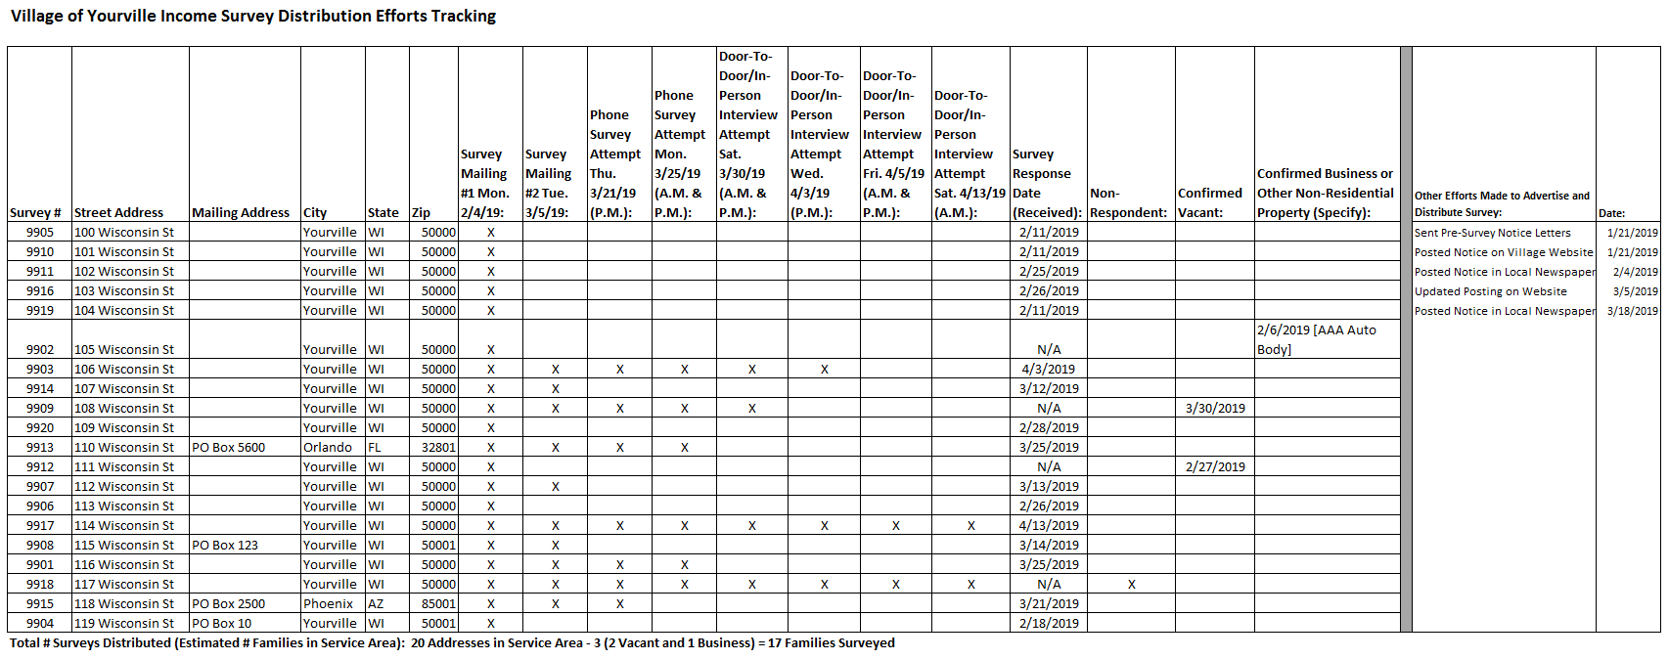

Appendix E

Service Area/Project Area Map Examples

Maps of the project area (i.e., the area in which the project activities/construction will occur) and service area (i.e., the area in which all primary beneficiaries reside; also known as the income survey area) must be submitted with the CDBG application. More than one map may be required to illustrate the project area, location and types of the project activities, location of the residential addresses included as primary beneficiaries (i.e., families included in the income survey), and identification of income survey respondents, non-respondents, and vacant and business/non-residential properties. Examples #1-#6 on the following pages illustrate the types of information to include on project area and service area (i.e., income survey area) maps.

[Note: Income survey responses may be recorded on the survey area map or a survey tracking list. For surveys involving a large number of residences, tracking responses on a survey area map may not be practical. Refer to Appendix D in this guide for income survey data tracking list examples.]

Map Example #1: Project Area/Survey Area Map with Response Type Tracking

Combination Map: Project Area Map with Project Activity Locations and Income Survey Map with Residential Address Locations and Response Type Tracking.

Mark respondents, non-respondents, and confirmed vacant and business/non-residential properties on the survey area map. Track the data from the responses (i.e., income and race/ethnicity data) on a separate tracking document. Refer to Appendix D in this guide for income survey data tracking list examples. Mark the types of work being completed in the service area on the project area map and/or the survey area map.]

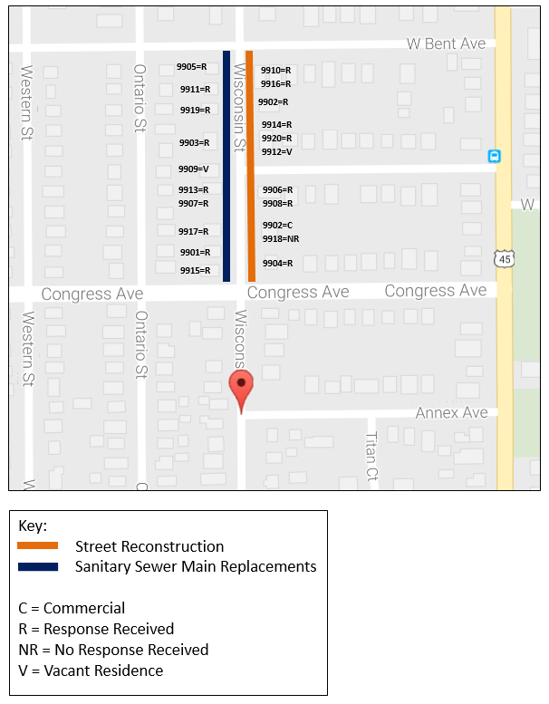

Map Example #2: Survey Area Map – Aerial View

Income Survey Map with Survey Area Boundaries Identified in Satellite View

If this map is submitted as the Income Survey Map, an additional document is required, that includes a listing of the street addresses of all residences in the Service Area/Survey Area and response tracking. Refer to Appendix D in this guide for income survey data tracking list examples.

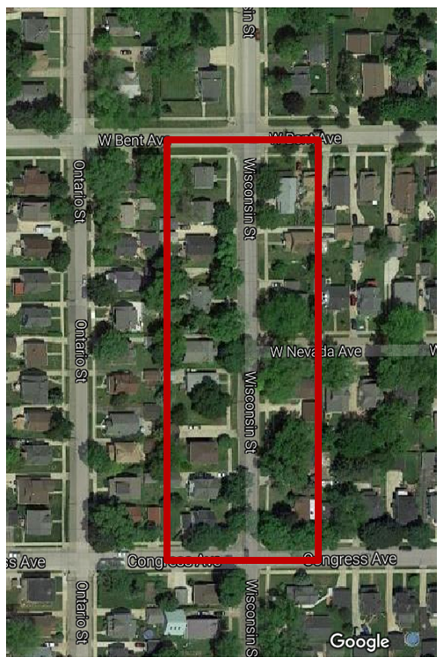

Map Examples: Project Area Maps – Utility Systems

Utility system maps are appropriate to submit with project area map documents for projects involving wastewater treatment facility, lift station, well, water main and/or sanitary sewer main upgrades to illustrate the system components, facility locations, water/sewer main sizes, main connections, etc., which may be necessary to view when determining primary beneficiary households (i.e., families to be surveyed). Wastewater treatment facility, lift station, and well projects are often deemed to have community-wide benefit unless multiple treatment facilities/lift stations/wells are serving the community residences. Various factors are considered such as main sizes, flow direction, looping and other system components when determining the primary beneficiaries of a water/sewer main improvement project.

One or more project maps illustrating utility components, similar to Examples #3-#6 on the following pages in this guide, are to be submitted with the applicant’s CDBG Application Attachments.

Map Examples #3: Project Area Map – Utility System

Project Area Map: Illustration of Utility System Showing System Components, Wastewater Treatment Facility and Lift Station Locations, and Sanitary Sewer Mains

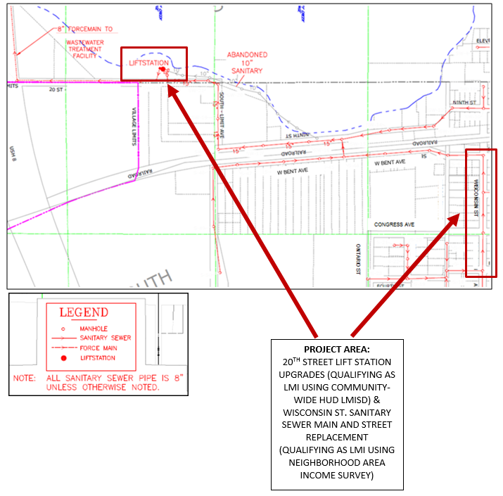

Map Example #4: Project Area Map – Water & Sanitary Sewer Systems

Project Area Map: Illustration of Water and Sanitary Sewer Mains/Services in Project Area

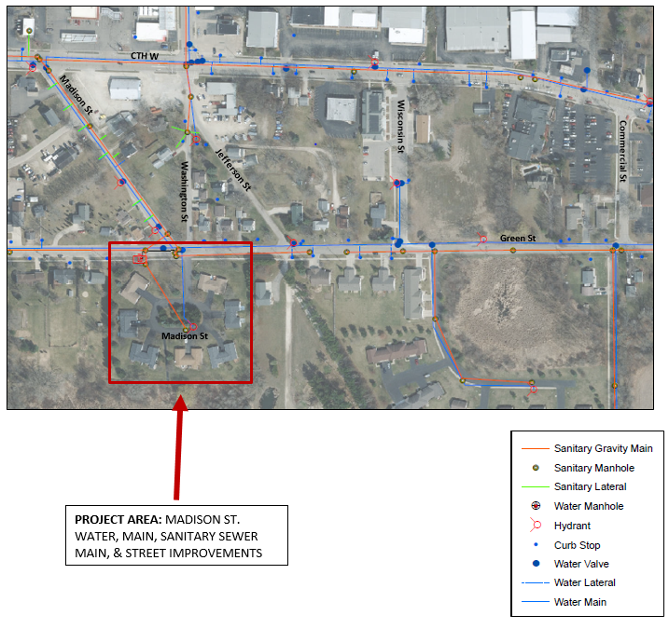

Map Example #5: Project Area Map – Water Distribution System

Project Area Map: Illustration of Water Distribution System in Project Area

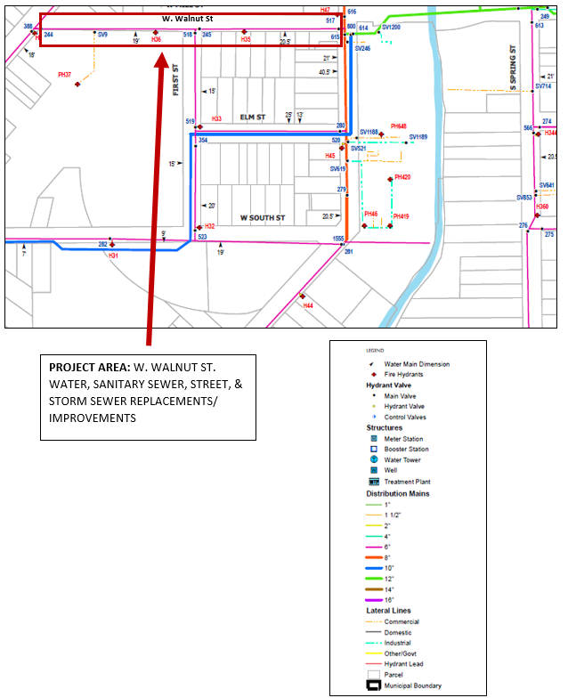
Map Example #6: Project Area Map – Sanitary Sewer Distribution System

Project Area Map: Illustration of Sanitary Sewer Distribution System in Project Area

