STATE OF WISCONSIN

COMMUNITY DEVELOPMENT BLOCK GRANT
COMMUNITY DEVELOPMENT PROGRAM

INCOME SURVEY GUIDE
REVISED 01/04/2019

Division of Energy, Housing and Community Resources
https://doa.wi.gov/Pages/LocalGovtsGrants/CommunityDevelopmentPrograms.aspx

CDBG COMMUNITY DEVELOPMENT PROGRAM

CONTACT INFORMATION

Mailing Address: Wisconsin Department of Administration
Division of Energy, Housing and Community Resources
Bureau of Community Development
101 E. Wilson St., 6th Floor
P.O. Box 7970
Madison, WI 53707-7970

Telephone: David Pawlisch, Director
Bureau of Community Development
(608) 261-7538

Email: DOACDBG@Wisconsin.gov

PLEASE NOTE:
The CDBG Community Development Program Income Survey Guide may be downloaded from the Bureau of Community Development section on the Division of Energy, Housing and Community Resources (DEHCR) website at https://doa.wi.gov/Pages/LocalGovtsGrants/CommunityDevelopmentPrograms.aspx. Please download the electronic document prior to conducting your survey to ensure that you are referencing the most up-to-date version of the guide.

Table of Contents
Reasons for Conducting an Income Survey 3
Guidelines and Resources 3
Determining the Service Area/Survey Area 4
Families in Service Area 5
Survey Types 6
Census Survey 6
Random Sample Survey 8
Survey Response Rate Determination Exceptions and Adjustments 9
Survey Content 9
Income Limits/LMI Levels 10
Survey Publicity and Distribution 10
Tabulating Survey Results 11
Income Survey Area Mapping 12
Income Survey Recordkeeping and Document Submissions 13
Documents to Submit with the CDBG Application 13
Additional Documents to Maintain in the Income Survey File 14
References 15
Appendix A 17
Income Survey Template 17
Appendix B 18
Income Survey Announcement Letter Template 18
Appendix C 19
Income Survey Results Tabulation Forms and Examples 19
Census Survey: Income Survey Results Income Tabulation Form – EXAMPLE 20
Census Survey: Income Survey Results Income Tabulation Form 21
Random Sample Survey: Income Survey Results Income Tabulation Form – EXAMPLE 22
Random Sample Survey: Income Survey Results Income Tabulation Form 23
Income Survey Results Race/Ethnicity Tabulation Form – EXAMPLE 24
Income Survey Results Race/Ethnicity Tabulation Form 25
Appendix D 26
Income Survey Tracking List Examples (Data to Maintain) 26
Appendix E 30
Service Area Map Examples 30

CDBG INCOME SURVEY GUIDE

Conducting an income survey for a Community Development Block Grant (CDBG) application may be necessary in order to determine the number and percentage of Low-to-Moderate Income (LMI) individuals living in the geographic area that will benefit from the project (i.e., the Service Area). A survey is needed when local government or census tract LMI Summary Data (LMISD) published by the U.S. Department of Housing and Urban Development (HUD) is unavailable or insufficient. The purpose of this guide is to provide the necessary information for conducting an income survey in the service area of a potential CDBG project, to ensure the survey activity meets CDBG Community Development Program standards and requirements.

Reasons for Conducting an Income Survey

Two key reasons for conducting an income survey are:
      - To provide data that the applicant believes is more accurate than the HUD LMISD. The LMISD is based on data drawn from the U.S. Census American Community Survey (ACS) 5-Year Estimates. HUD LMISD data sets are available at https://www.hudexchange.info/manage-a-program/acs-low-mod-summary-data. Refer to the “Data Sets” section for local government and block group data. If the LMISD shows the population is near 51.0% LMI or if local social and/or economic factors have changed significantly in recent years, and the unit of general local government (UGLG) believes that the service area is at or above the 51.0% LMI threshold, it may be worthwhile to conduct an income survey.
  - To obtain LMI data that is unavailable for the service area of the potential CDBG project. If the service area is not coterminous with the census block(s)/tract(s) or represents only a portion of the UGLG or census block(s)/tract(s) boundaries, the HUD LMISD is not available/usable for the area. A survey is required to calculate the percentage of LMI persons among the beneficiaries in the service area. If the service area includes an area that is coterminous with the census block(s)/tract(s) (for which HUD LMISD is available/usable), but also includes an area that is not coterminous with the census block(s)/tract(s) (and therefore HUD LMISD is not available/usable for this area), the area that is not coterminous with the census block(s)/tract(s) must be surveyed. The HUD LMISD for the coterminous area and the survey data for the non-coterminous area are compiled to calculate the LMI percentage for the full service area.

Guidelines and Resources
For data from an income survey to be accepted by the Division of Energy, Housing and Community Resources (DEHCR) for calculating the LMI percentage for the service area, the following criteria must be met:
- the survey was initiated (first distributed) on or after July 1, 2014 (after the HUD LMISD began being based on American Community Survey 5-Year Estimates data);
[Note: The date by which a survey must be initiated is subject to change as HUD data and HUD income survey guidance/requirements are updated each year. Consult with DEHCR to check for updates regarding this requirement.]
- the HUD income limits in effect at the time the survey was initiated were the income thresholds used/listed on the survey form;
- no significant demographic, economic, and non-economic changes in the service area occurred since the survey was conducted;
- the survey distribution and collection process (from start to finish) was held within a reasonable period of time that is deemed acceptable by DEHCR as methodologically sound;
- the survey data calculations are accepted as valid and methodologically sound;
- the survey data are submitted for the CDBG application on the most current versions of the Income Survey Results Income Tabulation Form and Income Survey Results Race/Ethnicity Tabulation Form provided in the current Income Survey Guide, with the LMI percentage calculated according to the specifications in the most current Income Survey Results Income Tabulation Form; and
- all requirements set forth in the most current Income Survey Guide that are deemed necessary by DEHCR to verify the survey is valid and methodologically sound are met.

When conducting an income survey, important considerations with regard to the service area, survey types, LMI levels, survey content, survey publicity, and results data calculation must be made, as described in the sections that follow.

Determining the Service Area/Survey Area

To determine the service area, which will be the survey area, the impact of the project and the benefits to residents must be considered. Service areas/survey areas must be determined on a case-by-case basis with several considerations factored into the determination. Consultation with DEHCR staff is strongly recommended prior to making a determination of the service area/survey area.

Common considerations for determining if the project will have community-wide benefit (and therefore the service area/survey area encompasses the entire community) include:
- Does the project have a community-wide focus (e.g., creating a Comprehensive Plan, Economic Development Plan or Downtown Revitalization Plan; completing downtown business district infrastructure improvements; improving a wastewater treatment facility that serves the entire community; etc.)?
- Is any area of the downtown/central location of the municipality, where goods/services generally utilized by all community residents as a whole are provided, impacted by the improvements being made? If so, to what extent?
- Is a local government building, school, main hospital/medical facility, library, central community center, central park, or other similar facility generally utilized by all community residents as a whole either the focus of the proposed CDBG project or located in the area being improved as part of the proposed CDBG project? If so, to what extent will users benefit from the improvements?
- Is the facility/are the facilities that are being built or improved for the proposed CDBG project of primary service/benefit to the entire community or only portions/sections of the community?

The extent of the impact and benefit to all residents in the community are considered when making a determination as to whether the proposed CDBG project is considered to have community-wide benefit.

Common considerations for determining which residences/families will be primary beneficiaries of a project when the project is deemed to not have community-wide benefit (e.g., neighborhood-specific street, utility, sidewalk, park or other facility improvements that benefit only residents in the immediate area in which the work will be performed/improvements will be made [i.e., the project area]) include:
- Who are the users or customers of the facilities (e.g., utility customers, residences located in a fire district, residences in the immediate area of the neighborhood-specific facility, etc.)?
- How will the improvements impact the residences in the project area?
- Which residences and/or driveways are located on the street(s) being improved?
- Which families/residences use the street(s) being improved as a primary route to/from their homes, and to what extent?
- Which residences are connected to the utility services or other infrastructure being improved?
- Will the street and/or utility service and/or other infrastructure improvements have a benefit to any residence that is not located on the section(s) of the street(s) being improved and/or is not directly connected to the utility service(s) or other infrastructure being improved? If so, to what extent?

The extent of the impact and benefit to the residents living in or near the project area are considered when making a determination whether the proposed CDBG project is considered to have primary or secondary benefit to those area residents.

Families in Service Area

The U.S. Department of Housing and Urban Development (HUD) requires a measure of families and population (all individual residents) in the service area in order to meet the LMI National Objective.
- “Family” includes all definitions listed in 24 CFR 5.403. The family may include but is not limited to the following, regardless of actual or perceived sexual orientation, gender identity, or marital status:
- A single person who may be defined, in 24 CFR 5.403, as an elderly person, displaced person, disabled person, near-elderly person, or any other single person; or
- A group of persons residing together, and such group includes but is not limited to:
- A family with or without children (a child who is temporarily away from the home because of placement in foster care is considered a member of the family); or
- Person(s) living in a household for which the relationship is defined, in 24 CFR 5.403, as an elderly family; a near-elderly family; a disabled family; a displaced family; and, the remaining member of a tenant family.
- “Household” means all persons who occupy a housing unit. A household may consist of persons living together or any other group of related or unrelated persons who share living arrangements, regardless of actual or perceived sexual orientation, gender identity, or marital status (pursuant 24 CFR 570.3).
- Persons occupying the same household without a familial relationship are to be counted as separate families.
- The HUD measure requires surveying families that will benefit from the proposed activity.
- The number of LMI individuals is extracted from the family data gathered through the survey. The number of LMI individuals in the families that respond to the survey is used to determine the LMI percentage in the service area. The percentage must be at least 51.0% or greater to meet the LMI National Objective.

After the service area is defined, the number of families living in the service area must be determined or estimated to determine the number of surveys to be conducted or distributed. If the exact number of families in the service area is not known, methods must be incorporated to obtain or estimate the number of families. Estimating the total population (the number of persons living in the service area) may also be necessary when tabulating the survey results. The method of determining the number of families and the total population in the service area will depend upon the data available.
- An initial estimate of the number of families living in the service area may be based on the number of households in the service area. Resources for determining or estimating the number of households in the area include U.S. Census data (use the most recent U.S. Census American Community Survey 5-Year Estimates number of occupied households data); area maps of residential neighborhoods; other records such as utility service customer lists, tax rolls, and telephone directories; or going door-to-door. Each of these methods for determining the number of families in an area has some limitations associated with it (e.g., census data only allows for estimations and is limited to a past point in time; area maps do not show how many families are living in each residence; telephone directories exclude people without phones or who exclusively use cell phones; tax rolls identify property owners, but not residents). The characteristics of the service area need to be considered when choosing a resource. Using multiple sources for estimating the number of families in the service area is recommended and may be necessary.
- While a list of households can be used to compile an estimate of families in the service area for the purpose of determining overall survey numbers and sample size, the survey itself needs to be addressed to families. Each family in each household should complete a survey.
- Part-time/seasonal residents do not need to be ‘counted’ as beneficiaries and be included in the income survey if the proposed project is deemed by DEHCR to have “incidental” benefit to the part-time/seasonal residents. If the part-time seasonal residents are deemed to have more than incidental benefit, they must be surveyed. Refer to HUD CPD Notice 14-013 at https://www.hudexchange.info/resources/documents/Notice-CPD-14-013-Guidelines-for-Conducting-Income-Surveys-LMI-CDBG-Activity.pdf for additional guidance.
If the part-time/seasonal residents are included in the survey, the survey should be distributed to both their local part-time/seasonal residence and their permanent residence to help ensure the survey is received. Applicants are strongly encouraged to seek approval from DEHCR regarding determinations for part-time/seasonal residents prior to proceeding with a survey.
- Demonstrate in the survey methodology a concerted effort to identify the actual number of families in the service area.

Survey Types

Census Survey

A census survey includes the entire population that will benefit from the proposed activity (i.e., 100% of the families in the service area). This method is required for service areas with 200 or fewer families/households. Census surveying is allowed for all sizes of service areas, regardless of the number of families included, however, and may be necessary for service areas with more than 200 families if the community seeks to have family income data for families living on specific streets or blocks or in particular neighborhoods within its borders.
- Efforts to distribute the survey to all families/households in the service area and the method(s) used (e.g., door-to-door interviews, telephone calls, survey mailing, web-based distribution, etc.) must be documented, including details of the data collection/survey distribution methods and follow-up efforts. The date(s) and method(s) of initial distribution; and date(s), day(s) of the week, approximate time(s) of the day and method(s) of follow-up to attempt to obtain additional responses must be recorded. The contact information for the method used to distribute the survey must also be kept on file (e.g., telephone numbers for survey calling, mailing addresses for mailed surveys, email addresses for emailed surveys). The street addresses for all families in the survey area must be on record so that their residential locations can be verified as being within the service area. Maintain all records of survey distribution and the results of follow-up survey solicitation attempts, including denoting which families were contacted and their responses (whether they responded, refused to respond, were not available/not home, etc.). Refer to the “Survey Distribution Efforts Tracking” example in Appendix D in this Guide for the types of information to maintain.
- The LMI percentage for a census survey is determined by calculating the number of individuals in the LMI families that responded to the survey, and dividing that number by the total population in the service area.
- Generally, a response rate of 80% or better (i.e., with 80% or more of the families in the service area responding to the survey) is acceptable for census surveys in service areas with 100 families/households or more. Service areas with a smaller number of families/households may require a higher response rate to achieve reasonably reliable and valid results. Determine the minimum number of responses needed for census surveys in service area with fewer than 100 families using the Sample Size Calculator by Creative Research Systems (CRS) [available online at: http://www.surveysystem.com/sscalc.htm].
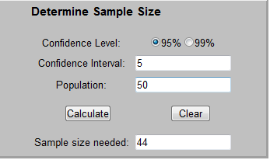
- For the results to be accepted as reasonably reliable and valid, a minimum confidence level of 95% and a minimum confidence interval of 5 must be applied when determining the minimum response rate using the Sample Size Calculator. Refer to Figure 1 to view Example #1 for using the CRS Sample Size Calculator. The example depicts determining the minimum number of responses needed for a census survey in a service area with 50 families/households. The user enters the Confidence Level, Confidence Interval, and Population, and then selects “Calculate.” The minimum number of survey responses needed, 44, appears in the “Sample Size needed” box.
Figure 1: Sample Size Calculator Example #1 – Census Survey (Only use for Census Survey when Population is Less Than 100 Families/Households)

The Sample Size Calculator cannot be used for determining the number of survey responses needed for census surveys in service areas with more than 100 families.

Random Sample Survey

A random sample survey uses a subset of the population chosen on a random basis to make assumptions about the whole population. This method is allowed, although not required, for service areas with more than 200 families.
- Determine the minimum number of responses needed for a Random Sample Survey for a specific size of population (using the number of families or households as the population) using the Sample Size Calculator by Creative Research Systems (CRS) [available online at: http://www.surveysystem.com/sscalc.htm]. For the results to be accepted as reasonably reliable and valid, the community must apply a minimum confidence level of 95% and a minimum confidence interval of 5 when calculating the sample size required using the Sample Size Calculator.
- Oversampling (i.e., surveying more than the minimum number required for reliable and valid results) is allowed by up to 20%.
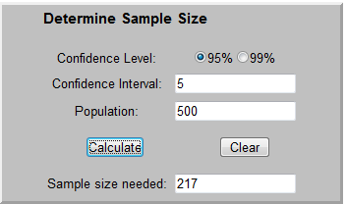
Refer to Figure 2 to view Example #2 using the Sample Size Calculator to determine the minimum sample size (responses needed) for a Random Sample Survey in a service area of 500 families. A minimum sample size of 217 (the minimum number of survey responses needed) is required for a confidence level of 95% and a confidence interval of 5. The maximum sample size allowed for this scenario is 260 surveys distributed/conducted:
Calculations for Example #2 (Figure 2):
Figure 2: Sample Size Calculator Example #2 – Random Sample Survey
217 x 20% = 43.4. Always round this number down to stay within 20% = 43.
43+217 = 260 surveys.
- The sample must be randomly selected. To randomly select the sample, numbers must be assigned to the entire population in the service area. Use an appropriate random number assignment methodology. DEHCR recommends using a random number table or using a random number generator such as www.randomizer.org.
- Demonstrate a concerted effort to obtain responses from the original randomly selected families/households for the survey.
- In the event of a non-response from one of these families/households, a method for follow-up, including how many times to follow-up with a family/household and how they will be reached for follow-up (mail, phone, etc.), needs to be documented. It is most accurate and random to obtain surveys from the original families/households chosen through random selection (in Example #2, the first 217).
- The families/households may be replaced by families/households in the oversample if the follow-up procedures are unsuccessful. Distributing/conducting the survey using the oversample families/households only after determining they are needed as replacements is recommended. In Example #2, the oversample would be families/households 218-260. The first family that is a non-respondent among families/households 1-217 would be replaced by the 218th family/household, the second non-respondent family/household would be replaced by the 219th family/household, etc.
- Distributing/conducting all surveys at once and only using the oversample surveys returned/completed as needed for replacements is acceptable. Maintain specific documentation of the surveys distributed/conducted, the responses, the follow-up attempts, the replacement families/households used, and where they fell on the random selection list.
- Refer to HUD Notice CPD 05-06 for further guidance on ensuring the reliability and validity of a random sample income survey:
https://www.hudexchange.info/resource/2195/notice-cpd-05-06-survey-methodology-lmi-cdbg-funded-activity/

Survey Response Rate Determination Exceptions and Adjustments
- If the community does not achieve the minimum response rate required, as specified by the Sample Size Calculator (for census surveys of less than 100 families, or for all Random Sample Surveys) or by the 80% calculation (for census surveys of 100 or more families), then it must contact DEHCR for consideration of approval of the lower response rate. The community must request and receive approval from DEHCR for a lower response rate prior to submission of the CDBG Application for the results to be accepted. A lower response rate may be considered if DEHCR is able to verify that the survey methodology and results are reasonably reliable and valid, the geographic location(s) in which the families that responded to the survey reside adequately represent(s) the service area population as a whole, and the actions taken to distribute and collect responses for the survey adequately demonstrate “best efforts” for attempting to achieve the required response rate. The margin of error of the results in relation to the LMI percentage rate calculated may be a consideration in reviewing the validity and reliability of the survey response data. Lack of planning (e.g., not allowing adequate time to distribute surveys and collect responses) is not an acceptable justification for an exception to the required minimum response rate. Contact DEHCR to verify acceptance of survey results prior to applying for CDBG funds.
- Be aware that adjustment to the minimum number of surveys needed may be necessary if the number of families in a service area is initially estimated by using the estimated number of households in the service area. If a household has more than one family within it, then the number of additional families within the household should be added to the total number of families in the service area calculation. A new calculation must be made to determine the minimum response rate for the adjusted number of families in the service area.

Survey Content

The survey content required for Wisconsin CDBG Community Development project grants is presented in Appendix A.
- At a minimum, the survey must include the questions about family size, total family income, and race/ethnicity.
- Avoid language that refers to the CDBG program, or ‘low-income’ or ‘low-to-moderate income’ based requirements in the survey instrument, cover sheet, cover letter, or publicity about the survey.
- A listing of survey respondents and non-respondents must be maintained with survey records. Apply a survey code system to allow for tracking the respondents while maintaining confidentiality. Applying a random numeric or alpha-numeric code to each survey form, which cannot be easily decoded by someone viewing the surveys, is recommended. Avoid using a code that can easily be tied to the alphabetical order sequence of the family name or numerical order sequence of the street address number (i.e., avoid assigning the survey code #1 to the lowest street address number, #2 to the second lowest street address number, #3 to the third lowest street address number, etc.). Do not collect street address information on the survey form.

Income Limits/LMI Levels

To collect income data from survey respondents, the HUD Section 8 income limits for the particular county must be added in the income table on the survey form. These change each year and are specific to each county. If the service area covers more than one county, a survey instrument for each county listing the appropriate income levels must be used. Each family included in the survey is to receive a survey form with the income table for the county in which the family lives.

Access the limits for counties in Wisconsin on the HUD website by following these seven steps:
  - Go to http://www.huduser.org/portal/datasets/il.html
  - Locate and select the current or most recent year that appears
  - Select the "Click Here for FY <most recent publication year> IL Documentation" icon
  - On next page: Under “First select a state” select "Wisconsin - WI;" then select the county in which the service area resides
  - Click the "View County Calculations" icon when it appears as the county is selected.
  - The income summary appears for the County/Area. The "Low (80%) Income Limits" are the threshold limits for low-to-moderate income (LMI) to include in the income table on the Income Survey form.

Income earned by all adult family members residing at the address (including any related, dependent persons over 65 or working dependent children over age 18) must be counted in the annual family income determination. An individual’s Adjusted Gross Income (AGI), as defined for purposes of reporting under Internal Revenue Service (IRS) Tax Form 1040 for individual Federal annual income tax purposes, from the most recent tax year, is used for income reporting. The income may be self-reported by the family and the collection of income documentation is not required.

Survey Publicity and Distribution

The survey may be conducted through mail, telephone, in-person door-to-door interviews, and/or web-based methods. Each type of survey distribution has limitations, which should be corrected by using more than one method of distribution (e.g., distribute the survey using web-based and/or mail services; then follow up with telephone and/or door-to-door interviews). Maintain records of all methods and family contact information used to distribute/administer the survey.

Publicizing when the survey will be conducted, how it will be conducted, and why it will be conducted can significantly increase the response rate. Providing information regarding the reason for conducting the survey also can make people less hesitant about answering questions regarding personal income information. Be aware of the following guidelines for publicizing the survey initiative:
- Stating the survey is being conducted to apply for CDBG funds or to find out how many low-to-moderate income (LMI) persons are in the area is not allowed.
- Providing some general information is acceptable, such as indicating that a current estimate of incomes in the service area is necessary in order to apply for grant funds.
- Avoid creating any bias in the survey results by including information that could lead respondents to answer the survey questions in a particular way.
- An example of an introductory letter that may be sent prior to conducting a survey is provided in Appendix B. It may be adapted to fit the needs of the survey plan (for mailing, telephone calls, door-to-door interviews, etc.), and may be adapted to be sent in the same mailing with the survey.

Tabulating Survey Results

- Tabulation forms are provided in Appendix C for both a Census Survey and a Random Sample Survey. Select the appropriate worksheet based on the type of survey conducted.
- Determine the percentage of LMI individuals/persons in the service area through calculations using the family survey data and the appropriate tabulation form.
- The service area population (number of persons living in the service area) must be determined. The population may be determined or estimated using the survey data; the most recent U.S. Census American Community Survey 5-Year Estimates data (community-specific ACS data may be searched at http://factfinder.census.gov/); or populations listed in the HUD LMISD for census blocks. Refer to the instructions on the survey tabulation form for guidance on which method should be used. HUD LMI estimates may be updated annually. Contact the Bureau of Community Development to be sure the most up-to-date data set is used. HUD LMISD data sets are available at https://www.hudexchange.info/manage-a-program/acs-low-mod-summary-data. Refer to the “Data Sets” section for block group data.
- If the service area is not community-wide and not coterminous with the census block(s)/tract(s), calculating an estimate of the total population using the survey data and appropriate tabulation form is required.
- Using a Census Survey, the LMI percentage is calculated using the total number of persons in the service area, and not just the number of persons in the responding families. Using a Random Sample Survey, the LMI percentage is calculated based on the number of persons included in the random sample (surveyed/responding families).
- When using an automated sample size generator, with a standard of a 95% confidence level and an interval of 5, the minimum sample size required is generated along with the projected margin of error (the “Sample Size Calculator” and similar tools may be used for all Random Sample Surveys, or Census Surveys with populations of 100 or fewer). If the survey results show an LMI percentage in the range of 51.0%-56.0%, further analyses may be required by DEHCR, depending on the population size, considering the +/-5% margin of error. Additional analyses will detect normal distributions and may further establish the validity and reliability of the results. Further calculation activities that may be required (for a Census Survey or Random Sample Survey) include:
  - Review the family size data from the individual surveys to check for outliers that caused large variances that may have compromised reliability and validity of the average family size calculations. This is particularly relevant when there are notable differences in average family size for the LMI families and non-LMI families. Corrections for these variances may be required, and may inform the decision on which methodology is appropriate for estimating the population of the service area.
  - Complete additional data review and manipulation as detailed in the HUD Notice CPD-14-013. Refer to the Analysis section on page 23 in the Notice, for more information. Notice CPD-14-013 is available at: https://www.hudexchange.info/resources/documents/Notice-CPD-14-013-Guidelines-for-Conducting-Income-Surveys-LMI-CDBG-Activity.pdf
  - Include with the application an explanation of additional verification efforts made to verify such results if the LMI percentage is a borderline value. Maintain copies of the raw data and calculations for DEHCR’s review upon request.
- Document results carefully. Maintain all completed surveys, a list of the families/households that were surveyed with the physical/street addresses as well as mailing addresses, tracking information for responses, raw data used for calculations, and for randomized sample surveys, documentation of the random selection process. Refer to Appendix D in this guide for examples of data tracking spreadsheet content that must be maintained in the income survey file.

Income Survey Area Mapping

Maps of the project area and the income survey area (i.e., service area) must be submitted with the CDBG application. More than one map may be required to illustrate the boundaries of the project area, location of the project activities, boundaries of the survey area, location of the residential addresses included in the income survey, and identification of responding and non-responding family residences, vacant residences, and business/non-residential properties.* Refer to Appendix E in this Guide for service area map examples.

*Survey responses may be recorded on the income survey area map or a survey tracking list. For surveys involving a large number of residences, tracking responses on the survey area map may not be practical. Refer to Appendix D in this Guide for income survey data tracking list examples.

Income Survey Recordkeeping and Document Submissions

Documents to Submit with the CDBG Application

The following income survey documents must be submitted with the CDBG Application:

- Map of Project Area with project location, type of work being completed on each street (if applicable), and Service Area/beneficiary area boundaries marked (project area map examples provided in Appendix E)
- Map of Income Survey Area/Service Area with survey area boundaries marked; residences surveyed marked; and responding, non-responding and vacant residences and business/non-residential properties marked or provided on a separate sheet (response tracking list examples provided in Appendix D; survey/service area map examples provided in Appendix E)
- LMI Calculation Worksheet for Beneficiaries Residing in Multiple Census Blocks or Multiple Local Municipalities (Applicable if calculating LMI percentage by using a combination of HUD LMI Summary Data [LMISD] for multiple census blocks/tracts and/or local governments and income survey data for additional areas not coterminous with the census blocks/tracts and/or local government boundaries; contact DEHCR for guidance)
- Map of Census Block(s)/Tract(s) (Applicable if service area is conterminous with census block(s)/tract(s), which were used to establish survey area boundaries; contact DEHCR for guidance)
- Income Survey Form used to conduct the survey (survey template is provided in Appendix A)
- Income Survey Letter and/or other related correspondence sent to residents regarding the survey distribution and collection process, if applicable (survey announcement letter template is provided in Appendix B)
- Income Survey Results Income Tabulation form (Census Survey or Random Sample Survey Income Survey Results Income Tabulation form provided in Appendix C)
- Income Survey Results Race/Ethnicity Tabulation form (Income Survey Results Race/Ethnicity Tabulation form provided in Appendix C)
- List of all families/addresses to which the survey was distributed (including both street address and mailing address, if different than the street address, and any other contact information used to make contact with the family to administer the survey, such as phone numbers, email addresses, etc.) and assigned survey number (refer to “Survey Distribution/Response Type Tracking List” example in Appendix D) [The list of addresses/contact information and the response type for each (e.g., respondent, non-respondent, vacant, business/non-residential property) must be submitted to DEHCR with the Income Survey Map if the residence locations and response type are not provided on the Income Survey Map.]
- Tracking list with all addresses to which the survey was distributed with the street address, assigned survey number and response type (e.g., respondent, non-respondent, vacant, business/non-residential property; refer to the “Survey Distribution/Response Type Tracking List” example in Appendix D) Important Note: When marking responding, non-responding and vacant residences on the income survey map or providing the list of addresses on a separate sheet, do not include the responses regarding the family size, income levels and race/ethnicity with the residential street address or contact information. The specific responses for each residence should be recorded on a separate sheet with the associated survey number as the identifier, rather than the address/contact information identifiers, for greater confidentiality.
- Tracking list that shows the survey response data for each survey form received from responding families (refer to “Survey Response Income Data Tracking” example and “Survey Response Race/Ethnicity Data Tracking” example in Appendix D) Important Note: Associate each street address/family with a survey number and record personally identifiable information such as family size, income levels and race/ethnicity information by survey number rather than the street address or contact information. The list of survey numbers with the associated street addresses should be maintained on a separate list for greater confidentiality.
- Tracking list with all efforts made to achieve the highest response rate possible, including a listing of date(s) and method(s) of survey notice postings, survey advertisements and survey distribution; and records of follow-up attempts to obtain responses from non-respondents. Provide distribution and attempt/contact information for each address/family in the service area, with the date(s), method(s), and approximate time(s) of day of each attempt/contact (refer to the “Survey Distribution Efforts Tracking” example in Appendix D).

Additional Documents to Maintain in the Income Survey File

The following income survey documents must be maintained in the UGLG’s income survey file, available for review during the project or monitoring activities upon the UGLG receiving a CDBG award:

- Copies of all completed income surveys returned by responding families
- Copies of all income surveys and related correspondence returned as “undeliverable” due to residential vacancy or a move
- For Random Sample Surveys only: documentation of the random sample selection, including the methods used for assigning numbers to and randomizing the families in the total population (i.e., all families in the service area), the sample group, and oversample group; and methodology for use/survey distribution in the oversample group
- Copies of all correspondence with DEHCR regarding the review of the income survey documentation and methodology prior to submittal of the CDBG application

References

American Community Survey 5-Year 2006-2010 Low and Moderate Income Summary Data. (2018). Office of Policy Development and Research. Washington, DC: U.S. Department of Housing and Urban Development HUD Exchange.
https://www.hudexchange.info/programs/acs-low-mod-summary-data/ [RE: LMISD Overview]
https://www.hudexchange.info/programs/acs-low-mod-summary-data/acs-low-mod-summary-data-local-government/ [RE: Current HUD Local Government LMISD]
https://www.hudexchange.info/programs/acs-low-mod-summary-data/acs-low-mod-summary-data-block-groups-places/ [RE: Current HUD Census Tract/Block Group LMISD]

Basically CDBG for States. (2014, July). U.S. Department of Housing and Urban Development. Washington, DC: U.S. Department of Housing and Urban Development HUD Exchange. https://www.hudexchange.info/resource/269/basically-cdbg-for-states/

Income Limits. Office of Policy Development and Research. Washington, DC: U.S. Department of Housing and Urban Development.
https://www.huduser.gov/portal/datasets/il.html

Electronic Code of Federal Regulations – Title 24: Housing and Urban Development. Washington, D.C.: U.S. Government Publishing Office.
http://www.ecfr.gov/cgi-bin/text-idx?tpl=/ecfrbrowse/Title24/24tab_02.tpl
24 CFR 570.3 [RE: Definitions for family and income]
24 CFR 570.483(b)(1)(i) [RE: Survey requirements and determining service area]
24 CFR 570.490(a)(1) [RE: Recordkeeping – race, ethnic, and gender composition of beneficiaries]
24 CFR 5.403 [RE: Definitions of family]

Office of Community Planning and Development Notice CPD-05-06. (2005, July 26). U.S. Department of Housing and Urban Development. Washington, DC: U.S. Department of Housing and Urban Development.
https://apps.hud.gov/offices/adm/hudclips/notices/cpd/05cpdnotices.cfm

Office of Community Planning and Development Notice CPD-14-10. (2014, June 10). U.S. Department of Housing and Urban Development. Washington, DC: U.S. Department of Housing and Urban Development.
http://portal.hud.gov/hudportal/documents/huddoc?id=14-10cpdn.pdf

Office of Community Planning and Development Notice CPD-14-013. (2014, September 23). U.S. Department of Housing and Urban Development. Washington, DC: U.S. Department of Housing and Urban Development.
https://www.hudexchange.info/resources/documents/Notice-CPD-14-013-Guidelines-for-Conducting-Income-Surveys-LMI-CDBG-Activity.pdf

State CDBG Grant Administrator Training: Module 14. (2009, May). PowerPoint presentation for grant administrators created by U.S. Department of Housing and Urban Development. Washington, DC: U.S. Department of Housing and Urban Development. https://www.hudexchange.info/trainings/courses/state-cdbg-grant-administrators-training1/

Guide to National Objectives and Eligible Activities for State CDBG Program. (2014, December). U.S. Department of Housing and Urban Development. Washington, DC: U.S. Department of Housing and Urban Development.
https://www.hudexchange.info/resource/2179/guide-national-objectives-eligible-activities-state-cdbg-programs/

Trochim, W.M.K. (2001). The Research Methods Knowledge Base. (2nd ed.). Cincinnati, OH: Atomic
Dog Publishing.

Appendix A

Income Survey Template
<Survey Number>
Dear Community Resident:
The <Municipality> is conducting a survey of its citizens to obtain income information which will help us decide whether to apply for grant funds to make infrastructure improvements. If we do not receive adequate survey responses, we will not be eligible to apply for this assistance. Your participation in this survey is voluntary.
Please complete one survey per family in the household. If there is more than one family in the household, contact <Contact Name, Title, Department/Firm> at <Contact Phone Number> or <Contact Email> to request additional copies of the survey. Return this survey by <Due Date> by <Instructions for Returning Survey [e.g., Returning Survey Using a Postage Paid Envelope Provided, and/or Other Method(s)]>. Survey data will be collected and compiled by <Contracted Firm Name or “the” Municipality Employee Title and Municipality Name>. Survey results will be tabulated in summary form for <Municipality Type> officials. Individual responses will be kept confidential.
Sincerely,

<Chief Elected Official’s Signature>
<Chief Elected Official’s Name and Title> <Date>

[MUNICIPALITY NAME]
INCOME SURVEY

Is there more than one family living in this household? _____ Yes _____ No

FAMILY ANNUAL INCOME INFORMATION
Locate your family size in the left. Use an “X” to indicate if you are below or above the income level for your family size.
FAMILY SIZE | FAMILY ANNUAL INCOME LEVEL |  | BELOW |  | ABOVE
1 | $00,000 [add income limit]
2 | $00,000 [add income limit]
3 | $00,000 [add income limit]
4 | $00,000 [add income limit]
5 | $00,000 [add income limit]
6 | $00,000 [add income limit]
7 | $00,000 [add income limit]
8 or More | $00,000 [add income limit]
FAMILY RACE/ETHNICITY INFORMATION
Indicate the race/ethnicity information for each family member or select the “Prefer Not to Answer” option below.
 |  | Number in Family with Race/Ethnicity Shown on the Left: |  | Number in Family with Race/Ethnicity Shown on the Left Who are Hispanic:
White
Black/African American
Asian
American Indian/ Alaskan Native
Native Hawaiian/ Pacific Islander
Amer. Indian/ Alaskan Native & White
Asian & White
Black/African Amer. & White
Amer. Indian/ Alaskan Nat. & Black/ African Amer.
Other Multi-Racial
Prefer Not To Answer
<Survey Return Instructions (Repeated) and Due Date>

Appendix B

Income Survey Announcement Letter Template (Optional)

[Municipality Letterhead]

<Date>

<Resident Full Name>
<Resident Street Address>
<Resident City, State, Zip>

RE: Community Income Survey for Grant Application - <Optional: Add Project Focus, e.g., “Sanitary Sewer Main Upgrades and Street Reconstruction on Wisconsin Street”>
Resident of: <Resident Street Address (In Project Area), City, State, Zip>

Dear Resident:

The <Municipality> plans to apply for a grant to help fund <Project Focus, e.g., “sanitary sewer main upgrades and street reconstruction on Wisconsin Street.”> A grant can help reduce the burden of the costs at the local level for the project.

The grant application process includes an income survey of <Municipality> residents in the project area. Each family in the area in which we will be conducting the improvements is asked to complete a survey. The information gathered from the survey will help determine if the <Municipality Type, e.g., Town/Village/City/County> will apply for grant funds. The <Municipality> is required to obtain completed surveys from a high percentage of families, so your participation is very important.

You will soon receive the survey in the mail. Please complete your survey and mail it to the <Municipality Type> in the envelope provided by <Date>. If you have more than one family in your household, you may contact <Contact Name>, <Contact Title>, at <Contact Information (Mailing Address, Phone, and/or Email Address) >, to request additional copies of the survey.

The response to individual surveys will be strictly confidential. If you have any questions, please contact <Contact Name>, <Contact Title>, at <Contact Information (Mailing Address, Phone, and/or Email Address)>.

Thank you for your assistance with this important survey.

Sincerely,

<Add CEO Signature>

<Chief Elected Official Full Name>, <Title>
<Municipality>

Appendix C

Income Survey Results Tabulation Forms and Examples

(Pages 20-25)

Census Survey: Income Survey Results Income Tabulation Form – EXAMPLE

Municipality: Village of Yourville
Survey Start Date (date first survey was conducted/distributed): 02/04/2019
Survey Completion Date (date last survey was conducted/collected): 04/15/2019
- Number of families in the project service area.  All families in the service area must be given the opportunity to complete the survey for a Census Survey. Refer to the “Families in the Service Area” section in this Income Survey Guide for guidance on determining or estimating the number of families in a project service area. | 100
- Minimum number of families needed to respond for a valid survey  Refer to the “Census Survey” section in this Income Survey Guide to determine the minimum number of responses needed for a Census Survey. | 80
- Number of families that completed a survey (i.e., survey respondents) [calculate using survey responses] | 90
- Survey response rate [line 3 divided by line 1; then multiplied by 100; enter with two decimal places (e.g., 85.55%] | 90.00%
- Number of LMI families among survey respondents [calculate using survey responses] | 50
- Number of LMI persons among survey respondents (this number is also considered the total number of LMI persons living in the project service area) [calculate using survey responses] | 150
- Number of Non-LMI families among survey respondents [calculate using survey responses] | 40
- Number of Non-LMI persons among survey respondents [calculate using survey responses] | 80
- Number of all persons in all families among survey respondents [line 6 added to line 8] | 230
- Average family size among all survey respondents [line 9 divided by line 3; enter with two decimal places (e.g., 2.22)] | 2.56
- Number of non-responding families (families that did not respond to the survey) [line 3 subtracted from line 1] | 10
- Estimated number of persons in non-responding families [line 10 multiplied by line 11 rounded up to the nearest whole number] | 26
- Number of persons living in the project service area (i.e., project service area population)  If a 100% survey response rate was achieved, enter the number from line 9. If the survey response rate was less than 100%, the population is estimated. Refer to the “Tabulating Survey Results” section in this Income Survey Guide and the items below for guidance on estimating population. Use one of the methods below to estimate the population and check the box to indicate which method was used:  ☐ Option 1: Total population based on the most recent U.S. Census American Community Survey 5-Year Estimates data (allowed for service areas that are community-wide and contingent upon being approved by DEHCR as methodologically sound)  ☐ Option 2: Total population based on HUD LMISD census block data (allowed for service areas that are coterminous with census block(s))  ☐ Option 3: Calculated estimate by multiplying the average family size of survey respondents by the number of all families in the service area [line 1 multiplied by line 10] (appropriate when the service area is not community-wide and the U.S. Census household size data does not appear to be representative of the service area based on survey results (i.e., the survey respondents’ average family size is notably different than the average household size listed in the Census data for the community)  ☒ Option 4: Calculated estimate by adding the estimated number of persons in non-responding families to the number of persons in responding families [line 9 added to line 12] (appropriate when the response rate is well above the minimum required and only a small number of families did not respond)  ☐ Option 5: (OTHER - CONTACT DEHCR): An alternative method may be used if pre-approved by DEHCR prior to application. Contact DEHCR for guidance on other options for calculating population to adjust for the statistical impact of significant outliers and/or data anomalies. | 256
- LMI Percentage for project service area (percentage of LMI persons in the project service area) [line 6 divided by line 13; then multiplied by 100; enter with two decimal places (e.g., 55.55%)] | 58.59 %

Census Survey: Income Survey Results Income Tabulation Form

Municipality:
Survey Start Date (date first survey was conducted/distributed):
Survey Completion Date (date last survey was conducted/collected):
- Number of families in the project service area.
All families in the service area must be given the opportunity to complete the survey for a Census Survey. Refer to the “Families in the Service Area” section in this Income Survey Guide for guidance on determining or estimating the number of families in a project service area.
- Minimum number of families needed to respond for a valid survey
Refer to the “Census Survey” section in this Income Survey Guide to determine the minimum number of responses needed for a Census Survey.
- Number of families that completed a survey (i.e., survey respondents) [calculate using survey responses]
- Survey response rate [line 3 divided by line 1; then multiplied by 100; enter with two decimal places (e.g., 85.55%)] | %
- Number of LMI families among survey respondents [calculate using survey responses]
- Number of LMI persons among survey respondents (this number is also considered the total number of LMI persons living in the project service area) [calculate using survey responses]
- Number of Non-LMI families among survey respondents [calculate using survey responses]
- Number of Non-LMI persons among survey respondents [calculate using survey responses]
- Number of all persons in all families among survey respondents [line 6 added to line 8]
- Average family size among all survey respondents [line 9 divided by line 3; enter with two decimal places (e.g., 2.22)]
- Number of non-responding families (families that did not respond to the survey) [line 3 subtracted from line 1]
- Estimated number of persons in non-responding families [line 10 multiplied by line 11 rounded up to the nearest whole number]
- Number of persons living in the project service area (i.e., project service area population)
If a 100% survey response rate was achieved, enter the number from line 9. If the survey response rate was less than 100%, the population is estimated. Refer to the “Tabulating Survey Results” section in this Income Survey Guide and the items below for guidance on estimating population. Use one of the methods below to estimate the population and check the box to indicate which method was used:
☐ Option 1: Total population based on the most recent U.S. Census American Community Survey 5-Year Estimates data (allowed for service areas that are community-wide and contingent upon being approved by DEHCR as methodologically sound)
☐ Option 2: Total population based on HUD LMISD census block data (allowed for service areas that are coterminous with census block(s))
☐ Option 3: Calculated estimate by multiplying the average family size of survey respondents by the number of all families in the service area [line 1 multiplied by line 10] (appropriate when the service area is not community-wide and the U.S. Census household size data does not appear to be representative of the service area based on survey results (i.e., the survey respondents’ average family size is notably different than the average household size listed in the Census data for the community)
☐ Option 4: Calculated estimate by adding the estimated number of persons in non-responding families to the number of persons in responding families [line 9 added to line 12] (appropriate when the response rate is well above the minimum required and only a small number of families did not respond)
☐ Option 5: (OTHER - CONTACT DEHCR): An alternative method may be used if pre-approved by DEHCR prior to application. Contact DEHCR for guidance on other options for calculating population to adjust for the statistical impact of significant outliers and/or data anomalies.
- LMI Percentage for project service area (percentage of LMI persons in the project service area) [line 6 divided by line 13; then multiplied by 100; enter with two decimal places (e.g., 55.55%)] | %

Random Sample Survey: Income Survey Results Income Tabulation Form – EXAMPLE

Municipality: Village of Yourville
Survey Start Date (date first survey was conducted/distributed): 02/04/2019
Survey Completion Date (date last survey was conducted/collected): 04/15/2019
- Number of families in the project service area  Refer to the “Families in the Service Area” section in this Income Survey Guide for guidance on determining the number of families in a project service area. | 1370
- Minimum number of responses needed (i.e., minimum sample size) for a valid survey  Refer to the “Random Sample Survey” section in this Income Survey Guide to determine the minimum sample size (i.e., number of responses needed). | 300
- Number of families included in the randomized sample survey (i.e., Number of surveys distributed/responses solicited)  Refer to the “Random Sample Survey” section in this Income Survey Guide to review the terms for oversampling for a randomized sample survey (line 3 cannot exceed: line 2 multiplied by 1.20). | 360
- Number of families that responded to the survey (i.e., actual sample size)  This number should be equal to or greater than line 2 to be an acceptable sample size. | 300
- Number of LMI families in sample/among respondents [calculate using survey responses] | 200
- Number of persons living in the LMI families in sample/among respondents [calculate using survey responses] | 500
- Average size of LMI families in sample/among respondents [line 6 divided by line 5; enter with two decimal places (e.g., 2.44)] | 2.50
- Number of Non-LMI families in sample/among respondents [calculate using survey responses] | 100
- Number of persons living in Non-LMI families in sample/among respondents [calculate using survey responses] | 280
- Average size of Non-LMI families in sample/among respondents [line 9 divided by line 8: enter with two decimal places (e.g., 2.22)] | 2.80
- Number of all persons in all families in sample/among respondents [line 6 added to line 9] | 780
- LMI ratio in sample/among respondents [line 6 divided by line 11; calculate to 4 decimal places (e.g., .5555)] | .6410
- Non-LMI ratio in sample/among respondents [line 9 divided by line 11; calculate to 4 decimal places (e.g., .4445)] | .3590
- Estimated LMI Percentage for project service area (percentage of LMI persons in the project service area) [line 12 multiplied by 100; enter with two decimal places (e.g., 55.55%)] | 64.10%
- Estimated number of persons living in the project service area (i.e., population)  Check the method used for determining the population among the options below:  ☐ Option 1: Total population based on the most recent U.S. Census American Community Survey 5-Year Estimates data (allowed for community-wide projects/service areas only and contingent upon being approved by DEHCR as methodologically sound)  ☐ Option 2: Total population based on HUD LMISD census block data (allowed for projects/service areas that are coterminous with census block(s) only; not allowed for estimate of community-wide population)  ☒ Option 3: Calculated estimate using survey data:  ☒ Method 1 (STANDARD): The total of: (line 1 multiplied by line 12, then multiplied by line 7) added to the total of: (line 1 multiplied by line 13, then multiplied by line 10); then rounded up to nearest whole number.  ☐ Method 2 (May be used to reduce the statistical impact of outliers): Determine average family size for all survey respondents (line 11 divided by line 4); then multiply line 1 by the average family size number; then round up to nearest whole number.  ☐ Method 3 (OTHER - CONTACT DEHCR): An alternative method may be used if pre-approved by DEHCR prior to application. Contact DEHCR for guidance on other options for calculating population to adjust for the statistical impact of significant outliers and/or data anomalies. | 3573
- Estimated total number of LMI persons in the project service area  [line 12 multiplied by line 15; then rounded to the nearest whole number] | 2,291

Random Sample Survey: Income Survey Results Income Tabulation Form

Municipality:
Survey Start Date (date first survey was conducted/distributed):
Survey Completion Date (date last survey was conducted/collected):
- Number of families in the project service area
Refer to the “Families in the Service Area” section in this Income Survey Guide for guidance on determining the number of families in a project service area.
- Minimum number of responses needed (i.e., minimum sample size) for a valid survey
Refer to the “Random Sample Survey” section in this Income Survey Guide to determine the minimum sample size (i.e., number of responses needed).
- Number of families included in the randomized sample survey (i.e., Number of surveys distributed/responses solicited)
Refer to the “Random Sample Survey” section in this Income Survey Guide to review the terms for oversampling for a randomized sample survey (line 3 cannot exceed: line 2 multiplied by 1.20).
- Number of families that responded to the survey (i.e., actual sample size)
This number should be equal to or greater than line 2 to be an acceptable sample size.
- Number of LMI families in sample/among respondents [calculate using survey responses]
- Number of persons living in the LMI families in sample/among respondents [calculate using survey responses]
- Average size of LMI families in sample/among respondents [line 6 divided by line 5; enter with two decimal places (e.g., 2.44)]
- Number of Non-LMI families in sample/among respondents [calculate using survey responses]
- Number of persons living in Non-LMI families in sample/among respondents [calculate using survey responses]
- Average size of Non-LMI families in sample/among respondents [line 9 divided by line 8; enter with two decimal places (e.g., 2.22)]
- Number of all persons in all families in sample/among respondents [line 6 added to line 9]
- LMI ratio in sample/among respondents [line 6 divided by line 11; calculate to 4 decimal places (e.g., .5555)]
- Non-LMI ratio in sample/among respondents [line 9 divided by line 11; calculate to 4 decimal places (e.g., .4445]
- Estimated LMI Percentage for project service area (percentage of LMI persons in the project service area) [line 12 multiplied by 100; enter with two decimal places (e.g. 55.55%)] | %
- Estimated number of persons living in the project service area (i.e., population)
Check the method used for determining the population among the options below:
☐ Option 1: Total population based on the most recent U.S. Census American Community Survey 5-Year Estimates data (allowed for community-wide service areas only and contingent upon being approved by DEHCR as methodologically sound)
☐ Option 2: Total population based on HUD LMISD census block data (allowed for projects/service areas that are coterminous with census block(s) only; not allowed for estimate of community-wide population)
☐ Option 3: Calculated estimate using survey data:
☐ Method 1 (STANDARD): The total of: (line 1 multiplied by line 12, then multiplied by line 7) added to the total of: (line 1 multiplied by line 13, then multiplied by line 10); then rounded up to nearest whole number.
☐ Method 2 (May be used to reduce the statistical impact of outliers): Determine average family size for all survey respondents (line 11 divided by line 4); then multiply line 1 by the average family size number; then round up to nearest whole number.
☐ Method 3 (OTHER - CONTACT DEHCR): An alternative method may be used if pre-approved by DEHCR prior to application. Contact DEHCR for guidance on other options for calculating population to adjust for the statistical impact of significant outliers and/or data anomalies.
- Estimated total number of LMI persons in the project service area
[line 12 multiplied by line 15; then rounded to the nearest whole number]

Income Survey Results Race/Ethnicity Tabulation Form – EXAMPLE

Municipality: Village of Yourville
Survey Start Date (date first survey was conducted/distributed): 02/04/2019
Survey Completion Date (date last survey was conducted/collected): 04/15/2019_____

Example 1: Represents two families of 2, which totals 4 people, with 2 of the people being White who also identify as being Hispanic; and 2 of the people being Black/African American. Enter “2” in the row for “White” and “2” in the row for “Hispanic” under the row for “White”; and enter “2” in the row for “Black/African American” in the column for the family size of 2, as shown in the table below.

Example 2: Represents three families of 4, which totals 12 people, with 1 of the people being White non-Hispanic, 4 being Black/African American non-Hispanic, 3 being American Indian/Alaskan Native non-Hispanic, and 4 being Other Multi-Racial and Hispanic. Enter “1” in the row for “White”; enter “4” in the row for “Black/African American”; enter “3” in the row for “American American/Alaskan Native”; and enter “4” in the row for “Other Multi-Racial” and the row for “# Hispanic” directly below it in the column for the family size of 4, as shown in the table below.
Family Size:
Enter the # of persons in each category for each family size.
Race/Ethnicity Totals: | 1 | 2 | 3 | 4 | 5 | 6 | 7 | 8 or More
White |  | Example 1: 2 |  | Example 2: 1
# Hispanic |  | Example 1: 2
Black/African American |  | Example 1: 2 |  | Example 2: 4
# Hispanic
Asian
# Hispanic
American Indian/ Alaskan Native |  |  |  | Example 2: 3
# Hispanic
Native Hawaiian/ Pacific Islander
# Hispanic
Amer. Indian/ Alaskan Native & White
# Hispanic
Asian & White
# Hispanic
Black/African Amer. & White
# Hispanic
Amer. Indian/ Alaskan Nat. & Black/ African Amer.
# Hispanic
Other Multi-Racial |  |  |  | Example 2: 4
# Hispanic |  |  |  | Example 2: 4
No Answer

Income Survey Results Race/Ethnicity Tabulation Form

Municipality:
Survey Start Date (date first survey was conducted/distributed):
Survey Completion Date (date last survey was conducted/collected):

Family Size:
Enter the # of persons in each category for each family size.

Race/Ethnicity Totals: | 1 | 2 | 3 | 4 | 5 | 6 | 7 | 8 or More
White
# Hispanic
Black/African American
# Hispanic
Asian
# Hispanic
American Indian/ Alaskan Native
# Hispanic
Native Hawaiian/ Pacific Islander
# Hispanic
Amer. Indian/ Alaskan Native & White
# Hispanic
Asian & White
# Hispanic
Black/African Amer. & White
# Hispanic
Amer. Indian/ Alaskan Nat. & Black/ African Amer.
# Hispanic
Other Multi-Racial
# Hispanic
No Answer

Appendix D

Income Survey Tracking List Examples (Data to Maintain)

Survey Distribution/Response Type Tracking List Example*:

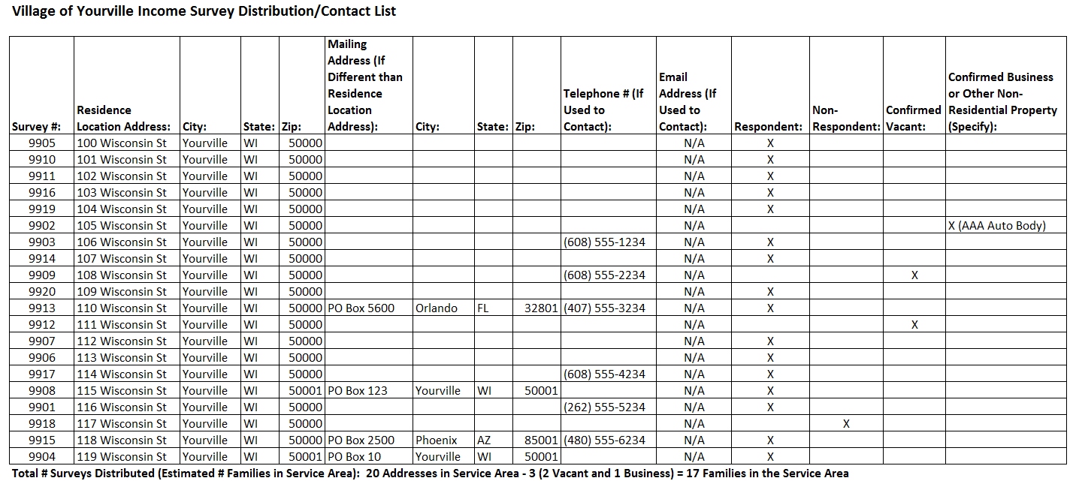

*This example is representative of survey distribution efforts made through surveying via mail, door-to-door, and telephone. If the survey distribution method is another form, the contact information used for the alternative method must be on record (e.g., email address used for email surveying methods).

Survey Response Income Data Tracking Example:

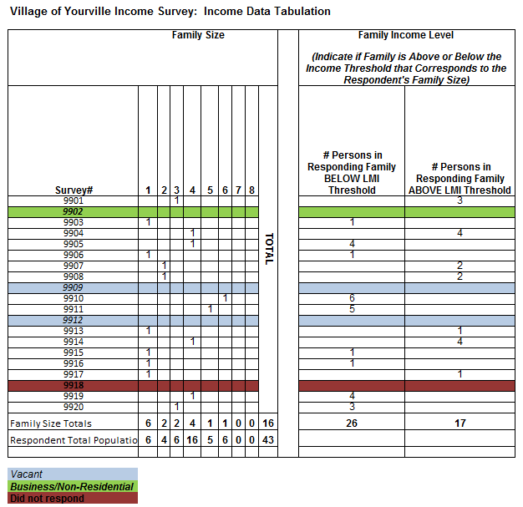

Survey Response Race/Ethnicity Data Tracking Example:

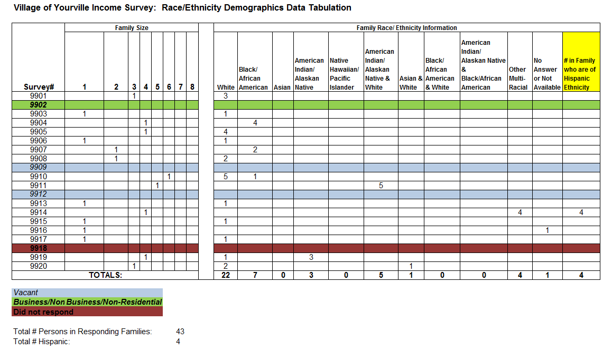

Survey Distribution Efforts Tracking Example:

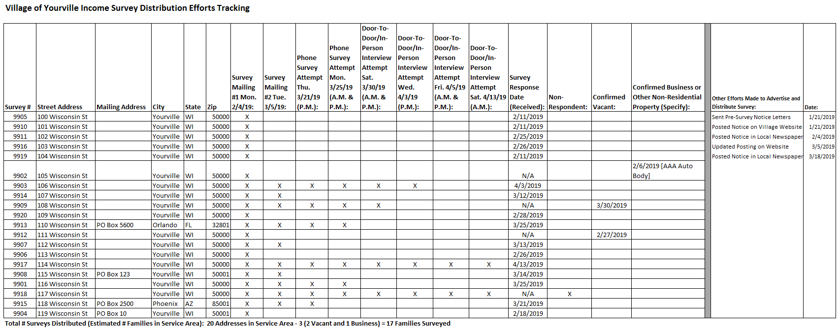

Appendix E

Service Area Map Examples

Maps of the project area and income survey area (i.e., service area) must be submitted with the CDBG application. More than one map may be required to illustrate the project area, location of the project activities, location of the residential addresses included in the income survey, and identification of respondents, non-respondents, and vacant and business/non-residential properties. Examples #1, #2 and #3 on the following pages illustrate the types of information to include on project area and income survey area maps (i.e., service area maps).

[Note: Survey responses may be recorded on the survey area map or a survey tracking list. For surveys involving a large number of residences, tracking responses on a survey area map may not be practical. Refer to Appendix D in this Guide for income survey data tracking list examples.]

Map Example #1: Project Area/Survey Area Map with Response Type Tracking

Combination Map: Project Area Map with Project Activity Locations and Income Survey Map with Residential Address Locations and Response Type Tracking.

Mark respondents, non-respondents, and confirmed vacant and business/non-residential properties on the survey area map. Track the data from the responses (i.e., income and race/ethnicity data) on a separate tracking document. Refer to Appendix D in this Guide for income survey data tracking list examples. Mark the types of work being completed in the service area on the project area map and/or the survey area map.]

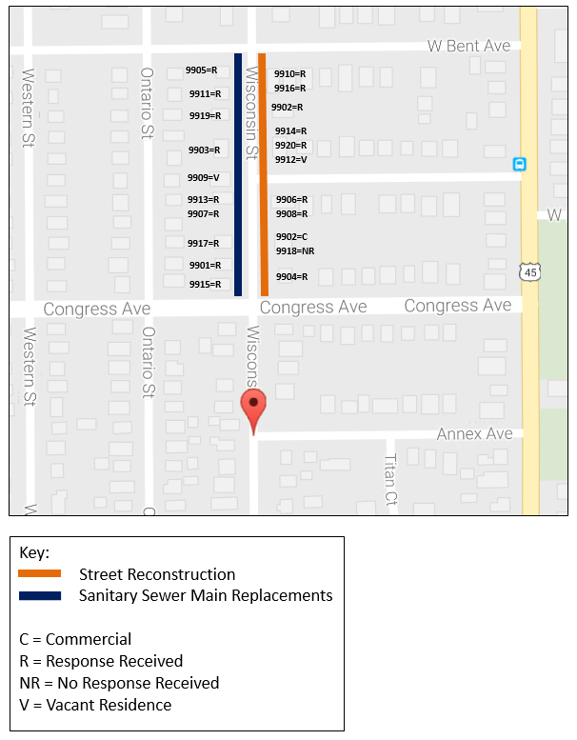

Map Example #2: Survey Area Map – Aerial View

Income Survey Map with Survey Area Boundaries Identified in Satellite View

If this map is submitted as the Income Survey Map, an additional document is required, that includes a listing of the street addresses of all residences in the Service Area/Survey Area and whether the family(ies) at each residence responded or did not respond or the residence was verified to be vacant or a business/non-residential property.
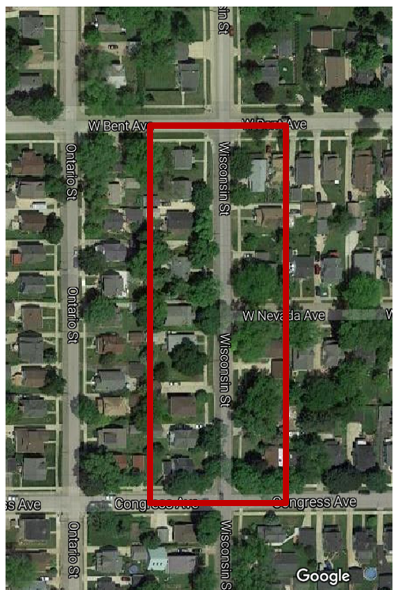

Map Example #3: Project Area Map – Utility System

Project Area Map: Utility System Map Showing System Components and Sanitary Sewer Main Connections (Partial Representation)

A utility system map may be necessary for a project involving water and/or sanitary sewer main upgrades to show the mains and connections to verify primary beneficiary households (i.e., families to be surveyed). Looping and other system components may result in having primary beneficiaries of a utility project that reside beyond the street(s) on which the new water or sanitary sewer mains will be installed. A utility system map provides additional information for determining the impact and beneficiaries of the proposed work to be performed. The example below represents only a portion of the full utility map of the area that may be submitted with the CDBG application.

